Practical applications of Open source software’s and web 2.0 tools in teaching and learning process
Dr. Sarika Sawant, SHPT school of library Science, SNDT Women’s University, India

Abstract: The present papers summarises the actual applications of open source software’s and web 2.0 tools in teaching & learning process at SHPT school of library science. Such applications can be implanted by any other faculty of arts, commerce, science etc for their teaching & learning purpose. In case of Open Source software, the Zotero and in case of Web 2.0 tools, the Wikispaces are explained in connections with how these can be used in giving assignments to the students. There are other open source software’s included in the paper such as open office and web 2.0 tools such as social networking sites, how they can be a platform of communication among the students and professional community.
Keywords: Open source software’s, web 2.0 tools, Wikispaces, Google docs, open office, social networking, facebook,

1.1 Open source software’s
In the past ten years, open source software has become one of the most discussed topics among software users, developers and practitioners. The increasing interest in open source software has been motivated by at least three factors:
- the success of products such as Linux and Apache, which are gaining increasing shares in their own markets (operating systems and http servers);
- the uneasiness about the Microsoft monopoly in the software industry; and, finally,
- the increasingly strong opinion that "classical" approaches to software development are failing to provide a satisfactory answer to the increasing demand for effective and reliable software applications (Fuggetta, 2003).
1.2 What is Open Source Software?
The Open Source Initiative ("OSI") defines Open Source as software providing the following rights and obligations:
- Unrestricted distribution: No royalty or other fee imposed upon redistribution.
- Source code distribution: Availability of the source code of of the entire open source product
- Modifications: Right to create modifications and derivative works.
- Author's source code integrity: May require modified versions to be distributed as the original version plus patches.
- No personal discrimination: No discrimination against persons or groups.
- No restriction on application: No discrimination against fields of endeavor or purpose.
- License distribution: All rights granted must flow through to/with redistributed versions.
- License must not be product-specific: The license applies to the program as a whole and each of its components.
- No restriction on other software: The license must not restrict other software, thus permitting the distribution of open source and closed source software together (Webbink, 2003).
- Technology neutrality. Licenses should not be issued on the basis of the specific technology involved (Lakhan & Jhunjhunwala, 2008).
1.3 Open source applications and its impact on teaching & learning
Open source learning software’s has emerged as a viable solution to many school, college and university administrators, particularly universities. The advantages of use of open source learning software’s are as follows:
- Free availability: Most universities annually pay large sums to software companies to use their products, but open source licenses are free. For example colleges the and universities pay to Microsoft for each license copy of operating system as well as office. But because of advent of Linux operating system and Open office which are freely available can cut the cost of annual subscription at a huge level.
- Documentation: All help and documentation required to use and run the open source software is available on the respective software’s site. So no need to purchase books or manuals to use such software’s. As well as these software’s communities provide continuous help in a form of FAQ or posting query on their blogs with immediate reply.
- Flexibility: Open source products are customizable and can involve third parties. New features and tools can be imported from the open source community.
- Service: The huge collaborative network of the open source community minimizes, although it does not eliminate, the risk of discontinued service. Volunteer help is available through open source support systems such as forums.
- Continuous improvement: Extensive collaboration ensures that software products keep improving. Programmers from different institutions and organizations, along with volunteers, contribute freely to projects.
- Tax benefits: Governments of many countries have implemented tax-exemption policies to boost open source projects, although the governmental role in promoting open source software is controversial. It has not yet been implemented in India but definitely going for open source software’s remove the VAT and other taxes that every institution has to pay after every purchase of such material. In India for educational purchase octri charges are waved on one condition if such a certificate is issued.
2 What is Web 2.0 and its tools
Web 2.0 refers to a perceived second generation of web-based applications and services and in particular the use of the web as a platform for user-generated content and web-based communities, including particularly social networking, wikis and folksonomies (O’Reilly, 2005).
The Web 2.0 applications hold profound potentials in education because of their open nature, ease of use and support for effective collaboration and communication. They change the traditional view of human knowledge and open up more opportunities in teaching and learning. Today, many teachers are exploring the use of Web 2.0 tools into teaching and learning. However, many researchers agree that studies of teachers’ perceptions and opinions are critical because teachers’ perceptions are significant to the implementation of technology innovations in teaching and learning.
The web 2.0 tools/applications include, blogs, wikispace, podcast/webcast etc.
The present papers summarises the actual applications of open source software’s and web 2.0 tools in teaching learning process at SHPT school of library science. Such applications can be implemented by any other faculty of arts, commerce, science etc. It has been divided into two categories: Open Source softwares & Web 2.0 tools
3 Open Source software’s
3.1. Referencing software/ Reference management software/ Bibliographic software/ Bibliographic Management Software
Referencing software’s enable authors/writers/students to manage references to journal articles, books, web pages and other e-sources, or other materials of interest. These references can be annotated in different ways with authors own notes, keywords, graphics and attached files, to provide a complete information management resource. It saves save authors/users/researchers time in creating and managing the references. Author can create a bibliography for his /her thesis, assignment or journal article in preferred citation style. Also can import the references from a database or catalogue. The example of such a software is Zotero.
Zotero is free, open source bibliographic software. It is a research tool for managing online references developed by the Center for History and New Media at George Mason University, Zotero is a Firefox extension that provides users with automated access to bibliographic information for resources viewed online. Online researchers can quickly and easily gather the information they will need later to review and cite references and create bibliographies. Zotero includes features to manage sources, and users can also manually enter sources. The result is a centralized location for gathering and storing references, significantly streamlining the research process.
Practicals based on referencing software
The Referencing software’s are taught to the MLISc (final year) students at the beginning of the second semester of the MLISc class. So the students can use this knowledge for their Seminar and Project that they required to submit at the end of the semester. The school promotes the Open Access Movement so encourages students to use Open source software’s such as Zotero. The students are instructed to download the Zotero software on their machines along with Mozilla browser. Even though Zotero and Mozilla is already installed in the computer it is deinstalled from the machine so that the students can have the experience of download and installation procedure. Initial orientation to the software is given to students with the help of Interactive white board installed in the class. The students are given assignment to prepare bibliography using Zotero software in APA style. The students are instructed to download Mendeley and repeat the same bibliography assignment. This enables students to understand the different software’s and their evaluation based on the criteria given by the teacher. This learning experience helps them to use, understand, and compare the various systems available on the web. Also helps them to generate the bibliographies for their seminar and project.
3.2 Other open source software’s
There are plenty of other open sources software’s such as open office which students can use instead of Microsoft office. Bluefish HTML Editor an open source software used in the Information processing practical to generate the metadata or to know how metadata is generated. Students in this way learns how to use and apply in the library.
There are few Google’s gadgets which are not open source but free to use that can be used by teachers and students such as Google docs. It is a web-based office suite and data storage service offered by Google. It allows users to create and edit documents online while collaborating in real-time with other users. Google docs can be used by the students if they are doing any group work in collaboration for example assignment on reference practical. Students are recommended by the teacher to use Google presentation to create presentation and store it online.
4 Web 2.0 tools
4.1 Wikispaces
Wikis is a website that allows the visitors themselves to add easily, remove, and otherwise edit and change available content via web browser. Wikis are typically powered by wiki software and are often created collaboratively by multiple users. Wikis may serve many different purposes. Some permit control over different functions (levels of access). For example, editing rights may permit changing, adding or removing material. Others may permit access without enforcing access control. Other rules may also be imposed for organizing content.
Advantages of wikis in teaching learning process is Increased student engagement, easy to monitor, creativity, collaboration, metacognition, interpersonal skills & a new interesting way to learn.
Students were given assignments to create the eNewsletter of various libraries on condition to use wikispaces to create eNewsletter. The students were divided into groups to visit different libraries and collect data for eNewsletter. The teacher gave the criteria to the students what information to look for while visiting libraries and collecting data for eNewsletter. In addition students carried their camera to take the pictures of the libraries. There is a plenty of documentation available about the wikispaces on wikis website, slideshare even youtube. With little orientation by the teacher students successfully created eNewsletter. The information collected were organized according to the library events, staff achievements etc. The homepages of the wikispaces as follows.
Picture no. 1: SNDT women’s university library eNewsletter
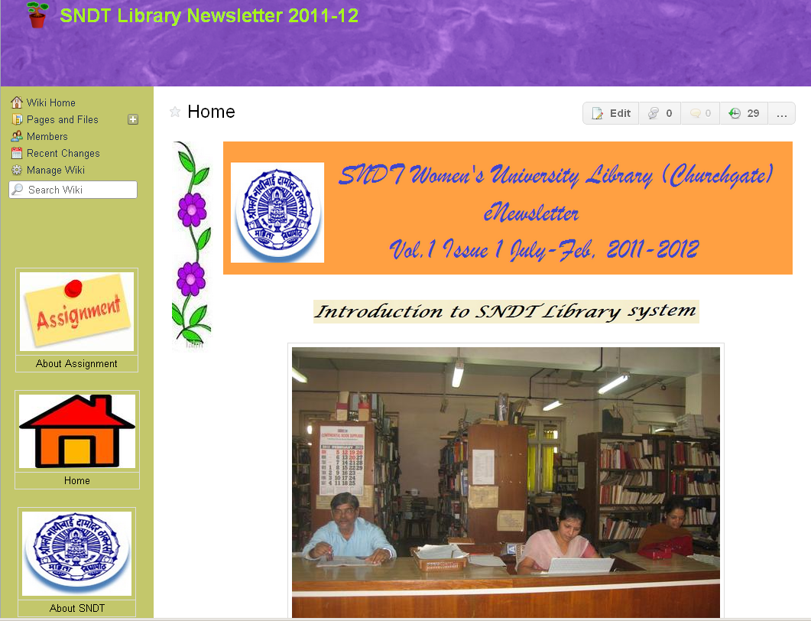
Picture no. 2: Jai hind college library eNewsletter
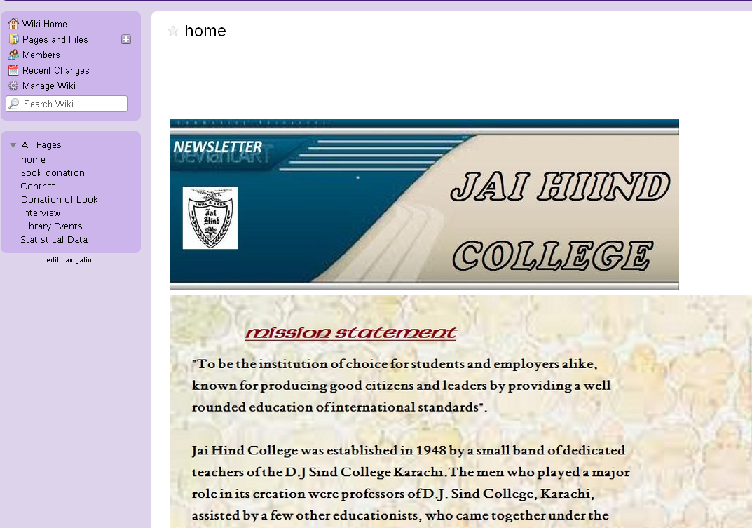

Picture no. 3: Sydenham college library eNewsletter
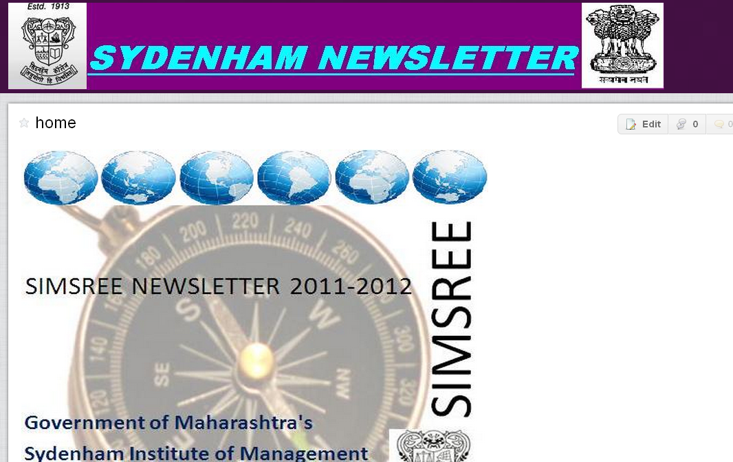

Picture no. 4: HR college library eNewsletter
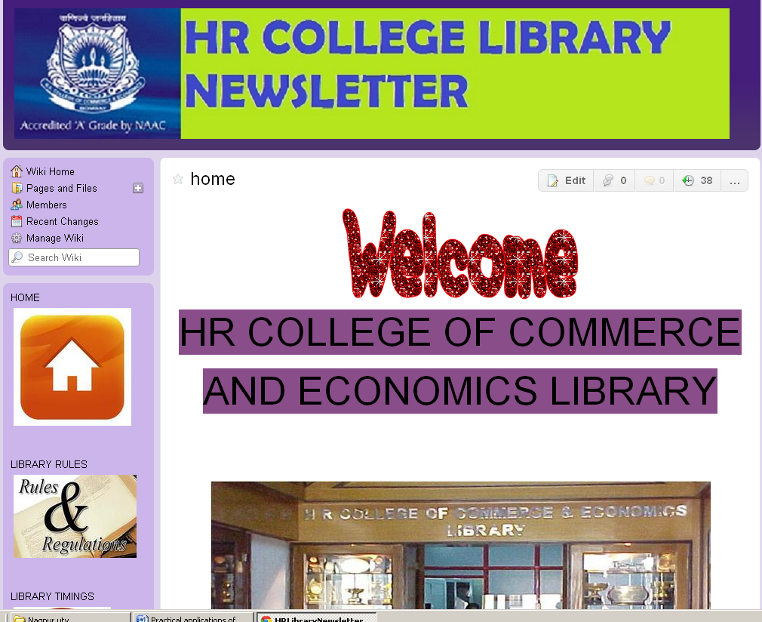

4.2 Other web 2.0 tools
There are plenty of other web 2.0 tools which can be used by teachers and students in an interesting ways. Such as social networking where information can be shared. For example to communicate to LIS professional and ex students about the state level conference which SNDT Women’s university library organized in January 2012, teacher created event in facebook and invited all members to attend the conference. In same way the event was created to invite members to visit the Mega Education Fair 2012 which SNDT Women’s university conducted in February 2012. Later pictures of the events were shared with the LIS professionals. Even the presentation prepared by the teacher for SHPT promotion was shared on slideshare.

Picture no. 5: Event created for the Mega Education Fair 2012
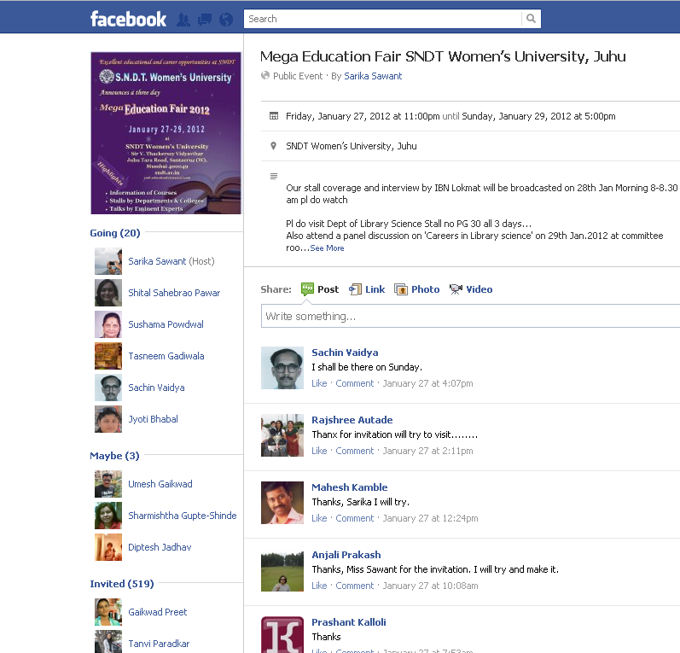
Picture no. 6: Event created for the ALEE 2012 conference
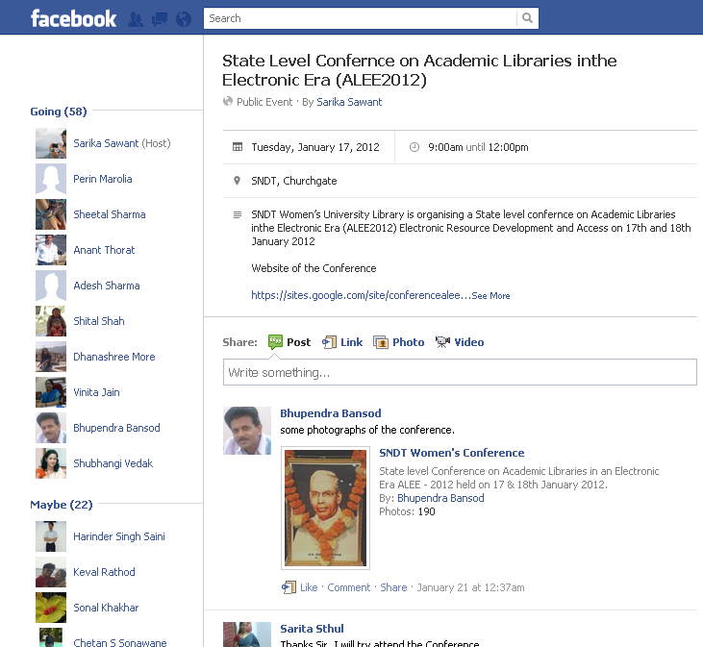
5 Conclusion and discussion
There are plenty of open source software’s and web 2.0 tools available on the web. It is a duty of every teacher to try to find out what applications are available and how it can be used for the teaching and enhance the students learning process. It is true that no such training is given to individual teachers but self orientation is the best practice in such a case. With available documentation, teachers can start to learn and implement in teaching to become real 21st century teacher. Recently SNDT women’s university took the initiative to train the teachers in web 2.0 environment. About five such workshops were conducted by the department of Educational Technology on how ICT is integrated in Higher Education with actual demonstration.
It is todays’ need to move on to the next level of teaching to enhance the learning process and achieve the goal of the profession. It is a demand to learn and flourish otherwise finish.

References
Fuggetta, A. (2003). Open source software––An evaluation. Journal of Systems and Software, 66(1). Retrieved on January 10, 2010 from http://www.sciencedirect.com/science?_ob=ArticleURL&_aset=V-WA-A-W-AWE-MsSAYZA-UUA-U-AAABWAWYDZ-AAAUDEBZDZ-EDYVYAEVD-AWE-U&_rdoc=79&_fmt=full&_udi=B6V0N-48FK950-5&_coverDate=04%2F15%2F2003&_cdi=5651&_orig=search&_st=13&_sort=d&view=c&_acct=C000020739&_version=1&_urlVersion=0&_userid=433544&md5=e3aeba78cb01a97bf7e5b8bc8badf169
http://en.wikipedia.org/wiki/Wiki (accessed February 14, 2012)
Lakhan, S. E. & Jhunjhunwala, K. 2008. Open source softwares in education. EDUCAUSE Quarterly. 31(2) (April–June 2008). Retrieved on February 14, 2012 from http://www.educause.edu/EDUCAUSE+Quarterly/EDUCAUSEQuarterlyMagazineVolum/OpenSourceSoftwareinEducation/162873
O’Reilly, T. (2005). What is Web 2.0 ? Design patterns and business models for the next generation of software. Retrieved on March 28, 2010 from http://www.oreillynet.com/pub/a/oreilly/tim/news/2005/09/30/what-is-web-20.html
Webbink, M. (2003). Understanding Open Source Software. Retrieved on March 28, 2010 from http://www.groklaw.net/article.php?story=20031231092027900

