Scientific Study of Middle East countries in Psychology (1996-2010)
M. H. Biglu¹, N. Chakhmachi², S.Biglu³
^{1,2}Department of Medical Library and Information Science, Management & Medical Informatics Faculty, Tabriz University of Medical Sciences, Tabriz, Iran
³Hamburg University, Asia-Africa Institute, Hamburg, Germany

Correspondent author: Dr. Mohammad-Hossein Biglu, E-Mail: mh_biglu@yahoo.com

Abstract:
Introduction: A bibliometrics analysis was conducted to explore the scientific activities in the field of psychology from Middle East countries in contrast to the leading countries in the world throughout 1996-2010.
Methodology: All row data was extracted from the SCImago. The SCImago Journal & Country Rank is a portal that includes the journals and country scientific indicators developed from the information contained in the Scopus database.
Results: The study showed that a total number of 5,186 citable publications in the field of psychology came from the Middle East countries. Israel with producing 82.2% of total citable publications was the most productive country in the region. The following countries were Iran (5.5%), Kuwait (3.0%), Lebanon (2.4%), and United Arab Emirates (2.3%). The fraction of other countries (Iraq, Jordan, Oman, Qatar, Saudi Arabia, Syria, and Yemen) in the region was 4.3%.
Conclusion: The most majority of publications came from North America (48%) and Western Europe (32%). Regarding to the subject categories 47% of total publications was in the subject area of miscellaneous Psychology, 12% in Neuropsychology and Physiological Psychology, 10% in Clinical Psychology, 10% in Experimental and Cognitive Psychology, 8% in Developmental and Educational Psychology, 7% in Social Psychology and 6% in Applied Psychology.

Keywords: Scientometrics, Bibliometrics, Scientific Profile, Psychology, Middle East

- Introduction
“Psychology is both an applied and academic field that studies the human mind and behavior. Research in psychology seeks to understand and explain thought, emotion and behavior. Applications of psychology include mental health treatment, performance enhancement, self-help, ergonomics and many other areas affecting health and daily life. Psychology evolved out of both philosophy and biology. Such discussions of the two subjects date as far back as the early Greek thinkers such as Aristotle and Socrates. The word psychology is derived from the Greek word psyche, meaning 'soul' or 'mind.' The field and study of psychology was truly born when Wilhelm Wundt established the first psychology lab in Leipzig, Germany.”[1] The psychological health is the most important thing in human’s life. That is why the policymakers in developed countries dedicate an appropriate budget for psychological health care of countries inhabitant. As the scientific output in subject areas can mirror the research activity of scientists in that subject field; [2] therefore in this paper we attempted to investigate the trend of scientific activities in the field of psychology in different categories during a period of fifteen years.
2. Materials and Methods
The web portal of SCImago was used to obtain row data about literature of science in psychology during a period of fifteen years. The obtained data was categorized in different disciplines of psychology. We took only the citable publications under consideration.” The SCImago Journal & Country Rank is a portal that includes the journals and country scientific indicators developed from the information contained in the Scopus® database (Elsevier B.V.). These indicators can be used to assess and analyze scientific domains. This platform takes its name from the SCImago Journal Rank (SJR) indicator, developed by SCImago from the widely known algorithm Google PageRank™. This indicator shows the visibility of the journals contained in the Scopus® database from 1996.”[3]
- Results
Analysis of data showed that a total number of 289,594 papers in the field of psychology was distributed during the period of study. As Figure 1 indicates, the number of publications increased in a power law relationship. It reached from 15,061 papers in 1996 into 26032 in 2010, an increase of 73%. Base on the information of Figure 2, the majority of publications was in miscellaneous psychology (47%) followed by Neuropsychology and Physiological Psychology (12%), Clinical Psychology (10%), Experimental and Cognitive Psychology (10%), Developmental and Educational Psychology (8%), Social Psychology (7%) and Applied Psychology (6%). The USA contributing of 42% (115,366 papers) of world’s publications was the most productive country in the world. Only seven countries distributed equal or more than 3% of world’s publications throughout the time and they are: U.K. 11% (28,785 papers), Canada 7% (18,131 papers), Germany 5% (14,757), Australia 4% (10,592), Netherlands 4% (9,748), France 3% (8,771) and Spain 3% (7,103). In the case of regions a total number of 5,186 citable papers came from the Middle East. Israel contributing of 4,265 papers was the most prolific country in the region. The following countries are Iran (258 papers), Kuwait (158), Lebanon (125), Saudi Arabia (72), Jordan (46), Qatar (16), Iraq (11), Syria (5) and Yemen 1 paper.

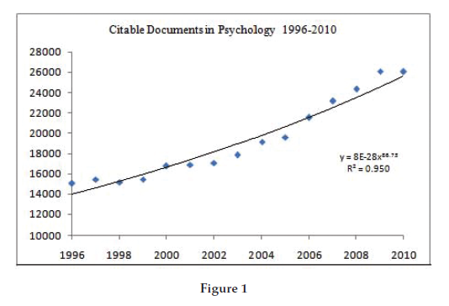
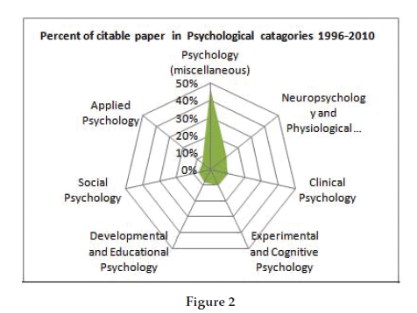

- Discussion
Analysis of data indicated that the number of publications increased in a power-law relationship during the period of study. The number of publications in the field of psychology in 2010 was 73% greater than those in 1996. The majority of publications in the field came from North America (48%) and Western Europe (32%). A total number of 5,186 papers (1.9% of world’s publication) came from the Middle East. Israel sharing 82.2% of total publications is the most prolific country in this region. The following productive countries are Iran 5.5%, Kuwait 3.0% and Lebanon 2.4%. The number of papers in the field of psychology published only by the USA is 21 times greater than all countries in the Middle East region. In conclusion the research activities in the field of psychology seem to be more interesting subject area of scientists in developed countries than those in developing countries. This is not the only study that proved this phenomenon; another similar researches have confirmed it likewise [4, 5, 6].

References
- http://psychology.about.com/od/psychology101/f/psychfaq.htm
- Biglu, M. H., & Askari, O. (2005). A bibliometric study of scientific output in Tabriz University of Medical Science. Processing of ISSI 2005, Vol. 2, 650-651.
- SJR -SCImago Journal & Country Rank. Retrieved July 26, 2011, from http://www.scimagojr.com
- S. Biglu, M.H. Biglu and C. Falk (2011). Scientometric study of scientific production in psychiatry. European Psychiatry, Volume 26, Supplement 1, 2011, Page 515
- M.H. Biglu and A. Asgharzadeh (2011). The prevalence of stress factors among medicine students in Iran. European Psychiatry, Volume 26, Supplement 1, 2011, Page 1577
- Biglu, M. H. (2007). Tendency towards the Self-citation among Journals in Iran and Turkey. Information World/Bilgi Dunyasi, 8(2).

