**The effect of Facebook adoption in an academic library**

Rabishankar Giria, Debal C. Karb, B. K. Senc

a Assistant Librarian, Presidency University, 86/1, College St, Kolkata, West Bengal 700073, E-mail: [rsgiri11@gmail.com](mailto:rsgiri11@gmail.com)

b University Librarian, Ambedkar University,Lothian Rd, Kashmere Gate, New Delhi, Delhi 110006. E-mail: [debal@aud.ac.in](mailto:debal@aud.ac.in)

c Chairman , Bibliometrics Experts Committee , Dept. of Science & Technology, Govt. of India

Member Research Council, History of Science, Indian National Science Academy

Res: 80 Shivaik Apartments, Alaknanda, New Delhi -110019, E-mail: bksen1938@gmail.com

**Abstract:**

The postings in library’s Facebook page was gleaned and analyzed. Data of important metrics of Facebook post usage were taken from ‘Facebook Insight’ metrics of Indira Gandhi Delhi Technical University for Women Library’s Facebook page. Alongside, library usage data were used to understand the change in behavior of library usage. The findings provide further support to the view that social network sites (i.e. Facebook) have the potential to be a cost-effective means of engaging users effectively irrespective of size of the academic library. It is also found that collaboration and communication through Facebook were far more effective than traditional approaches. Since only the experience of a single institution is considered, it cannot be definitively stated that Facebook will be effective in every institutional context. However, the result provides a basis for academic libraries to consider experimenting with Facebook and it page insight data may be taken to understand its effectiveness. This paper provides evidence that such initiatives can provide a measurable impact of Facebook as outreach tool with minimal efforts.

**Keywords**: Social networks, Facebook, Education, Library marketing, Academic libraries, India

**Introduction**

Invention of social media and its fascinating appeal among the youths have changed the online world dramatically over the last decades. The unique nature of social media by enabling its users to form, maintain and rediscover relationship in a completely different way irrespective of time and space has made it unbelievably popular among the youth. They have gradually become major catalysts in reshaping the manner in which individuals and organizations collaborate, communicate and create relationships with friends, colleagues, peers and prospective users. This has made it an increasingly important topic of research for scholars across a wide spectrum of disciplines ranging from social and behavioral science, computer science, economics, law to business and marketing. Librarians and information professionals did not remain aloof about this important technological advancement. Rather, they began exploring the possibilities of applying these social networking sites (SNS) as a tool for education as well as for promoting library awareness and marketing from the time of their origin. Studies have shown that social networking tools can make educational activities more live by making interaction, collaboration, active participation, information plus resource sharing, and critical thinking possible (Ajjan & Hartshorne, 2008; Mason, 2006). Hence, using social networks in educational and instructional contexts can be considered as a potentially powerful means simply because students spend a lot of time on these online networking activities (Mazman & Usluel, 2010). Libraries that play a pivotal role in both formal and informal education viewed social media as a powerful information dissemination tool that offers an easy and cost effective way to promote their activities, resources and services while allowing a two-way dialogue with stakeholders (Canty, 2012). Thus, many librarians have considered social media as a low cost minimal effort venue with current and potential users of library. Web 2.0 tools especially social media are usually associated with younger generation and their implementation in library is often justified by the argument that there is a need to adapt to the new expectation and demands of the web savvy digitally naïve generation (Mercun and Zumer, 2011). Thus, many libraries across the globe hooked with social media seem to be pervasive in its use throughout society in order to remain relevant with contemporary users.

Social networks started with Six.Degrees.com in 1997 followed by other social networks sites (SNS) such as Livejournal, Friendster, LinkedIn, MySpace, etc. (Boyd & Ellison, 2007). Facebook was launched in 2004 as a Harvard-only Social Network site. It expanded rapidly to include other college and university students, professionals inside corporate networks, and eventually everyone who have access to the online world (Cassidy, 2006). By December 2010, it had become the most visited social networking site in the world, with over 600 million of active users (<https://newsroom.fb.com/Timeline>). According to Socialbaker, Facebook has the 3rd largest number of its users from India in the world and Delhi has second most users among the metro cities of India (Socialbaker.com, 2012). Statistics by socialbakers.com also shows that among the user of Facebook, 49% users’ age between 18-24 followed by age between 25-34 with 27% of total users. As a result of its strong user base among youth, Facebook appears to be the most logical social networking website to be used by an academic library whenever it considers reaching its prospective users through SNS. Thus, the library of Indira Gandhi Delhi Technical University for Women ((IGDTUW) has adopted Facebook since December 2011.

**Background**

Indira Gandhi Institute of Technology (IGIT) was the Government engineering college for women under GGS Indraprastha University, Delhi. This college has recently been upgraded to university and renamed as Indira Gandhi Delhi Technical University for Women. This institute is predominantly for undergraduate students with four B Tech Courses. It has recently introduced four new M Tech courses after its up-gradation to a University. The student population totals around 1400 including the postgraduate students.

The library of this institute has a highly selective collection of around 21,000 books along with thousand of e-resources accessible through different e-consortia. The library is always open to experimentation whenever it comes to adoption of new technology. In order to facilitate services to its users it has adopted NewGenLib, an open source integrated library management system from 2008 without any vendor support ( Giri and Sengar, 2011; Giri, 2012). In mid-2011, the library staff decided to have library’s presence in the much used social media, preferably Facebook and Twitter. But some of the advisory members of library were suspicious about its future as they thought that it requires regular updating and promotion. They believed that social media would be better useful for the big libraries that hosts a lot of events, exhibit workshops and other activities. But the staff prefers the ‘active librarian’ role by coordinating with students preferably class leaders, board members of different society of this institute like IEEE society and HODs for first hand information on different events, workshops, etc. After a few brainstorming discussions, in mid-December 2011, the Library opened its account in Facebook and created the library page as www.Facebook.com/IGDTUWLibrary.

**Literature Survey**

Given the widespread diffusion of Facebook among the student population, a quite significant number of investigations have been carried out to understand and evaluate the value of Facebook as an educational tool and as a learning environment. Manca & Ranieri ( 2013) viewed that social networking sites blur the distinction between learning spaces, social spaces and leisure spaces, thus suggesting that mixing all sorts of activity together can be useful. In a networked world, the connectivist approach of learning states that the locus of learning relies on a concept of learning based on exploration, connection, creation and evaluation within networks that connect people, digital artifacts and content (Siemens, 2005). Thus, use of SNS for learning relies on the fact that they would support ‘‘the process of building networks of information, contacts and resources that are applied to real problems’ (Anderson & Dron, 2011, p. 87). But, the extent of adoption of Facebook by its users in an educational context will rely on a positive relationship and usefulness, ease of use, social influence, facilitating conditions and community identity, and that among these variables the usefulness dimension is the most important determinant in Facebook adoption (Mazman & Usluel, 2010). Therefore, contrasting results are obvious while investigating Facebook’s educational value given the different environmental and social context of students using Facebook (Madge et. al, 2009, Selwyn 2009, Wodzicki, et. al , 2012)

Libraries being an important part of the academic sphere have also leveraged these communication tools as a new means to reach, interact with its users. Many libraries across the globe made their presence in Facebook and numerous literatures attempted to explore the opportunity and drawbacks of Facebook application in libraries. In 2007 , Farkas argued that the librarian should ‘go where patrons are’ and opined that linking the library’s website with the Facebook page can act as a portal to the library. As students frequently use outside search engines for academic research, even a basic Facebook page can serve as a reminder to use the resources available in an academic library. Breeding (2007) viewed that using Facebook as a venue for the library’s outreach to students might be an ambitious approach but librarians cannot ignore this trend. But the survey of opinions and perceptions of librarians of academic health science institutes by Hendrix et al. (2009) revealed the opposite. It was found that majority of the librarians participated in the survey believed that Facebook had hardly any place in academic settings and librarians had hardly any time to set up a library page in Facebook.

As the librarians became ambitious and more open to experimentation, library-centric case studies started to appear. Mack (2007) presented an interesting investigation in which a librarian at Penn State marketed his own page to the undergraduate students and documented the number of reference and research questions he received. It is found that almost 29% questions were received through Facebook, and all of them from undergraduate students. Therefore, the author recommended that library professionals whose positions require them to interact with undergraduates seriously consider making use of Facebook. Graham, Faix and Hartman (2009) presented a case study of their Facebook adoption at Kimbel Library of Coastal Carolina University in which they observed that library’s visibility has increased substantially after Facebook adoption.

Many librarians surveyed their student’s opinions before joining social network. Connel (2009) presented a study, where she surveyed 366 new comers at Valparaiso University to elicit their opinion on libraries presence in social networking sites. It was found that though most of the students use Facebook, only 17% of the students surveyed would proactively add a library as a friend, while 58% would accept the library's request but not be proactive about it, and 25% would not accept a request to become friends with the library. In contrast Burhana et al. reported that most of the participants prefer a clear delineation between educational and social communication. The same has also been supported by Ismail (2010) as well as Epperson and Leffler (2009).

As time passed, a growing number libraries started tapping Facebook. Literature started to explore the contents, likes and comments posted in walls of library Facebook page. Jacobson (2011) tried to find out reported versus actual use of Facebook in libraries. He found that marketing / announcements along with OPAC search and RSVP of the events are more popular than reference service and discussion forum. While Gerolimos (2011)’s attempt to understand the level of engagement of library with students by analyzing user posted comments on different library Facebook walls showed that students prefer to press the ‘Like’ button rather than challenging the library and its personnel, either by giving a suggestion, making a complaint, or even asking a simple question. Phillips (2011) analysis of contents posted in Consortium of Academic and Research Libraries in Illionis (CARLI) members’ Facebook walls revealed that Facebook offers a dynamic environment for academic libraries to cultivate relationships with students. He concluded that if librarians using Facebook present themselves as approachable in order to develop a rapport with students, it would ultimately facilitate the delivery of service.

The studies cited above were mostly carried out by the libraries/ librarians of developed countries. Only a few studies have been done on the libraries of developing countries. For instance, Riza Ayu and Abrizah ‘s (2011) study on usage and applications of Facebook pages among academic libraries in Malaysia gives some insight of level of usage by the libraries of the country. Besides, a very few research has attempted to record the effectiveness of Facebook adoption in library by providing some measurable results except the study of Mack et.al (2007).Thus, unlike most research of to day, the present study attempt to investigate

a) Response behaviour towards library postings .

b) Impact on activities and services of the library after adopting Facebook.

**Methodology**

***Data collection***

Collection of data on the following steps.

**(i)** Students' social media usage and their perception

The Library of the Institute is responsible for preparing student ID cards for freshers which are bar-coded. It is mandatory for students to submit their admission details along with contact information during the preparation of ID card. At that time, additional information like preference for SNS, presence in SNS and their views on joining to library’s SNS networks were collected. The data are upgraded regularly by the circulation staff of the library.

**(ii)** Facebook insight data

Facebook provides a unique opportunity to the page administrator to view and export page level and post level data through ‘Facebook Insights’, the metrics about how people are using the Page (Facebook, 2012) which is not visible to students or others. Their insight data were exported in Excel sheet for analysis.

**(iii)** Data on usage of learning materials by users

The library has been using the NewGenLib, an open source software for integrated library management system since August 2008. All the activities and services of library have been automated. Data regarding circulation statistics, OPAC statistics, etc, were culled out from the database.

***Data analysis***

In this phase collected data were tabulated in Excel sheet and analysis was carried out. Facebook insights data provide more than 60 usage parameters. Among them, only three parameters, viz. ‘total reach’, ‘like’ and ‘comments’ were considered of our interest for this study. Glazer (2012) recommended that impression could be used as ranking popularity of the post, we emphasize on total reach rather than impression. Because ‘impression’ measures the number of times a post from a ‘Page’ is displayed, whether or not the post is clicked. One may see multiple impressions of the same post whereas ‘reach’ measures the number of unique people who received impressions of a Page post (Facebook.com). Thus, it is thought that reach may be the important parameter rather than impression when we consider ‘reach’ to unique people.

‘Likes’ have been taken as it is believed that it is more active way of engagement with users than reach. Total page ‘likes’ is good but post-level ‘likes’ have more importance on measuring the effectiveness of the post as a user may like the library's presence in Facebook for several reasons but liking a particular post indicates its suitability. 'Comments' are taken as it is the most active way of engaging the users.

All the posts in Facebook are divided into several categories according to their contents and then analysed.

The usage data of library were divided into two periods, i.e., the usage data of pre- and post-adoption of Facebook by the library. The data were tabulated and analysed.

**Results and Discussion**

The initial data collection of student’s preference for SNS has revealed that 89% of the students use Facebook and about 9% use Twitter. The uses of other SNS by the students are negligible. The details are summarized in Table 1.

Table-1: Students’ SNS accounts and their willingness to join Library’s SNS account

|  |  |  |  |  |  |
| --- | --- | --- | --- | --- | --- |
| **Students enrolled with the Library** | **Name of SNS** | **Students reported having Account** | **Students joined in library’s network** | **Students having the A/c**  **(%)** | **Students willing to join library’s network having the A/c**  **(%)** |
| 1406 | Facebook | 1253 | 1054 | ~ 89 | ~ 84 |
| Twitter | 127 | 72 | ~ 9 | ~ 57 |

* (Data as on 31st January 2013)

.

This has prompted the library to use Facebook, though library has its presence in Twitter but it is integrated with Facebook i.e., whenever we put a message in Facebook wall that would automatically be posted in Twitter.

When, the 1st year students joined this institute in June 2012, they were targeted to have an idea about their perception of library’s Facebook adoption. It is found that undergraduate students are less concerned about their privacy and security rather than their postgraduate counterparts. Table 2 depicts the scenario.

Table-2: Freshers SNS accounts and their willingness to join with Library’s SNS account.

|  |  |  |  |  |  |
| --- | --- | --- | --- | --- | --- |
|  | **Number of 1st year students** | **Students reported having Facebook A/c** | **Student joined in library’s Facebook network** | **% of Total students having the A/c** | **% of students willing to join library’s network having the A/c** |
| Total Admitted | 395 | 341 | 239 | 86.33 | 70.09 |
| Undergraduate | 302 | 251 | 185 | 83.11 | 73.71 |
| Postgraduate | 93 | 90 | 54 | 96.77 | 60 |

Most of the unwilling students perceive Facebook as the private and personal space and they do not want to share it with library staff. Some have even apprehension that library staff may be peeping into their personal life and that may have the potential to jeopardize their college/university life. The above results are in line with Sachs et al.’s (2011) findings. Thus, unwilling students prefer to click ‘like’ button of the library’s Facebook page rather than joining library’s Facebook network as a friend as clicking on ‘like’ will automatically share the updated content in the library’s Facebook’s wall. .

***Insights from Facebook***

The library has posted 117 items in its Facebook wall from its inception to February 2014. It has got 608 likes so far. The total likes may not be the most important element of assessing the popularity of the page, but it provides a measure of the level of interest that a library attracts on Facebook (Gerolimos, 2012).

When we see the ‘reach’ towards each post, it reveals the pattern given in Graph 1.**

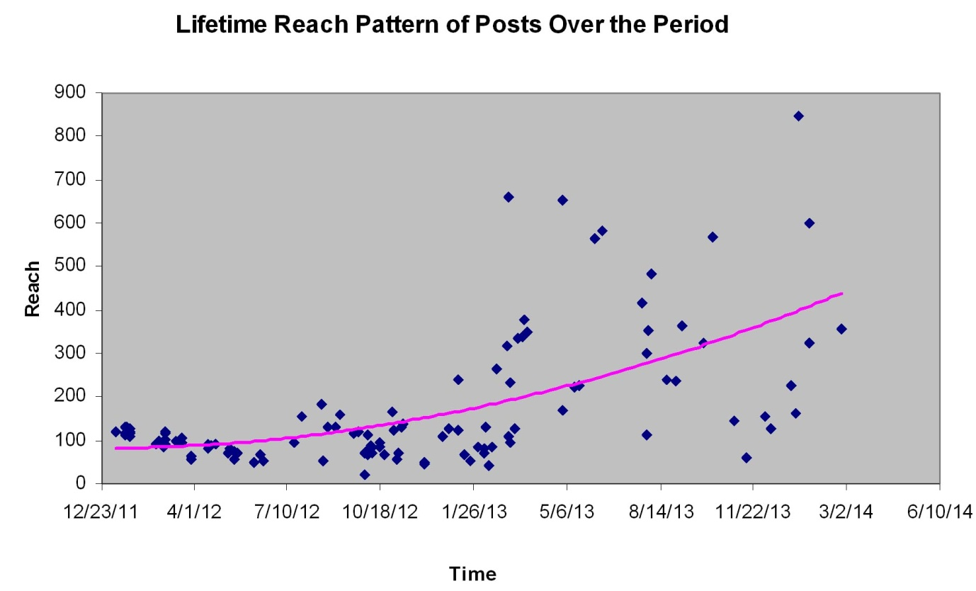

Figure -1: Reach pattern towards Facebook postings

Though ‘reach’ depends on several factors including time of posting, interest on a particular post, etc. It may be safely inferred that library postings are gradually becoming popular among the ~~patron~~s users. The lifetime reach data also help greatly to understand the time of postings. It has been observed that during long holiday (ex. summer/winter ) or during examination time, hardly any users access the library facebook page and as a result some postings even get less than 100 total reach.

Posts are broadly categorized according to their contents and average *reach*, *like*, and *comments* towards each category (Table 3).

Table-3: Categorization of postings of average *reach, like* and *comments*

|  |  |  |  |  |  |
| --- | --- | --- | --- | --- | --- |
| **Content type of Posts** | **Number of postings** | **% of total items posted** | **Avg. no. of *reach*es (approx)** | **Total *likes*** | **Total no. of *comments*** |
| Institutional events | 9 | 7.69 | 258 | 107 | 3 |
| Institute information | 3 | 2.56 | 133 | 5 | 1 |
| Greetings | 6 | 5.13 | 183 | 40 |  |
| Cultural and social activity | 8 | 6.84 | 266 | 40 | 2 |
| Institute workshop | 22 | 18.8 | 115 | 8 |  |
| General | 7 | 5.98 | 186 | 31 | 1 |
| Tech festival | 5 | 4.27 | 135 | 2 |  |
| Collection & facility | 5 | 4.27 | 387 | 79 | 12 |
| Web resources literacy | 28 | 23.93 | 131 | 35 | 5 |
| Library operation | 19 | 16.24 | 170 | 26 | 8 |
| Suggestion on library resources and services | 5 | 4.27 | 102 | 3 | 2 |
| **Total** | **117** |  |  | **376** | **34** |

From the above data, it may be inferred that on average non-library related postings are relatively more popular among users. But, adding those varieties of information (around 50% of total postings) increases engagement with users. This ultimately helps library’s new collection & facility related information to reach the highest number of unique users. This data emphatically support the view that in order to make journey in the social media landscape, libraries should talk about things that seem to be the interest of the users and may be other than the library (Glazer, 2012).

Among the library related posts, it is found that users are more interested in collection & facility related information followed by library operation related message. This may be justified by the fact that the library is a growing entity and there is a gap between the demand and supply of learning resources and required infrastructures in the library. Thus, when a library posts the information in its facebook that library has enabled wi –fi facility, the message got the highest number of *reaches, likes* as well as *comments*. Initially Web Resources Literacy could not garner much support from users possibly because this could be related to their nature of needs and expectations. As most of the users were undergraduate students, they basically needed textbooks rather than research articles. Thus, they were more interested in new textbooks that were coming to the library rather than availability of e-resources in web. But in recent times, this category of postings ( i.e, web resource literacy) has catched up with other category of items posted. This is because after upgradation of the Institute to university, the University has started new post-graduation courses. It is found that postgraduate students frequently need scholarly articles and reference services for their project works and research.

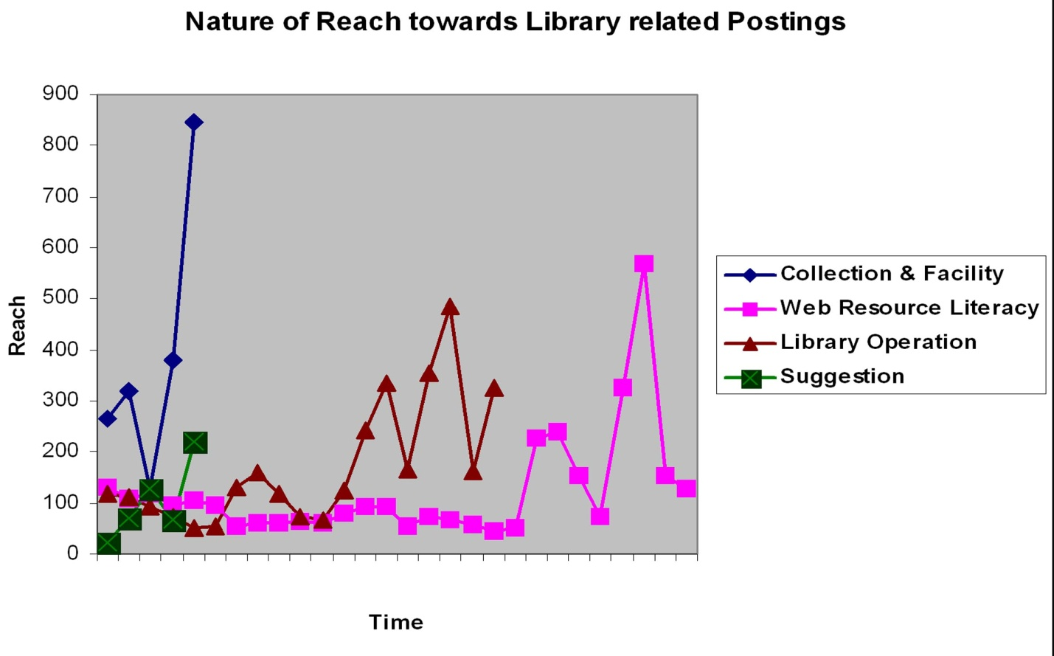

Figure -2: Reach pattern towards postings related to library activities and services

In the above background, investigation was carried out to asses the actual impact by collecting measurable information in some service area of the library.

***Book Bank issue behaviour****:*  Book Bank (BB) is a part of the library where most used books generally the essential textbooks prescribed by the class teachers are kept. Students most often look for the BB books as these are much needed and are used for whole semester. BB books are issued at the beginning of each semester on scheduled dates. The book issue nature of six specific instances is presented in Table 4 . Of them, three instances (i.e, Aug 2010 to August 11) predate the social media adoption and the remaining three instances (January 2012- to January 2013) postdate the social media adoption.

Table 4: Issue of books pertaining to the Book Bank

|  |  |  |  |  |  |
| --- | --- | --- | --- | --- | --- |
| **Date of Issue** | **No. of Students enrolled by the date** | **No. of students to whom books issued** | **No. of defaulting students\*** | **% of students to whom books issued** | **% of defaulting students** |
| Jan-13 | 1287 | 754 | 34 | ≈ 58.59 | ≈ 2.64 |
| Aug-12 | 1279 | 696 | 42 | ≈ 54.42 | ≈ 3.28 |
| Jan-12 | 1004 | 586 | 51 | ≈ 58.37 | ≈ 5.08 |
| Aug-11 | 999 | 501 | 109 | ≈ 50.15 | ≈ 10.91 |
| Jan-11 | 901 | 426 | 125 | ≈ 47.3 | ≈13.87 |
| Aug-10 | 890 | 401 | 101 | ≈ 45 | ≈11.35 |

* Defaulting students are those who did not come to get books issued on their schedule date but came at a later date and reported they did not see the BB notice.

The above data show that after the adoption of Facebook there is a relative increase in the number of students getting BB books issued and considerable decrease in number of defaulting students. Before the Facebook adoption, generally BB notices were placed in the departmental and library notice boards. Students hardly see the notice boards regularly. Generally, the information is diffused through conversation among students. Thus, many students came at a later date and informed the library staff that they did not know the issue date because of this or that. But Facebook helps to remove this time and space barrier to a great extent.

***Nature of Issue of Current Arrivals (CA)***

The demand for newly arrived books depends on several factors. The most important is the relevancy of the procured books for the ongoing semester. Between August 2011 to December 2011 and February 2013 to March 2013, a considerable number of books were procured that were believed to be the demandable titles for that ongoing semester. Newly arrived books are kept in the display section after their processing. Before adopting Facebook, notice regarding the current arrivals was placed in different notice boards of the Institute. In 2013, the Library announced the current arrivals through Facebook and notice boards of the Institute. The dates of announcements and the issue nature of the books arrived by the date are given in Graph 3 (before adoption of Facebook) and Graph 4 (after adoption of Facebook).



Fig. 3. Issue Nature of current arrivals before Facebook adoption



Figure- 3: Issue of current arrivals after Facebook adoption

From the above graphs, it is clear that peak demand period for the newly arrived titles before adoption of Facebook goes beyond twentieth day after its announcement whereas adoption of Facebook helps to reduce the gap between the announcement and peak demand considerably.

The other important observation by the library staff beyond this numerical statistics is that Facebook helps more democratic uses of current arrival resources. In the absence of wider dissemination of CA information, generally it happens that whenever a student notices relevant titles in multiple copies, s/he only informs his/her close friends and they get issued their desired copy whereas others who notice late does not get the desired copy. But, Facebook being an effective announcement tool removes this shortcoming to a great extent and attracts more number of students to visit the library.

***OPAC hits behaviour***

All modules of NewGenlib, an open source software (OSS) for library management was implemented in the Library in January 2009 (Giri & Sengar, 2011). Since then the, OPAC was in the institute’s LAN and that was announced through several library orientation programs as well as notice boards. The Library first posted message about OPAC on 11 December 2011. The OPAC was then in LAN only. From 15th June 2012, the OPAC went online. The NewGenLib provides OPAC hit statistics, i. e, how many times search was carried out through OPAC. The result is given in Table 5.

Table – 5: OPAC usage

|  |  |  |
| --- | --- | --- |
| Hits before adopting Facebook and OPAC available in LAN only (≈ 35 months) | Hits after adopting Facebook and OPAC available in LAN only  (≈ 6 months ) | Hits after adopting Facebook and OPAC available in Internet  (≈ 20 months) |
| 978 | 1102 | 10245 |

From the above data, it is very much transparent that Facebook message has substantial role in attracting students towards OPAC search. Even, it can be argued that it is far more effective than library orientation program while OPAC search is concerned. It is to be noted that library OPAC of the institute is available online only in library timings. It has also been observed that there is a positive correlation between the *reach* towards the post-related OPAC search message or message about library collection and OPAC hits.

***Engaging users in collection development***

Since, the library is a growing entity; it welcomes suggestions from students about the prospective learning resources in order to make library’s collection development more exhaustive. Till 2011, library received suggestions of about 25 to 30 new book titles on average annually. After the adoption of Facebook, when suggestions were asked through Facebook postings with a link to the online form created in Google docs, it was found that submission of suggestion by students increased more than three folds (Table 6).

Table – 6: Suggestion behavior of students after Facebook adoption

|  |  |  |
| --- | --- | --- |
| **No. of titles suggested** | **Number of users suggested the titles** | **Submitted through** |
| 63 | 21 | Google online form |
| 32 | 20 ( 15 of them suggested after seeing the Facebook message) | Reference desk |
| 12 | 6 | Library OPAC |
| 9 | 5 | Facebook message/ comments |
| ∑ = 116 | ∑ = 52 |  |

Given the convenience of suggesting online, most of the student netizens prefer this mode as reflected through the huge hike in their recommendation. Thus, it can be safely argued that if a library can harness the potential of web 2.0 carefully, it can engage students proactively and effectively in collection development and better utilization of library resources.

**Conclusion**

Considering the dynamics and increasing importance of online communication among the student netizens in everyday life, academic libraries must seek new avenues like social media to reach them timely and effectively. Application of social media in library needs a well thought out strategy to become an effective vehicle in the present information super highway. As this study shows, pervasiveness of the particular social media in the targeted populace should be the initial criterion for selection of the SNS. Though frequent postings are golden rule for its success, timings of postings may also be another criterion to optimize the effect on users. The recent study by Houk and Thornhill (2013) has also supported the same. It is not at all necessary that all the postings should be related to the library; in contrast it is found that non- library-related postings attain higher *reach*. The findings of this study shed light as to how a small library has been benefited, by adopting Facebook, the most pervasive social media among its users. Thus, a library may not host a lot of events, but if librarians are resourceful, and a bit intuitive to assess the inclination of its prospective users, they can attract more users who can help develop the better library collection that can deliver effective and timely library services

**References**

1. Ajjan, H. and Hartshorne, R. 2008. “Investigating faculty decisions to adopt web 2.0 technologies: theory and empirical tests*.” The Internet and Higher Education*, 11(2), 71 -80.
2. Anderson, T. and Dron, J. 2011. “Three generations of distance education pedagogy.” *The International Review of Research in Open and Distance Learning*, 12(3), 80– 97.
3. Boyd, D. M. and Ellison, N. B. 2007. “Social network sites: definition, history, and scholarship.” *Journal of Computer-Mediated Communication*, 13(1), 210–230.
4. Breeding, M. 2007. “Librarians face online social networks.” *Computers in Libraries*, 27 (8), 30-32.
5. Burhanna, K. J., Seeholzer, J. and Salem, J. Jr. 2009. “No natives here: a focus group study of student perceptions of web 2.0 and the academic library.” *The Journal of Academic Librarianship*, 35 (6), 523-532.
6. Canty, N. 2012. “Social media in libraries: it’s like is complicated.” *Alexandria*, 23 (2), 91-54.
7. Cassidy, J. May 15, 2006. “Me media: how hanging out on the internet became big business.” *The New Yorker, 82* (13), 50. Available at <http://www.newyorker.com/archive/2006/05/15/060515fa_fact_cassidy>. Last date of access: 3 February 2013.
8. Connell, R. S. 2009. “Academic libraries, Facebook and MySpace, and student outreach: a survey of student opinion.” *Portal: Libraries and the Academy,* 9(1), 25–36.
9. Epperson, A. and Leffler, J.L. 2009, “Social software programs: student preferences of librarian use.” *New Library World*, 110 (7/8), 366-372.
10. Facebook. 2010. “Facebook reaches 608 million users.” Available at <https://newsroom.fb.com/Timeline>. Last date of access 21 December, 2012.
11. Facebook. 2012. “About Facebook insights.” Available at <https://www.facebook.com/help/pages/insights>. Last date of access 21 December, 2012
12. Farkas, M. 2007. “Going where patrons are: outreach in MySpace and Facebook.” *American Libraries*, 38(4), p.27.
13. Gerolimos, M. 2011. “Academic libraries on Facebook: an analysis of users' comments.” *D-Lib Magazine,* 17(11/12). Available at DOI:10.1045/november2011-gerolimos. Last date of access 21 December, 2012.
14. Giri, R. and Sengar, D. S. 2011. “Use of open source software in the learning resource centre of Indira Gandhi Institute of Technology: a case study.” *Annals of Library and Information Studies,* 58 (1), 41-47.
15. Giri, R. 2012. “NewGenLib 3: an integrated open source library management system that makes your library visible in web”. *Library Hi Tech News.*  29 (10), 4-12.
16. Glazer, H. 2012. “ “ Likes” are lovely, but do they lead to more logins? developing metrics for academic libraries’ Facebook pages.” *College & research Library News*, 73(1), 18-21.
17. Graham, J.M., Faix, A. and Hartman, L. 2009. “Crashing the Facebook party: one library’s experiences in the students’ domain.” *Library Review*, 58 (3), 228-236.
18. Hendrix, J., Chiarella, D., Hasman, L., Murphy, S. and Zafron, M. 2009. “Use of Facebook in academic health sciences libraries.” *Journal of Medical Library Associations*, 97(1), 44−47.
19. Houk, K. M. and Thornhill, K. 2013. “Using facebook page insights data to determine posting best practices in an academic health sciences library.” *Journal of Web Librarianship*. 7 (4), 372-388.
20. Ismail, L. 2010. "What net generation students really want: Determining library help-seeking preferences of undergraduates." *Reference Services Review*, 38 (1): 10—27.
21. Jacobson, T. B. (2011). “Facebook as a library tool: perceived vs. actual use.” *College & Research Libraries*, 72 (1): 79—90.
22. Mack, D. M., Behler, A., Roberts, B. and Rimland, E. 2007. “Reaching students with Facebook: data and best practices.” *Electronic Journal of Academic and Special Librarianship*, 8(2). Available at <http://southernlibrarianship.icaap.org/content/v08n02/mack_d01.html>. Last date of access 11 October, 2012.
23. Madge, C., Meek, J., Wellens, J. and Hooley, T. 2009. “Facebook, social integration and informal learning at university: ‘It is more for socialising and talking to friends about work than for actually doing work’.” *Learning, Media and Technology*, 34(2), 141–155.
24. Manca, S and Ranieri, M. 2013. “Is it a tool suitable for learning? A critical review of the literature on Facebook as a technology-enhanced learning environment.” *Journal of Computer Assisted Learning*, 29, 487–504.
25. Mason, R. 2006. “Learning technologies for adult continuing education”. *Studies in Continuing Education*, 28(2), 121 -133.
26. Mazman , S. G. and Usluel, Y. K. 2010. “Modeling educational usage of Facebook.” *Computers & Education*, 55, 444 - 453.
27. Mercun, T. and Zumer, M. 2011. “Making Web 2.0 works for users and libraries”, p 13-22 in Guta, D. and Savard, R. edited *Marketing Libraries in Web 2.0 World,* Hauge, IFLA/ De Gruyter Saur.
28. Phillips, N. K. 2011. “Academic library use of Facebook: building relationships with students.” *The Journal of Academic Librarianship,* 37(6), 512-522.
29. Riza Ayu, A. R. and Abrizah, A. 2011. “Do you Facebook? Usage and applications of Facebook pages among academic libraries in Malaysia.” *The International Information & Library Review,* 43(4), 239-249.
30. Sachs, D. E., Eckel, E. J. and Langan, K. A. 2011. “Striking a balance: effective use of facebook in an academic library.” *Internet Reference Services Quarterly*, 16 (1-2), 35-54
31. Selwyn, N. 2009. “Faceworking: exploring students' education-related use of Facebook.” *Learning, Media and Technology*, 34 (2), 157-174.
32. Siemens, G. 2005. “Connectivism: learning as network creation.” *ElearnSpace*. Available at <http://www.elearnspace.org/Articles/networks.htm>. Last date of access March 21, 2013.
33. Socialbakers.com. 2011. “India Facebook statistics.” Available at <http://www.socialbakers.com/Facebook-statistics/india>. Last date of access 11 December, 2012.
34. Wodzicki, K., Schwämmlein, E. & Moskaliuk, J. 2012. “Actually, I wanted to learn: study-related knowledge exchange on social networking sites.” *Internet and Higher Education*. 15, 9–14.