Access to and use of Web 2.0 and social media applications within the NHS in England: the role and impact of organisational culture, information governance, and communications policy

Catherine Ebenezer
Information School, University of Sheffield. Regent Court, 211 Portobello, Sheffield S1 4DP. lip12cme@sheffield.ac.uk.
Peter A Bath
Information School, University of Sheffield. Regent Court, 211 Portobello, Sheffield S1 4DP. p.a.bath@sheffield.ac.uk.
Stephen Pinfield
Information School, University of Sheffield. Regent Court, 211 Portobello, Sheffield S1 4DP. s.pinfield@sheffield.ac.uk.

“We trust our staff with patients’ lives, so why don’t we trust them with social media?”
(NHS Employers, 2013, p. 9)

Abstract
The paper focuses on health professionals’ attitudes to and use of Web 2.0 and social media within their professional practice and on the management of access to Web 2.0 and social media applications within NHS organisations. It discusses the following specific issues:
1) the nature and extent of restrictions on access to such applications within NHS organisations arising from organisational policies;
2) their impacts on professional information seeking and sharing, and working practices in general;
3) the attitudes, professional norms, presuppositions and practices which bear on how social media policy is implemented within NHS trusts, in relation to overall organisational strategies.
There is a need to develop a better understanding of, on the one hand, a clear need for robust information governance and network security, with, on the other hand, systems and procedures that enable appropriate access to valid online resources to support professional information needs. Particular questions that need to be addressed include: Why are restrictions imposed on access to Web 2.0 or social media-based information resources, or technologies to support professional information seeking? What differing stakeholder perspectives are involved? In what ways are mobile devices (laptops, tablets, smartphones) being used by health professionals to access social media? What issues for the accessibility of information within the English NHS are posed by current approaches to information governance risk?
Keywords:, collaboration, communications policy, health professionals, information brokering, information governance, information seeking, National Health Service; qualitative case study; organisational culture; professional norms, risk management, social media.

Introduction
Use of social media in the professional context can provide considerable benefit for professional discussion and networking; for research dissemination and current awareness; for information seeking, sharing and collaboration; and for learning support (Bradley, 2012; Fenwick, 2014). Nevertheless, it can also present significant risks: of breach of confidentiality, relating both to patient and to corporate information; of breach of privacy (often linked to the use of mobile device cameras), to reputation, whether of the employer, profession or individual; of time wasting or distractions leading to errors; and even of cyber-bullying (Cain, 2011). This paper discusses approaches taken to managing this tension within the NHS.
The research described was part of a wider study investigating access to online resources for seeking, storing and sharing published information, including websites, web applications and e-learning material. The research involved consultation with a variety of stakeholders in different NHS trusts in order to gain a number of perspectives on the issues. A number of interesting results emerged in relation to social media in particular which are reported here.

Literature review
The impacts upon information seeking of current NHS security policies and practices are widely recognised informally, but have been little documented. The concerns of NHS librarians, as outlined by Blenkinsopp (2008), about the blocking of websites in particular led to the former Strategic Health Authority Library Leads’ (SHALL) Technical Design and Authority Group (TDAG) undertaking a survey of NHS librarians (n=151) in December 2008 (TDAG, 2008, 2009). Among the issues identified by the survey were the blocking of websites and web applications, in particular Web 2.0 and social media tools.
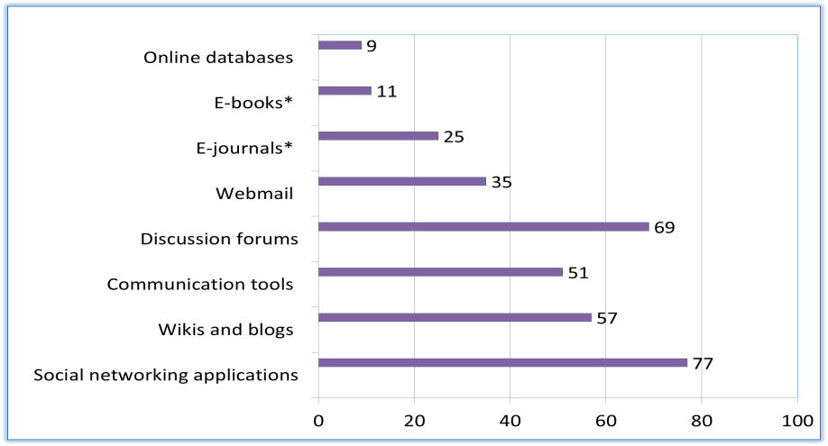
% of trusts

Online resources and applications blocked within NHS trusts
SHALL IT subgroup survey of NHS librarians (2008)

Access to learning resources for junior doctors was investigated by Prince, Cass, and Klaber (2010); these authors undertook a survey within 37 NHS trusts of accessibility of web-based resources to postgraduate medical trainees. In each trust a doctor on a computer within a clinical area tested access to a sample of 22 different online resources, including Web 2.0 and social media applications. They found that online video and audio (podcast) content was often difficult to view, and sound was usually absent. YouTube was blocked in most trusts, and iTunes University was not accessible, as it requires iTunes to be installed. These authors commented, “Shouldn’t we be managing the risks more effectively in order to allow learners the freedom to use IT resources to better effect?” (Prince et al., 2010, p. 437).

While there is little previous work that bears directly upon the research topic, highly relevant studies exist in related areas. Hughes and colleagues (Hughes, Joshi, Lemonde, & Wareham, 2009; Hughes, Joshi, & Wareham, 2008) studied applications of Web 2.0 and social media within medicine, particularly with reference to medical information seeking. Cain (2011), Hamm et al. (2013) and von Muhlen and Ohno-Machado (2012) provided overviews in relation to policy concerns of Web 2.0 and social media use within health professions education and practice. Osman, Wardle, and Caesar (2012) conducted a survey to investigate levels of privacy awareness and e-professionalism among medical students and junior doctors with regard to Facebook use. Kolkowska (2011) undertook a qualitative case study, using semi-structured interviews and documentary analysis, within two academic departments of a Swedish university investigating the respective attitudes and values of IT professionals and end-users regarding information security matters, using Schein’s three-tier model of organisational culture (Schein, 1996). Leidner and Kayworth (2006) comprehensively reviewed the literature on the relation of IT to various aspects of organisational culture. IT departmental subcultures were studied by Orlikowski and Baroudi (1991), by Guzman and colleagues (Guzman et al., 2004; Guzman, Stam, & Stanton, 2008) by Ramachandran and Rao (2006), and by Jacks (2011, 2012).

Methods
Anecdotal evidence indicates that there are readily observable variations both between individual NHS trusts and between types of trust in overall corporate culture and climate. There are also indications that trust IT departments can vary considerably in levels of resource, quality of service and what may be termed “customer focus”. This study adopted a qualitative case study method, taking three NHS foundation trusts of different types (district general hospital, mental health / community services, and teaching hospital) as its setting. The choice of different types of trust was intended as far as possible to include such variations, and therefore to present different perspectives on the issues being investigated.
As the main data collection method the lead researcher [CE] conducted semi-structured interviews in each trust with a variety of clinical managers holding responsibilities for staff training and development (medical, nursing, allied health, pharmacy), with library and workforce development staff, and with managers from the following groups: communications, human resources, information governance, and information technology. Interview findings are set in the context of relevant reports, policies, strategies and standards. Potential respondents were identified by the library manager or research office, or by the researchers via organisational intranets and websites, and contacted initially via email. An interview guide was developed for each staff category. The IT managers’ interview guide was developed first and piloted on one previous and one current NHS IT manager, being significantly revised as a result. The main interview themes were as follows: 1) IT infrastructure, 2) published information resources, 3) e-learning, 4) social media, and 5) mobile devices. A total of 40 interviews were conducted with 43 staff members; training and development staff in each trust were interviewed in pairs at their request. Interviews were recorded and sent to a professional transcriber for verbatim transcription. The interview data were supplemented with analysis of relevant internal and external policies, strategies, standards and reports.

Initial findings
Corporate use of social media as a communications channel for research dissemination and public engagement was well established at two of the trusts. At the third, such use of social media had not yet started; a breach of confidentiality via Facebook had apparently resulted in a total ban on social media use, inhibiting all activity for several years until a social media policy had been developed. All the trusts restricted access to and use within their networks of popular Web 2.0 and social media applications and platforms, even for purposes of professional information sharing and access. Such restrictions appeared to relate primarily to perceptions of risk in respect of breaches of confidentiality or privacy, and also appeared to reflect concerns about possible excessive non-work-related use. However, there were significant variations.
None of the respondents used social media at work for professional purposes other than YouTube videos. Podcasts were used for educational purposes, but could not always be downloaded owing to insufficient network bandwidth. Social media were often perceived as being high-risk in terms of confidentiality, especially by nurses, and were also frequently viewed as time-consuming, trivial, or of no interest. Use of online forums was reported as well-established within the professional culture of AHPs. Wide generational differences in use and expectations of social media were evident. Lack of access to file storage and sharing applications was perceived by some respondents as seriously hindering collaborative projects spanning organisational boundaries.
Evolving policies reflected an increasing recognition of the educational usefulness of YouTube content. Generally a gradual process of acceptance of social media and Web 2.0, as a tool for professional learning, information sharing and staff engagement as well as for public engagement, was in evidence. This appeared to be driven substantially by the increasing use of social media applications by NHS and professional bodies, and by the increasing availability of policy guidance. Bring Your Own Device (BYOD) implementation within one of the trusts facilitated use of social media applications via personal mobile devices.
Detailed findings in respect of the availability and usage of individual applications for each trust and application type are summarized in the tables following:

T1– district general hospital trust
T3 – mental health / community trust
T4 – teaching hospital trust
Web applications are categorized according to Kaplan and Haenlein’s (2010) classification.

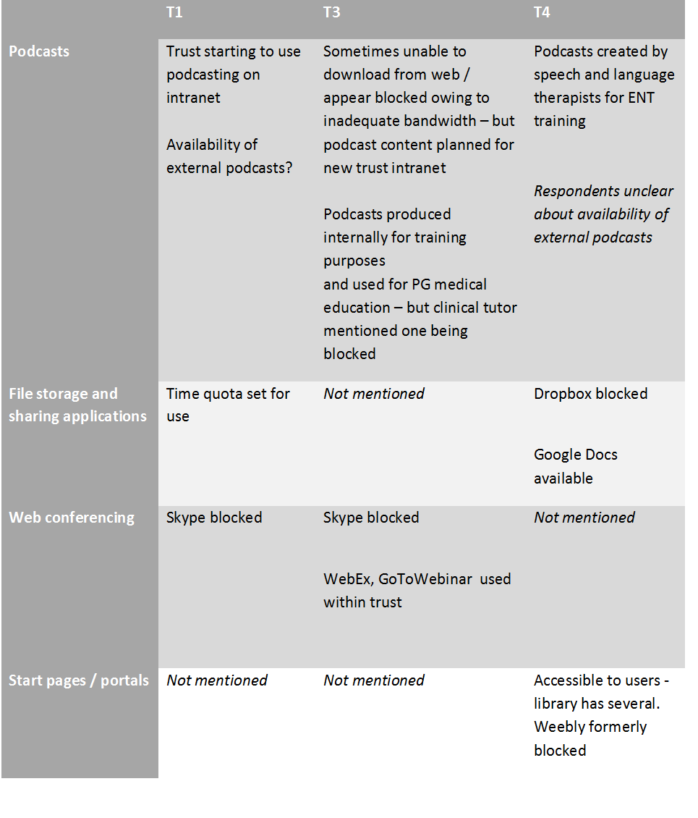

Table 1. Web 2.0: summary of findings
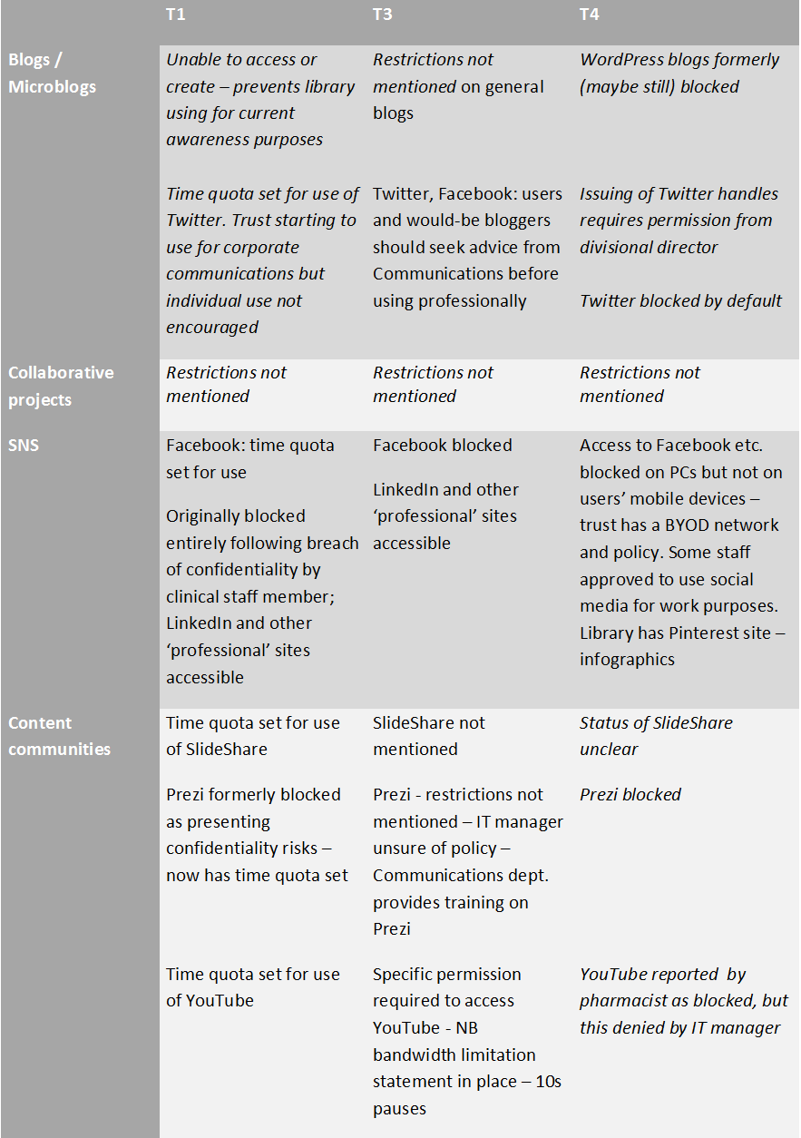

Table 2. Social media: summary of findings

Conclusions

Little attention has been paid within the NHS information systems community in general to the issue of access to legitimate published information or to web applications that support collaborative work and professional learning within and across organisational boundaries. Secure and appropriate management of clinical records and systems appears to be their main focus; there appears to have been minimal strategic engagement with NHS research dissemination or e-learning initiatives, either nationally or locally. Despite initiatives by NHS Employers (2013, 2014) to promote the wider use of social media, their use within corporate networks continues to be tightly regulated. Increasingly widespread corporate use by NHS trusts of social media for patient and public engagement has not yet given rise to widespread use by individual health professionals. Study respondents tended to cite high levels of attendant risk, and a need for clear organisational guidance and training, as well as shortage of time, as reasons for not using social media for professional purposes.

References
Blenkinsopp, J. (2008). Bookmarks: web blocking – giving Big Brother a run for his money. He@lth Information on the Internet, (62), 10–11.
Bradley, P. (2012). Why librarians need to use social media. Retrieved from http://www.slideshare.net/Philbradley/why-librarians-must-use-social-media
Cain, J. (2011). Social media in health care: the case for organizational policy and employee education. American Journal of Health-System Pharmacy : AJHP : Official Journal of the American Society of Health-System Pharmacists, 68(11), 1036–40.
Fenwick, T. (2014). Social media and medical professionalism: rethinking the debate and the way forward. Academic Medicine: Journal of the Association of American Medical Colleges, 89(10), 1331–1334.
Guzman, I. R., Stam, K. R., & Stanton, J. M. (2008). The occupational culture of IS/IT personnel within organizations. ACM SIGMIS Database, 39(1), 33.
Guzman, I. R., Stanton, J. M., Stam, K. R., Vijayasri, V., Yamodo, I., Zakaria, N., & Caldera, C. (2004). A qualitative study of the occupational subculture of information systems employees in organizations. In SIGMIS (Vol. 1). Tucson, AZ.
Hamm, M. P., Chisholm, A., Shulhan, J., Milne, A., Scott, S. D., Klassen, T. P., & Hartling, L. (2013). Social media use by health care professionals and trainees: a scoping review. Academic Medicine : Journal of the Association of American Medical Colleges, 88(9), 1376–83.
Hughes, B., Joshi, I., Lemonde, H., & Wareham, J. (2009). Junior physician’s [sic] use of Web 2.0 for information seeking and medical education: a qualitative study. International Journal of Medical Informatics, 78(10), 645–55.
Hughes, B., Joshi, I., & Wareham, J. (2008). Health 2.0 and Medicine 2.0: tensions and controversies in the field. Journal of Medical Internet Research, 10(3), e23.
Jacks, T. (2012). An examination of IT occupational culture: interpretations, measurement and impact. University of North Carolina at Greensboro. Retrieved from http://libres.uncg.edu/ir/uncg/f/Jacks_uncg_0154D_10981.pdf
Jacks, T., & Palvia, P. (2011). A Cultural Sociology Perspective on IT Occupational Culture. In AMCIS 2011 Proceedings - All Submissions. Retrieved from http://aisel.aisnet.org/amcis2011_submissions/395
Kaplan, A. M., & Haenlein, M. (2010). Users of the world, unite! The challenges and opportunities of social media. Business Horizons, 53(1), 59–68.
Leidner, D. E., & Kayworth, T. (2006). A review of culture in information systems research: towards a theory of information technology culture conflict. MIS Quarterly, 30(2), 357–399.
NHS Employers. (2013). HR and social media in the NHS: an essential guide for HR directors and managers. London: NHS Employers.
NHS Employers. (2014). A social media toolkit for the NHS. London: NHS Employers
Osman, A., Wardle, A., & Caesar, R. (2012). Online professionalism and Facebook--falling through the generation gap. Medical Teacher, 34(8), e549–56.
Prince, N. J., Cass, H. D., & Klaber, R. E. (2010). Accessing e-learning and e-resources. Medical Education, 44(436-437).
Ramachandran, S., & Rao, S. V. (2006). An effort towards identifying occupational culture among information systems professionals. In Proceedings of the 2006 ACM SIGMIS CPR conference on computer personnel research Forty four years of computer personnel research: achievements, challenges & the future - SIGMIS CPR ’06 (p. 198). New York, New York, USA: ACM Press.
Technical Design Authority Group. (2008). TDAG survey of access to electronic resources in healthcare libraries. London: TDAG.
Technical Design Authority Group. (2009). Survey of access to online resources in healthcare libraries in England conducted on behalf of the National Library for Health. London.
Von Muhlen, M., & Ohno-Machado, L. (2012). Reviewing social media use by clinicians. Journal of the American Medical Informatics Association, 19(5), 777–81.

Biographies

Catherine Ebenezer is a former NHS library manager, now a PhD student in the Information School, University of Sheffield.

Peter Bath is Professor of Health Informatics, Information School, University of Sheffield.
Stephen Pinfield is a Senior Lecturer in the Information School, University of Sheffield. He was formerly Chief Information Officer at the University of Nottingham, with responsibility for a large converged IT and library service.

