**Web 2.0 features: An effective use in academic library websites**

**Santosh S Biradar**

Librarian

Indian Maritime University (Mumbai Campus)

Marine Engineering and Research Institute

Hay Bunder Road Mumbai – 400 033

ssbiradar84@gmail.com

**Basavaraja M.T**

Research Scholar

Dept. of Studies and Research

in Library and Information Science

Tumkur University, Tumakuru. India.

e-mail: [basumnc@gmail.com](mailto:basumnc@gmail.com)

**Abstract**

Web 2.0 technologies are really mash-up of traditional library services and innovative. It has engrossed the attention of libraries around the world as a means for endorsing and extending their services. Web 2.0 technologies such as synchronous messaging and streaming media, blogs, wikis, social networks, tagging and RSS feeds might intimate changes in library services. This study has made an attempt to know the various features of Web 2.0 technologies and also deals with how Web 2.0 technologies could be used in the academic library context. It also provides solid evidence of the application of Web 2.0 in academic libraries websites.

**Keywords:** Web 2.0 technologies; Web sites; Academic libraries.

**Introduction:**

Academic library web sites are libraries virtual presentation to the world says Liu (2008). These virtual spaces have evolved rapidly over the years. These dynamic or interactive web sites, which encourage user participation, have forced their way into replacing the early static library web sites. The progression of dynamic web sites can be traced by the emergence of commercial web conglomerates like amazon.com, ebay.com etc. These commercial web sites have initiated a trend that made web users into content contributors as well. Features like user reviews, collaborative filtering and similar, available in these commercial web sites, laid the foundations for social navigation which have initially started to influence web users around the world (Morville and Rosenfeld, 2007). The interactivity, characterizing the Web 2.0 can be interestingly used by librarians to bring order out of chaos and making information readily available (Bradley, 2007). Since it has revolutionized whole of the global community, it can be correctly termed as a social revolution. Web 2.0 has rejuvenated every sphere of information communication cycle. Ian Davis justly says that Web 1.0 took people to information; Web 2.0 will take information to the people (Harinarayana and Raju, 2010).Web 2.0 tools are getting in tune with the present information retrieval systems are adopting the interactive features of Web 2.0 like RSS, blogs, wikis, podcasts, social networking, bookmarking, instant messaging etc. at a very faster rate. Library web sites are changing in their content and structure, with the introduction of social networking sites (SNS) in recent years and the ever-increasing usage among teenagers. This development has made libraries around the world keen to integrate Web 2.0 features into their library web sites. This paper aims to study and explore the application of these Web 2.0 technologies in the context of academic library web sites.

**What is Web 2.0?**

Web 2.0 is a term first coined by the Tim O’Reilly in a conference brainstorming session between O’Reilly and MediaLive International (O’Reilly, 2005). According to O’Reilly, Web 2.0 is the business revolution in the computer industry caused by the move to the internet as platform, and an attempt to understand the rules for success on that new platform. A much simpler definition of Web 2.0 is a space that allows anyone to create and share information online – a space for collaboration, conversation, and interaction; a space that is highly dynamic, flexible, and adaptable (Coombs, 2007). A key feature of Web 2.0 technologies is philosophy of mutually maximizing collective intelligence and added value for each participant by formalized and dynamic information sharing and creation (Meckel et al., 2006). Web 2.0 includes the second generation web based services such as collaborative publishing sites (Facebook, Bebo, MySpace and Friendster etc), wikis, blogs, social bookmarking sites (del.icio.us, furl, digg etc), and photo sharing sites (flickr, photobucket, etc.). It appears that Web 2.0 phenomenon is not going to stop here but will grow in popularity at a faster pace. Its impact can be felt in all frontiers of knowledge and professions. According to Breeding (2007), the need of embedding these contemporary technologies to enrich library services, Web 2.0 has become a trendy marketing concept. It helps librarians let go of very outdated views of the Web and move forward in the adoption of newer technologies and services.

**Features of Web 2.0**

**Really simple syndication (RSS)**

The Internet provides an abundance of information which makes it difficult for the user to sift through. RSS in that way would greatly serve the purpose not only for managing information but also reducing the information overload. RSS (Really Simple Syndication; Rich Site Summary; RDF Site Summary) is a simple lightweight XML format to share web site content (C¸ elikbas¸, N.D.). This resembles traditional library services such as current awareness and selective dissemination of information (SDI). Libraries have been already making use of this new Internet tool for disseminating library news and current alerts.

**Blogs:**

Blogs are the most widely used Web 2.0 feature. Blogs are personal diaries, in which each entry is organized in a reverse chronological order. Its simplicity in publishing the contents and the feature that allows others to record their comments has revolutionized the web publishing world (Lenhart et al., 2007). Library web sites as information dissemination spaces have leveraged this medium to provide information services to their users and to act as a library promotional mechanism. Blogs are the best informal communication channel to extract latent feedback information from the users to enhance the quality of library services.

**Table-1: Use of Blogs by various universities for different purpose**

|  |  |  |
| --- | --- | --- |
| Universities | Blog address | Usage |
| Imperial College of London | [www.imperial.ac.uk/library/aboutthelibrary/news/blogs](http://www.imperial.ac.uk/library/aboutthelibrary/news/blogs) | Specific subject blogs to keep user current with subjects of interest |
| Nanyang Technological  University | [www.ntu.edu.sg/library/collections/Pages/blogs.aspx](http://www.ntu.edu.sg/library/collections/Pages/blogs.aspx) |
| Caltech University | http://library.caltech.edu/news/ | Provide news and library services |
| John Hopkins university | <http://blogs.library.jhu.edu/wordpress> |
| University of Queensland | [www.library.uq.edu.au/services/blogsindex.html](http://www.library.uq.edu.au/services/blogsindex.html) |
| New York University | <http://liblink.wordpress.com> |
| Case Western Reserve University | http://blog.case.edu/orgs/ksl/news/ |
| Georgia Technological University | http://weblog.library.gatech.edu/news/ |
| Cornell University | <https://blogs.cit.cornell.edu/askalib> | web-based reference services |
| University of Rochester | <https://rheesblog.lib.rochester.edu/> |
| The  National University of Singapore | http://linusonline.wordpress.com/ | using a blog as a library newsletter |

**Wikis**:

It is a free online encyclopedia that gives a background knowledge and definition of concepts. It offers a platform for users to access, edit and contribute to content. This is a collaborative web page for developing web content. According to the wikipedia.org Wiki is defined as a collaborative web site which can be directly edited by everyone with access to it. The popularity of Wikipedia itself is a testimony for the success of wikis Engard (2006) and others have discussed extensively on how libraries can use wikis. With examples, they have given brief descriptions on their experiences as to how they have successfully implemented wikis to their web-based library services.

**Podcast and vidcast:**

Podcasts are audio content available on the internet that can be automatically delivered to a personal computer or MP3 player – simply put it, podcasts are audio on the web (Geoghegan and Klass, 2005). The podcasts have given the user an opportunity to listen to recorded intellectual outputs online without any additional software and to download for later use. Podcasts and vidcast have been successfully used in delivering library web-based services. Earlier, a few years ago web sites were adding interactive features such as audio and video, animation /flash contents to see and listen. Political arena (Gibson and Ward, 2000) and media (Schultz, 1999) web sites were the early adopters of these technologies.

Applications of podcasts in libraries as suggested by Abram (2006) are:

* Story hours/story time (record your kiddy librarians);
* Information literacy and research help;
* Collecting and indexing good free podcasts (found through the podcast search engines);
* Local history (collected from veterans, pioneers, local characters, etc.);
* Teen book/DVD/game reviews (collected by the circulation desk);
* Music collections;
* Audio book collections (on iPods and MP3 players);
* Library events (like Science Fair help, Literacy nights, author readings);
* Library debates;
* archiving class lectures;
* Library marketing podcasts (how to use RSS, databases, VR, etc.);
* Training;
* Library gadget petting zoos (for staff and patrons); and
* Public speaking training (partnering with groups).

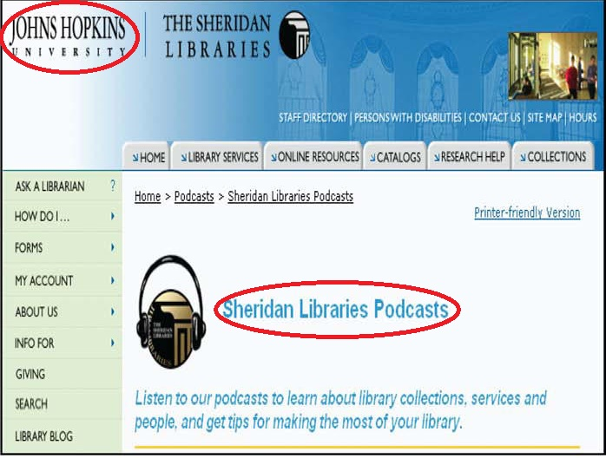

**Figure-1: The Sheridan Libraries Podcasts**

**Instant messaging (IM)**

IM is a live online synchronous communication channel which facilitates online interaction between two people. Corporate firms have found IM very useful to exchange communication between their employee to increase productivity (Breeding, 2003). Chat/IM Internet technology has been making its presence felt in libraries by sidelining the traditional e-mail and form-based reference services. From just an interactive feature, IM has evolved into offering not only text messages, but also multimedia resources such as photos, videos etc. The real-time online communication puts this on the bandwagon of Web 2.0. The study found that IM features have extensively been used in libraries to provide quick online reference services.

**Social networking sites (SNS)**

Much of the buzz in the online world today is about social networking sites (SNS). The likes of the video sharing site YouTube, community sites like MySpace, Facebook, Friendster, photo sharing sites Flickr, user tagging/sharing sites, LinkedIn have made a strong impact among Internet users around the world. According to the Alexa.com – premier web site ranking site – Wikipedia, MySpace, YouTube, Facebook and Friendster and similar social networking sites which have been ranked highly receive the highest hits compared with any other sites. The uniqueness of these social networking sites is to share information among users ranging from highly personal to academic interests of the participants.

For example:

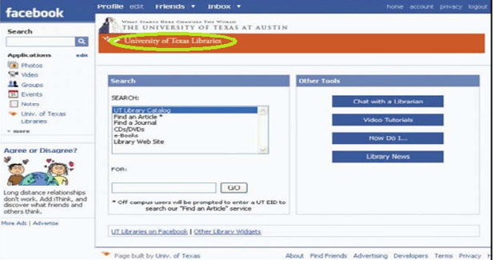**Figure-2: University of Texas Library’s Facebook page**

**Table-2: Universities/Colleges and Facebook links**

|  |  |  |  |
| --- | --- | --- | --- |
| SL.NO | Universities/college |  | Facebook Link |
| 1 | University of Michigan |  | www.facebook.com/apps/application.php?id ¼ 2538811407&b |
|  |  |  |  |
| 2 | University of Adelaide |  | [www.facebook.com/pages/Adelaide Australia/The-Barr-Smith Library/](http://www.facebook.com/pages/Adelaide%20Australia/The-Barr-Smith%20Library/)  22489518232 |
| 3 | University of Texas |  | www.facebook.com/p.php?api_key¼ 4963fecef0e8dc55bbc10cceb67e9a87 |
| 4 | California state university |  | [www.facebook.com/CSULibrary](http://www.facebook.com/CSULibrary) |
| 5 | American university library |  | [www.facebook.com/AULibMedia](http://www.facebook.com/AULibMedia) |
| 6 | University of Kansas |  | [www.facebook.com/KULibraries](http://www.facebook.com/KULibraries) |
| 7 | Boise state University |  | [www.facebook.com/albertsonslibrary](http://www.facebook.com/albertsonslibrary) |
| 8 | Santa Barbara City College |  | [www.facebook.com/lurialibrary](http://www.facebook.com/lurialibrary) |
|  |  |  |  |
| 9 | University of Utah |  | [www.facebook.com/pages/J-Willard-Marriott-Library-University-of-Utah](http://www.facebook.com/pages/J-Willard-Marriott-Library-University-of-Utah) |
|  |  |  |  |
| 10 | Syracuse University |  | [www.facebook.com/SyracuseULib](http://www.facebook.com/SyracuseULib) |

**Social bookmarking/user tagging**

Social bookmarking sites – del.icio.us, furl, digg, flickr, connotea, CiteUlike etc. have become well known among web users. One of the advantages of the user tagging system is community development. Like-minded users can easily create their own community with same subject interest.

**Conclusion:**

The world is changing because of emergence of technologies, and so are academic libraries. The challenge of academic libraries in the technology era, making their presence felt and so they are synchronizing their services to the Web 2.0 world. The user expectations always changing, libraries have been escalating their services by providing user-oriented services via Web 2.0 facilities. Collaboration and participation are the most attractive features of Web 2.0 and its utility will increase in libraries. Librarians must, in turn, adapt these changes judiciously and quickly. The present study provides features of Web 2.0 and also focused on how Web 2.0 is being integrated into academic library services.

**References:**

1. Abram (2006). “Podcasts and libraries” available at: http://stephenslighthouse.sirsidynix.com/archives/2006/11/podcasts_and_li.html (accessed 10 February 2015).
2. Breeding, M. (2003). “Instant messaging: it’s not just for kids anymore”, *“Computers in Libraries”*, 23 (10). 38.
3. Breeding, M. (2007), “We need to go beyond Web 2.0”, Computers in Libraries, Vol. 27 No. 5, pp. 22-6.
4. Bradley, P. (2007). “What is Web 2.0. How to use Web 2.0 in your Library” *Facet, London,* 1-9.
5. Coombs, K.A. (2007). “Building a library web site on the pillars of Web 2.0”, *Computers in Libraries*, 27(1) available at: [www.infotoday.com/cilmag/jan07/Coombs.shtml](http://www.infotoday.com/cilmag/jan07/Coombs.shtml)(accessed 10 February 2015).
6. Engard, N. (2006). “IL 2006: Wikis for libraries”, available at: http://librarianinblack.typepad.com/librarianinblack/2006/10/il_2006_wikis_f.html (accessed 10 February 2015).
7. Gibson, R.K. and Ward, S.J. (2000). “Proposed methodology for measuring the function and effectiveness of political web sites”, *Social Science Computer Review*, 18(3). 301-19.
8. Geoghegan, M.W. and Klass, D. (2005). Podcast Solutions: The Complete Guide to Podcasting, Friends of ED, Berkeley, CA.
9. Lenhart, A., Madden, M., Smith, A. and Macgill, A. (2007). “Teens and social media”, available at: www.pewinternet.org/pdfs/PIP_Teens_Social_Media_Final.pdf (accessed 10 February 2015).
10. Harinarayana, N.S., Kumbar, M. and Pradeep, P. (2007). “RSS-based information services in libraries: a study”, *Library Herald*, 45(2). 130-9.
11. N.S. Harinarayana N. Vasantha Raju, (2010). "Web 2.0 features in university library web sites", *The Electronic Library*, 28 (1) 69 – 88.
12. Liu, S. (2008). “Engaging users: the future of academic library web sites”, *College & Research Libraries*, 69 (1). 6-27.

1. Morville, P. and Rosenfeld, L. (2007). Information Architecture for the World Wide Web, 3rd ed., O’Reilly, Beijing.

1. Meckel, M., Stanoevska-Slabeva, K. and Martignoni, R. (2006). “Overview of business models for Web 1.0 communities”, *Proceedings of GeNeMe*, 23-37.
2. O’Reilly, T. (2005). “What is Web 2.0: Design patterns and business models for the next generation of software”?, available at: www.oreillynet.com/pub/a/oreilly/tim/news/2005/09/30/what-is-web-20.html (accessed 10 February 2015).

1. Schultz, T. (1999). “Interactive options in online journalism: a content analysis of 100 US newspapers”, *Journal of Computer Mediated Communication*, 5 (1), available at: http://jcmc.indiana.edu/vol5/issue1/schultz.html (accessed 10 February 2015).