Successful Tactics for Introducing New Databases to CDC Library Patrons: A Case Study
Deidre Mallett, Centers for Disease Control and Prevention, Atlanta, GA, USA
Pamela Sedgwick-Barker, Centers for Disease Control and Prevention, Atlanta, GA, USA
Jarvis Sims, LAC Group, Los Angeles, CA, USA
Ted Bazemore, LAC Group, Los Angeles, CA, USA
Natalia Madjarevic, Altmetric, London, UK
Stacy Konkiel, Altmetric, London, UK

Abstract
When libraries subscribe to new resources, encouraging patrons’ adoption of these services can be challenging. Moreover, when the resource offers access to a service or information type that is relatively unknown amongst patrons, such as altmetrics, the challenge is even greater. Altmetrics are data from the social web that can be used to track discussions and reuse of scientific outputs (journal articles, books, data sets, presentations, and beyond) across a variety of platforms like news outlets, scholarly peer review websites, social media, scholarly reference managers, and public policy documents. Promoting, consulting and conducting workshops are just some of the methods that libraries stimulate use of new resources. Some approaches work better than others.
In this paper, we discuss the joint approach of the Stephen B. Thacker Centers for Disease Control and Prevention’s (CDC) Library training team and Altmetric to promote the use of an altmetrics database, Altmetric Explorer for Institutions, amongst CDC staff. These organizations worked together closely to offer training and consultations, each with complementary approaches.
Introduction
The Stephen B. Thacker Centers for Disease Control and Prevention (CDC) Library supports diverse information needs in public health, medicine, food safety, toxicology and related disciplines. CDC’s mission is “to protect America from health, safety and security threats, both foreign and in the U.S.” (Centers for Disease Control and Prevention 2014). To accomplish this mission, CDC works to provide health information that puts science into action and conducts critical science, protecting against expensive and dangerous health threats. The CDC Library plays an important role in CDC’s mission by providing access to information resources including scientific journals, books, and other resources.
The CDC Library currently subscribes to 170 databases and over 36,000 journals and electronic books. As part of one of the premier public health agencies in the world, the CDC Library actively seeks to identify new products and services that will be of use to its public health workforce. CDC’s scientists and public health practitioners are interested in measuring the impact of their work and tracking how their work is being discussed, shared, and disseminated. This interest is what encouraged the CDC Library to invest in learning more about altmetrics.
Though still in its infancy in 2015, altmetrics were already being adopted by institutions worldwide to track the influence of public health scientific articles online. Altmetrics are complementary to citation-based impact data in that they start accruing as soon as an article is published, apply to scientific outputs beyond journal articles, and track influence across a wide variety of stakeholder groups, including the general public, students, the media, and policymakers.
Altmetric provided the product, “Altmetric Explorer for Institutions,” to measure and benchmark the impact of scientific activities conducted by CDC scientists and practitioners. The document, Altmetrics: A manifesto (J. Priem 2010) succinctly describes the evolving functionality altmetrics tools should strive towards as “continue[ing] to build systems to display altmetrics, developing methods to detect and repair gaming, and creating metrics for use and reuse of data.” Of the three tools considered, Altmetric had implemented preliminary steps to identify outputs that exploit the system for personal gain (Adie 2013). It used a sophisticated algorithm for measuring attention paid to science across the widest range of non-traditional scholarly and general public-oriented, online platforms. Altmetric’s software developers collaborated with the CDC Library to tailor the Altmetric @ CDC platform to the needs of CDC scientists and practitioners.
Altmetric offers products designed for research institutions (Explorer for Institutions) and for publishers (Altmetric Badges) which is helpful to CDC since the agency is both a science generating institution and a publisher. The Altmetric “donut” or “badge” on journal websites is a visual representation of social media attention is gauged. An institution’s license enables journals, institutional repositories, and CDC Library discovery systems to display badges on the item-level (see Figure 1).
Figure 1. The Altmetric badge
Source: https://www.altmetric.com/details/6659948
CDC selected Altmetric Explorer for Institutions and the Altmetric Badges as its altmetrics service because it provides an institutional dashboard, with the capability to search across the entire Altmetric database for all tracked content, and embeddable badges on journal content. The CDC Library collaborated with Altmetric and designed a one-year pilot project, Altmetric @ CDC, which launched in September 2015. A core team of reference librarians, systems librarians, a communications and policy health scientist, an electronic resources librarian, and program evaluators was formed to create the Altmetric Library Implementation Team (ALIT). A project coordinator was assigned to ALIT to ensure the progress and success of the pilot implementation and provide in-depth training for CDC Library staff and CDC users of the product and technical support during the pilot.
A 14-member interest group was recruited from programs across CDC; including ALIT, three CDC published open access journals (Morbidity and Mortality Weekly Report, Emerging Infectious Diseases Journal and Preventing Chronic Disease Journal), and CDC’s institutional repository, CDC Stacks.
The interest group met frequently to discuss the planned implementation process and technical specifications associated with the pilot project, focusing on the needs of CDC. A number of issues were identified that could present significant challenges to agency-wide adoption of the Altmetric platform. Some of the challenges for CDC journals’ implementation of Altmetric Badges were ensuring proper formatting of articles with the correct metadata to enable indexing by Altmetric and obtaining approval from information security offices for approval of the badges for display on the journal and institutional repository web sites. Another critical issue was identifying the best source of authoritative data for CDC produced literature to use for Altmetric @ CDC. After initially considering CDC Stacks’ dataset, it was determined that a current awareness bibliographic EndNote file that has been produced by CDC librarians, known as “Science Clips,” was the most comprehensive dataset available. Science Clips is an online bibliographic digest, featuring scientific articles and publications that are shared with the public health community each week, to enhance awareness of emerging scientific knowledge. Science Clips began in 2009 and was meant to serve as a complete listing of all publications produced by authors and researchers at the Centers for Disease Control and Prevention. Other challenges included, CDC staff had limited awareness of the value of altmetrics. Therefore promotion and training activities had to not only teach staff how to use the new tool, but also generate interest in and excitement about its use. It should be noted that the training and marketing of Altmetric @ CDC presented major challenges due to the novelty of altmetrics, which required not only demonstrating the product, but also educating CDC leadership and staff on the value of altmetrics overall.
Implementation Plans
To ensure efficiency and timeliness of the pilot project, ALIT designed an implementation plan built in Microsoft SharePoint mainly using the timeline and interactive form functionalities. Every task on the timeline was entered from the interactive form. Each task on the implementation plan was assigned an owner, start date, due date, and status (on-track, off-track, or complete). Technical tasks were scheduled to take place alongside a major publicity campaign that included regular briefings to specific programs within the agency and an evaluation plan, designed to measure the viability of the Altmetric @ CDC pilot. These briefings, which continued throughout the pilot, were instrumental in obtaining support for the project from high-level leadership.
One of the major tasks identified within the implementation plan was the creation of a formal communications plan. The communications plan specified that Altmetric @ CDC would be announced and promoted with targeted communications among the following groups: published CDC authors, scientific leadership and division leadership, CDC communications professionals, CDC journal editors, and CDC Library users. Specific communications channels were planned for each group.
Soft Launch
ALIT worked with representatives from Altmetric to schedule a soft launch of Altmetric @ CDC, which took place in November 2015. The purpose of the soft launch was to allow only a targeted group to access Altmetric @ CDC in order to test the product and the site, ensuring that there were no errors present before going live for the entire agency. The soft launch involved the CDC Library’s Systems Librarian placing the Altmetric @ CDC’s web page on a development server. Two focus group sessions were scheduled in early December 2015 at separate CDC campuses using the Altmetric @ CDC dataset to gauge reaction to the product from a cross-section of users. Participants in the group sessions were asked to perform a small number of simple tasks to gauge usability of the system and were asked to answer open-ended questions to gain feedback on end-user concerns and perceived issues.
Feedback from the focus groups was useful for developing training materials and evaluating of the pilot. ALIT developed a list of frequently asked questions (FAQs) from these sessions and later posted them on the Altmetric @ CDC webpage. Additional CDC Library staff were trained prior to the official start date. The feedback received from each session was incorporated into training materials. As the official launch date approached, ALIT communicated and provided updates to the interest group and also solicited feedback from the group about the project.
It should be noted that evaluation was treated as an essential task from the beginning of the project. In the early stages of the implementation process, program evaluators were consulted to develop an effective and comprehensive evaluation strategy. The evaluation strategy included several goals. The first and most important was to determine the usage of Altmetric @ CDC among CDC staff. Others noted the level of satisfaction of the end users and best methods for dissemination based on Altmetric data. The evaluation strategy also provided guidance as to how to tailor the trainings and marketing materials to attract and influence CDC staff.
One important detail to note when designing an implementation plan is the impact of timing. Quite a few of the interest group sessions were scheduled around the holiday season (Thanksgiving and Christmas). This greatly affected the participation rate because many were not available to attend the sessions. Much of the work of the implementation group was dependent on the successful scheduling, execution, and analysis of these sessions in order to proceed. Due to scheduling constraints for the participants in the sessions, ALIT reluctantly adjusted the official “Go Live” date from early December of 2015 until mid-January of 2016. Fortunately, this delay provided additional time for ALIT the team to create and fine-tune training materials, promotional literature, web-based FAQs and the training schedule.

Altmetric @ CDC Goes Live
Roll-out announcements of the official launch of Altmetric @ CDC (scheduled for January of 2016) were placed in CDC Connects, the official internal announcement page maintained on CDC’s Intranet site. Announcements highlighted the altmetric measured impact of CDC authors’ scientific publications. Briefings were also sent to CDC leaders. A briefing sent to the CDC Office of the Director stated:
The Stephen B. Thacker CDC Library just launched Altmetric, an exciting new tool that will help authors quickly find out who is talking about their work. It captures online attention as well as news stories about your publications. Altmetric not only tells you how many mentions you’ve had but links the author directly to each news report and social media mention.
Stephen B. Thacker CDC Library [2016].

Launch day of Altmetric was the culmination of months of effort on behalf of ALIT and was featured prominently on the CDC Library’s homepage. In addition to CDC’s Library webpage promotion, the CDC Library featured Altmetric @ CDC once a week for the next 5 weeks on the CDC Connects employee newsletter available daily to all CDC staff. (See Figure 2). Due to these promotional strategies, usage tripled within the first two months, with 931 page views and 381 unique users by March 2016. The average number of page views settled to an average of 300 page views and 165 unique users from April to October 2016.
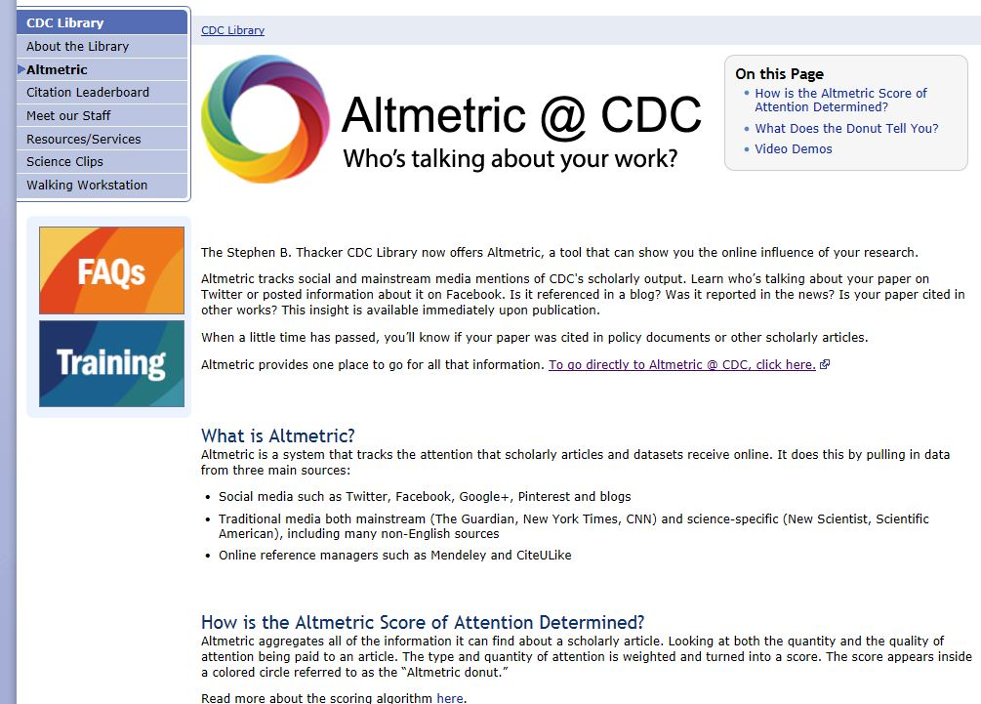
Figure 2. Altmetric @ CDC Library Intranet page
Training classes for CDC employees, contractors, and fellows began one week after the launch date. Classes were offered bi-weekly, alternating between in-person training and virtual classes, to ensure all interested parties had the opportunity to learn about Altmetric @ CDC. The official learning portal for CDC, known as “CDC University,” was used to schedule classes. Training materials for these sessions were also developed by ALIT. A 17-page handout documented all topics covered during the sessions, with full color screenshots depicting the user’s experience working in Altmetric.
Feedback from the training sessions was taken in two forms. The first was a form that was sent to the users from CDC University once their training session was completed. The other was a form designed in SharePoint by the ALIT team and given to users at the end of sessions to gauge their immediate thoughts. The form results were anonymous. Near the end of the first year, the training schedule was reduced to bi-monthly sessions.
Less formal “Lunch and Learn” and “Brown Bag” sessions were also offered, often at the request of individual program leads within the agency. For these sessions, the trainer (a member of ALIT) traveled to various CDC campuses to address specific, targeted audiences. Communications professionals, in particular, found Altmetric to be an intriguing tool for their work and asked many detailed and challenging questions.
Altmetric support staff were instrumental in answering technical questions posed by CDC users. Some questions were also forwarded on to Altmetric developers. The questions and answers contributed to the evolution of the product. For example, some user questions led to the tracking of CDC policy documents in Altmetric. Altmetric also began following the official CDC YouTube channel as a result of a question from a CDC user during training. This type of in-depth conversation and feedback has proved useful to CDC as we gain understanding of the Altmetric product.
Beta Testing and Version II
To spur discussion of Altmetric @ CDC, ALIT created an internal listserv for its “power users” across CDC to discuss how their particular program or office uses Altmetric’s products and a discussion of altmetrics in general. The listserv was used to identify potential beta testers for the launch of Version II of Altmetric that was scheduled for the summer of 2016. A total of eleven CDC users participated in beta testing for Version II of the product.
Altmetric developers provided a login of the beta version and asked for feedback on the new, different interface. CDC beta testers offered suggestions for usability enhancements, additional features (including the ability to view mentions in a specific time-period) and became more versed in the field of altmetrics itself. ALIT currently utilizes the listserv to provide updates on Altmetric and the Altmetric @ CDC project in addition to promoting other CDC Library services. There have also been occasional posts from end users, asking questions about a particular feature or publication that is included in the Altmetric database.
While still a work in progress, initial impressions of Version II indicate that the substantial changes from Version I represent a thoughtful re-design of the product with an emphasis on simplicity of use. CDC librarians have been teaching Version II since it was introduced at CDC in November of 2016. The training sessions for Altmetric @ CDC have transferred from being the responsibility of the systems librarians of ALIT to the reference librarians, who also teach classes on scholarly metrics in general. Currently, ALIT is reviewing the evaluations of the Altmetric @ CDC pilot and deciding what the next steps should be to support the project moving forward.
Altmetric supported ALIT through trainings, phone calls, and emails; many of which included technical advice on changes made to repository and journal metadata. This allowed Altmetric to harvest publication metadata from CDC systems, making it much easier for CDC-authored science to be tracked in an accurate and comprehensive manner. Altmetric also provided access to their support portal (help.altmetric.com) which featured a knowledge base and FAQs.
The CDC implementation was managed from Altmetric’s side using a tool called Basecamp, which offers a shared space to post documents and questions, in addition to allowing for messaging and long-form discussion. Basecamp served as a hub of communication between the Altmetric and CDC teams. The app allowed Altmetric to provide context to CDC staff for steps in the implementation process in a manner that was more wide-reaching and organized than email. Altmetric led training webinars were conducted for “power users” and key CDC staff. Altmetric staff also visited the CDC campus on several occasions to offer in-person trainings for CDC staff from all departments. Based on CDC feedback, Altmetric developed and delivered custom, advanced trainings for using Altmetric data in CDC workflows across various parts of the agency. Altmetric also ran various post-implementation calls with the CDC Library team that offered advice on running training sessions.
Conclusion
The roll-out of Altmetric @ CDC has been a success for a variety of reasons. Paramount among these reasons was the decision to use a project management approach with a formal implementation plan to track each step in the roll-out process in SharePoint. Another key factor to the project’s success was developing formal briefings for leadership to gain buy-in for the product from the beginning. The decision to employ focus groups early on to assess Altmetric @ CDC also provided useful information about how altmetrics data and the product itself were perceived by users at CDC. These sessions also informed the development of training sessions by anticipating user questions. Using SharePoint to track and follow-up on training sessions has also been an effective tool, for logistical and evaluation purposes. Another successful strategy for the roll-out of Altmetric was collaborating with experts in various fields at CDC and going directly to individual users, using a variety of tactics and venues, to explore how individuals and specific programs can incorporate altmetrics data into their work.
Additionally, the resources and support from the Altmetric team contributed to the success of the CDC roll-out. Ready-made trainings that are also adaptable to meet specific customer needs and offered regularly to key influencers and “power users” in a subscribing organization can help customers get over the initial challenge of raising awareness of new tools amongst library patrons. Moreover, having well-organized and adaptable documentation ready to be shared using collaborative project management tools like Basecamp, lessened the burden on CDC staff to create their own training and outreach materials. Finally, the ability of a vendor to work with a customer-side implementation team as well-organized and efficient as CDC Library staff would increase the probability of a new product’s roll-out being successful.

Endnotes
E. Adie. “Gaming altmetrics”. Last modified September 18, 2013. https://www.altmetric.com/blog/gaming-altmetrics/
Centers for Disease Control and Prevention. "Centers for Disease Control and Prevention (CDC) - CDC's vision, mission, core values, and pledge". Last modified April 14, 2014. https://www.cdc.gov/about/organization/mission.htm.
J. Priem, D. Taraborelli, P. Groth, C. Neylon. “Altmetrics: A manifesto”. Last modified October 26, 2010. http://altmetrics.org/manifesto/.
Stephen B. Thacker CDC Library. 2016. "Office of the Director Briefing." Briefing.

