Research in the iSchools: An Examination

K. S. Raghavan
Documentation Research & Training Centre, Indian Statistical Institute
Bangalore 560 059
E-mail: raghavan@isibang.ac.in
Phone +91-80-28483003 Fax +91-80-28484265

B. Preedip Balaji
Documentation Research & Training Centre, Indian Statistical Institute
Bangalore 560 059
pradipbalaji@gmail.com

July 2012

Abstract
The iSchool movement is not merely a reaction of the information science community to the criticism that there is a mismatch between LIS education and needs of the information job market but also represents the growing recognition that there is a need to elevate the status of the discipline in the higher education system to a level on par with other professions/disciplines. This paper attempts to construct the domain of interest to the iSchools by profiling the ongoing and recent research in the iSchools. The profiling is carried out by examining the publications emanating from six iSchools. The findings suggest that there is as yet no clear construct of what constitutes the domain of interest of iSchools. The research profiles of these iSchools also appear to differ significantly. The study also suggests the emergence of certain new information specialities.
Keywords: iSchools, information sciences, LIS education, LIS research, iSchool education, case study.
Introduction
It is widely conceded that innovative technological developments have brought about significant changes in education system in general and education programmes for information professionals in particular. A major change that is very visible in the information domain is the iSchool phenomenon. It is believed that the iSchool model provides more operational freedom, by enabling different disciplinary perspectives and methodologies to reinforce one another in research. As Pollack puts it: “This is an exciting time for many elements of Human Computer Interaction, including Design, the input and display device renaissance, a flowering of domain-specific HCI – yet this period may be most remembered for its embrace of Information (Pollack, 2010).” As a result restructuring of LIS education programmes was continuously represented on the agenda of professional bodies and organizations in several countries. The initiatives in the United States resulted in the famous Kaliper Report (Association for Library and Information Science Education, 2000). The European Union and Japan also initiated parallel processes. There was also a movement by a group of East Asian countries to examine their LIS education programmes as part of the LIPER Project initiated in Japan (Miwa, 2006). In India the University Grants Commission initiated many major curriculum reforms, the most recent being the report of the Karissidappa Committee formed in 2000 (Joshi, 2000). Several factors appear to have necessitated a re-examination of the LIS educational programmes. The important factor has been the developments in information technology sector that brought about significant changes in the information environment. The emergence of the information economy, globalization, the Web and social media substantially altered the ways in which information is perceived, accessed, handled, used and applied and have been major influencing factors for electronic information services delivery. In addition, the growing importance accorded to information management practices by large corporations and governments alike in an increasingly competitive world created information institutions very different from the library. Libraries also underwent major transformations in the ways in which they were being run and managed from physical service points to virtual information centres. Several studies, many of which preceded and some that followed these developments, had examined the needs of the emerging information job market vis-à-vis the LIS education programs. Despite the fact that the studies have been reported from different countries with substantial differences in course structure and the obtaining information environment the findings appear similar (Ferreira, 2007; Flood, 2003; Kavulya, 2007; Lee & Fang, 2008; Raghavan & Agrawal, 2006; Raghavan & Giri, 2009). The studies largely suggest that the information-related job market is diversifying and that there is a widening gulf between ground realities of LIS education and knowledge, skills and domain expertise required for the information workplace. However, iSchools should not be seen merely as a reaction to the increasing realization among Library and Information Science (LIS) schools of the widening ‘mismatch’ between products of (LIS) schools and the manpower requirements of the job market? They are characterized by both information-centric and user-centric approaches and perspectives to information research. There are several angles to view iSchools from. The iSchools could be seen as an effort to elevate the status of the discipline of Information Studies in the higher education system to a level on par with the more established disciplines. The iSchools are also intended to emphasize the need to take notice of the wider information environment not limited to libraries so as to elevate the information profession to a level on par with the established professions like Law and Medicine with new missions and goals (Seadle, 2007; Pollack, 2010). The disciplinary status of LIS has been an issue for debate almost since the time university education in LIS began in the 19th Century. Surely the emphasis in iSchools appear to be, on the one hand, on preparing the professional workforce for the new wider information environments dominated by technology, and on emphasizing the study of “information as an interdisciplinary area investigating the properties and behaviour of information, the forces that govern the flow and use of information, and the techniques, both manual and mechanical of processing information for optimal storage, retrieval and dissemination (Borko, 1968).” Clearly the idea is to move to a situation in which ‘information studies’ will be developed into an academic discipline like psychology or chemistry which are not linked to any specific institutionalized field of practice. For the purpose of this these 6 iSchools are used for data collection. Table 1 looks at the origin of the schools and their respective school history, tracking the trajectory of library science to iSchools.

Table 1: Year and name of iSchools established
iSchool, University Name and Abbreviation Used | Year Established | URL
School of Information, University of Michigan, Ann Arbor, Michigan (UMAA) | 1969, Library studies; 1996 School of Information | http://www.si.umich.edu/about-SI/mission.htm
School of Information Studies, Syracuse University, Syracuse (SUS) | School of Library Science in 1896, School of Information Studies, first Information School in 1974. | http://ischool.syr.edu/About/mission.aspx
Department of Information Studies, University of California, Los Angeles (UCLA) | 1958, The School of Library Service; School of Education and Information Studies | http://gseis.ucla.edu/about/gse-is/gse-is-at-a-glance
School of Library and Information Science, Humboldt University, Berlin (HUB) | 1955, Institute for library science. Now Berlin School of Library and Information Science | http://www.ibi.hu-berlin.de/
SMU – Founding member of Consortia of iSchools Asia Pacific (SMUS) | 2003, School of Information Systems | http://www.sis.smu.edu.sg/news/news_03.asp
University of Technology (UTSA) | 1989, Faculty of Arts and Social Sciences, School of Communication, Academic Group Information and Media Studies/ Information and Knowledge Management | http://datasearch2.uts.edu.au/fass/academic/group/journalism/index.cfm
Gilchrist (1979) had noted way back “if there is such a discipline as information (and we believe there is) then it is time that an international consensus was established as to its definitions and the area in which it should fruitfully be applied. Bawden (2007) has described information studies as “a multidisciplinary field of study, involving several forms of knowledge, given coherence by a focus on the central concept of human, recorded information, and underpinning several practical disciplines.” When such a situation fully develops, ‘information studies’ will be viewed as the science of information studying the phenomenon of information in general without reference to any specific professional field of practice; even references to librarianship may tend to get omitted. In addition, iSchools also claim to differ from traditional LIS schools in many ways; they have a highly multi-disciplinary faculty. Studying the diversity of the faculty in iSchools, Wiggins, McQuaid, and Adamic (2008) noted that, “while most of the faculty received degrees in the categories of computer and information sciences and library science, nearly half of the faculty members completed their doctoral study in other disciplines.” Thompson (2008) had also examined the growing interdisciplinarity of the information science in terms of its metamorphosis with different sub-disciplines ranging from librarianship to speciality subjects like information security. Dillon and Norris (2005) have reasoned that “the changes are indicative of an opportunity to significantly affect the long-term future of the field.” Career shifts of people from different mainstream science disciplines had been found onto library and information science (Hallmark and Lembo, 2003). Chen (2008), studying the thematic maps of 19 iSchools found the major research concepts in iSchools with their bursting rates from 2000 to 2007 and how their diversity had grown among the iSchools research pursuits is shown in Table 2. This result can be compared with results analyzed out of the present data, ranked based on occurrence of keywords as medical informatics (3%) and knowledge management (3%) constituting a small part of the different sub-themes. Web search engines are more categorized broadly as information technology (21%), web technology (3%), social informatics (3%) and cultural informatics (1%). See figure 3.
Table 2: The burst of research topics (Chen, 2008)
Concept Phrases | Burst Rate | 2000 | 2001 | 2002 | 2003 | 2004 | 2005 | 2006 | 2007
regression-testing | 3.38
knowledge-management | 4.95
peer-to-peer-network | 3.47
routing-protocol | 3.36
web-search-engine | 3.20
biomedical-literature | 3.26
protein-structure | 3.38
complex-network | 3.27
graphical-model | 3.73
intrinsic-disorder | 4.42
The iSchool movement that started in the United States has spread to Europe, Asia and Pacific. As on November 2011 there were 33 institutions claiming to be iSchools.¹ All the iSchools have not emerged from a similar background. If one were to go by the members of the iSchool community, it does indeed appear that iSchools have evolved from LIS Schools, business schools, schools of communication or integrated under schools of computer sciences. Some have also been established de-novo as iSchools.
Objectives
How different are the iSchools from the more conventional LIS schools? Is there consensus and agreement on what constitutes the domain of study and interest to iSchools? This paper has these as its main objectives. The focus is not much on the contents of the courses offered by iSchools, but on the focus of research in iSchools. We believe that an examination of research carried out by iSchools will answer such questions as:
- Is there a fairly clear construct of what constitutes the information domain as seen and perceived by iSchools? What are its central and sub-fields?
- How different or how similar are the constructs of the domain as perceived by and reflected in the research activities of different iSchools?
Hypothesis

The tentative hypothesis that is sought to be tested in this study is:
- There is no consensus and homogeneity in the perception of what constitutes the information domain for the iSchools.

Research Methodology
The objectives defined above required the adoption of a methodology appropriate for domain construction. The principal method generally used to construct a domain is to base the construct on an examination of what is published in the core journals in the domain collectively representing the subject. Such an approach, however, was not seen as appropriate to an emerging domain such as the information discipline. While there could be a reasonably wide acceptance and agreement on core journals in LIS, it is doubtful if a uniform, acceptable list of journals for the information discipline exists. Given this, the methodology that was adopted in constructing the domain for the purpose of this paper was to use the information available on publications by members of faculty of iSchools. The constructs developed using the publication outputs of iSchools were evaluated to represent the cohesive structure as perceived by the iSchools themselves.

For the present study, six iSchools were identified – three from the United States and one each from Europe, Asia² and Australia³. The choice of the schools for the study was influenced by the fact that these exist in different geo-political regions and it was thought that an examination should, therefore, bring out any major differences in focus and emphasis. The data has been collected during October 2010 to January 201l and the publications are taken into account published by each faculty as available on the institute websites and institutional repository and active during their tenures. Details of all faculty publications including papers in peer-reviewed journals, conference proceedings, research reports, etc were gathered from the websites of the respective iSchool. The publications listed as emanating from an iSchool were considered for the purpose of this study. Each of the publications was assumed to indicate an area of interest of the iSchool community. All the papers were examined and the keywords assigned by the authors of the papers noted. In case of papers for which the authors had not assigned any keywords, the title and abstract were examined and keywords were assigned. This resulted in a very large number of keywords each keyword representing the subject of one or more publications. In the next stage the keywords were grouped into a number of broad categories, each category representing a reasonably major area of interest of iSchools.

The journals in which the members of the iSchool community published papers were also identified to find out the differences. The analysis of the data to identify the macro-level characteristics, if any, that differentiate the emphasis of iSchools from that of the more conventional LIS schools is presented in the analysis.

Analysis
The keywords assigned to the publications published from iSchools were grouped into various categories on the basis of the subject, and their rankings are shown in Table 3. Information technology (IT) related keywords figured in a very large number of publications. It was found necessary to further classify them based on the area of application in order to have a more meaningful analysis such areas as information retrieval, digital libraries, natural language processing, web technology, text and data mining etc. Even after this many had to be left within the broad category of information technology and its applications. The categorization was based to a certain extent on the scheme employed in the 3rd Edition of the Encyclopedia of Library and Information Science (ELIS), (Bates and Maack, 2009). For example, in this encyclopedia archives, medical informatics, cultural informatics, etc are identified as disciplinary specialities within Information Science. Telecommunications, science and technology studies including policy studies, communication and media are identified and termed as domains that are cognate to Information Science. However, the ELIS schema was not employed entirely as more detailed classification of certain areas was necessary. The Table 3 presents a macro picture of domains that are the areas of research activity of iSchools ranked on the basis of frequency of keyword occurrence.

Table 3: Ranked List of Domains of Interest

Category | Frequency  (Total= 1807)
Information technology | 379
Libraries, librarianship and library services | 250
Information Infrastructure, science and public Policy | 201
Management sciences (including economics of information, marketing of information and information industry) | 146
Knowledge society | 127
Digital libraries | 80
Communication and media Studies | 64
Web technology | 63
Natural language processing | 59
Information retrieval and metadata | 57
Education and learning | 56
Social informatics | 55
Medical informatics | 53
Arts collections/museum studies | 38
Archive science | 34
Intellectual property and rights | 34
Knowledge management | 29
Cultural informatics | 22
User studies | 21
Bibliometrics | 20
Text and data mining | 19

TAPoRware⁴ tool was used to find out the co-occurrence of the keywords to get the frequency of the words and pairs of word as Figure 1 and Figure 2 shows.

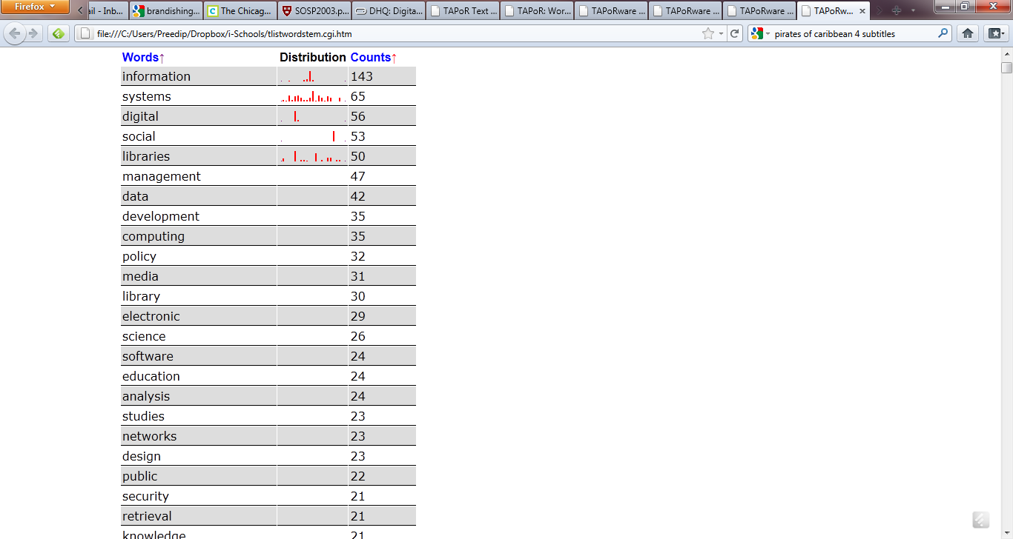

Figure 1. Top frequency of words by co-occurrence

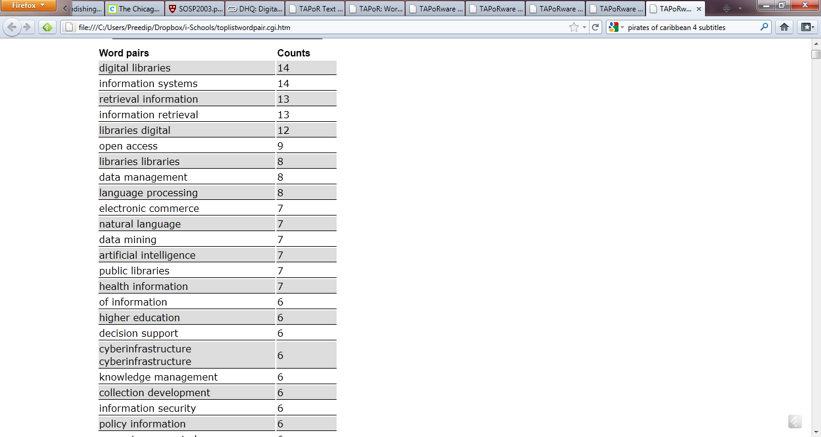

Figure 2. Top frequency of word pairs by occurrence

Table 4 below shows the unit of words list occurred most in the frequency. Their correlation coefficient shows the data are highly correlated: digital with information (0.88272), and digital with libraries (0.83513), information and libraries (0.50108), policy and libraries (0.65061), systems and management (0.56631), data and information (0.48018), digital and policy (0.43928), policy and computing (0.40351), systems and computing (0.41017), systems and policy (0.26803).
Table 4: Unit words list table

Text unit | computing (35) | data (42) | development (35) | digital (56) | information (143) | libraries (50) | management (47) | policy (32) | social (53) | systems (65)
1 | 3 | 1 | 3 | 1 | 0 | 4 | 6 | 2 | 1 | 3
2 | 2 | 7 | 9 | 1 | 9 | 0 | 3 | 3 | 2 | 8
3 | 6 | 20 | 3 | 53 | 5 | 14 | 9 | 0 | 1 | 11
4 | 0 | 0 | 1 | 1 | 12 | 4 | 4 | 2 | 0 | 5
5 | 2 | 0 | 2 | 0 | 92 | 1 | 3 | 7 | 0 | 5
6 | 0 | 0 | 4 | 0 | 12 | 11 | 9 | 4 | 0 | 11
7 | 7 | 3 | 2 | 0 | 4 | 2 | 4 | 0 | 1 | 10
8 | 3 | 0 | 7 | 0 | 5 | 5 | 4 | 6 | 0 | 5
9 | 8 | 8 | 3 | 0 | 3 | 5 | 3 | 5 | 47 | 2
10 | 4 | 3 | 1 | 0 | 1 | 4 | 2 | 3 | 1 | 4

Table 5: Correlation coefficient table

Text unit | 1 | 2 | 3 | 4 | 5 | 6 | 7 | 8 | 9 | 10
1 | 1 | -0.26314 | -0.19569 | -0.11171 | -0.45194 | 0.34722 | 0.27281 | 0.40351 | -0.27026 | 0.41017
2 | -0.26314 | 1 | -0.29311 | 0.41933 | 0.48018 | 0.28958 | 0.38249 | 0.36447 | -0.25439 | -0.1114
3 | -0.19569 | -0.29311 | 1 | -0.17504 | -0.19818 | -0.26851 | -0.22424 | -0.54605 | -0.3237 | -0.33176
4 | -0.11171 | 0.41933 | -0.17504 | 1 | 0.88272 | 0.83513 | 0.26894 | 0.43928 | -0.33264 | -0.07444
5 | -0.45194 | 0.48018 | -0.19818 | 0.88272 | 1 | 0.50108 | 0.09913 | 0.25461 | -0.1651 | -0.27304
6 | 0.34722 | 0.28958 | -0.26851 | 0.83513 | 0.50108 | 1 | 0.37965 | 0.65061 | -0.40087 | 0.241
7 | 0.27281 | 0.38249 | -0.22424 | 0.26894 | 0.09913 | 0.37965 | 1 | 0.20655 | -0.22964 | 0.56631
8 | 0.40351 | 0.36447 | -0.54605 | 0.43928 | 0.25461 | 0.65061 | 0.20655 | 1 | -0.47991 | 0.26803
9 | -0.27026 | -0.25439 | -0.3237 | -0.33264 | -0.1651 | -0.40087 | -0.22964 | -0.47991 | 1 | -0.18973
10 | 0.41017 | -0.1114 | -0.33176 | -0.07444 | -0.27304 | 0.241 | 0.56631 | 0.26803 | -0.18973 | 1

Information technology related aspects appear to be the principal area of research activity of iSchools. The count would be even higher if one were to include such topics as web technology, information retrieval, natural language processing, digital libraries, and text and data mining. However, libraries and library services continue to be a major area of emphasis for iSchools. The other predominant areas of interest are science and public policy, management aspects, knowledge society and digital libraries. The emergence of focus on what has been referred to as “disciplinary specialities” by Bates and Maack (2009) is clearly visible as archive science, medical informatics, cultural informatics, social informatics, arts and museum studies are such areas, while study of archives, arts librarianship, museum studies have traditionally been a part of LIS school curricula the other specialities are largely characteristic of iSchools. Table 4 exhibits the principal keywords which are highlighted in the information research. The distribution of different themes is presented as a pie chart in Figure 3.

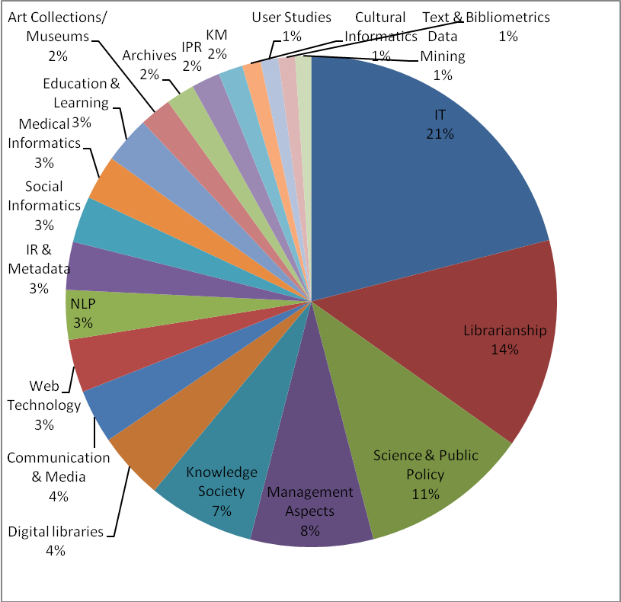

Figure 3. Domains of interest to iSchools

In order to see emphasis of individual iSchools, the data in Table 6 were distributed among the six iSchools.

Table 6: iSchools wise distribution of Domains of Interest
Category | UMAA | SUS | UCLA | HUB | SMUS | UTSA
Information technology | 189 | 54 | 15 | 13 | 106 | 2
Librarianship | 51 | 23 | 50 | 112 | 7 | 7
Science and public policy | 101 | 28 | 33 | 31 | 0 | 8
Management aspects | 30 | 21 | 10 | 27 | 3 | 1
Knowledge society | 42 | 39 | 18 | 15 | 5 | 8
Digital libraries | 30 | 6 | 9 | 28 | 4 | 9
Communication & Media Studies | 5 | 9 | 13 | 10 | 5 | 27
Web technology | 32 | 9 | 1 | 20 | 2 | 0
Natural language processing | 35 | 20 | 0 | 2 | 0 | 2
Information retrieval & metadata | 27 | 10 | 3 | 12 | 4 | 1
Social informatics | 44 | 4 | 7 | 0 | 0 | 0
Medical informatics | 37 | 2 | 1 | 2 | 0 | 11
Education & Learning | 28 | 11 | 11 | 3 | 0 | 3
Art collections/ Museum studies | 12 | 12 | 13 | 13 | 0 | 0
Archives | 14 | 12 | 10 | 8 | 0 | 1
Intellectual property rights | 24 | 1 | 3 | 6 | 8 | 0
Knowledge management | 8 | 6 | 3 | 2 | 5 | 5
Cultural informatics | 7 | 7 | 10 | 4 | 0 | 1
User studies | 8 | 2 | 0 | 10 | 0 | 5
Bibliometrics | 9 | 3 | 2 | 5 | 0 | 1
Text & data mining | 15 | 4 | 0 | 0 | 0 | 0

The significant differences in the focus, concentration and emphasis in the iSchools are evident from the data in Table 6. While information technology related research occupies a predominant position in the output of iSchools of Michigan, Syracuse and SMU, Librarianship continues to be the major focus of the iSchools attached to UCLA, UTSA and HUB. The University of Technology, Sydney works on information media and information and knowledge management area under the school of communication. It does indeed appear that the roots from which the iSchool has evolved impact the focus and emphasis of the iSchool. The iSchool community is composed of faculty from a broad range of academic disciplines, significantly varying from one school to another. UCLA and Humboldt University have had a long tradition of training and research in LIS and it should not be surprising, therefore, that this continues to influence their research interests.

An attempt was also made to see any major differences in the preferred channels of publication. The periodicals in which the iSchool faculty published papers were identified. Most published journals and their frequency is given in Table 7. The top six journals in which the six iSchools were published are listed in Table 8 and comparable with the findings of Bar-llan, (2010).

Table 7: Top published journals by iSchool faculty

S. No. | Name of the journal | No. of papers
1 | Journal of the American Society for Information Science and Technology | 59
2 | IEEE Transactions on Knowledge and Data Engineering | 28
3 | The Library Quarterly | 22
4 | CMS Journal | 22
5 | Communications of the ACM | 21
6 | Telecommunications Policy | 20
7 | The Information Society | 18
8 | Library Hi-Tech | 15
9 | Information Technology and People | 12
10 | First Monday | 12
11 | Information Processing and Management Journal | 12
12 | AI Magazine | 13
13 | Library Trends | 13
14 | American Archivist | 13
15 | Journal of Library History | 11
16 | Journal of Education for Library and Information Science | 10
17 | Decision Support Systems | 10
18 | Journal of Documentation | 10
19 | D-Lib Magazine | 10
20 | EMIE Bulletin | 10
21 | American Economic Review | 10

Table 8: Most published journals by iSchools

UMAA | SUS | UCLA | HUB | SMUS | UTSA
Telecommunications Policy | Communications of the AIS | Journal of Library History | Berliner handouts for Library Science | JASIST | The Library Quarterly
The Information Society | Canadian Journal of Information Science | EMIE Bulletin | CMS Journal | IEEE Transactions on Knowledge and Data Engineering | Journal of Documentation
AI Magazine | School Library Media Research | Libraries & Culture | Library Hi-Tech | Communications of the ACM | Annual Review of Information Science & Technology
Library Trends | Knowledge Quest | Journal of Education for Library and Information Science | First Monday | Information Technology and People | Online Information Review
American Archivist | School Library Media Activities Monthly | IFLA Journal | D-Lib Magazine | Information Processing and Management | Information Research
Journal of Library History | Journal of Electronic Commerce Research | Library Resources & Technical Services | LIBREAS: Library Ideas | Decision Support Systems | Information Research-An International Electronic Journal

Observations

Based on the analysis the following observations were made.

- The predominance of IT and applications of IT-related areas in the research activities of –iSchools is evident. Majority of information technology and IT related peer-reviewed scholarly communications are being published in conference proceedings increasingly, which was found at School of Information Systems of Singapore Management University. Few examples of refereed conference proceedings are: International Conference on Mobile Systems, Applications and Services, IEEE International Conference on Communications and Signal Processing, IEEE International Conference on Computer Communications, Pacific Asia Conference on Information Systems, IEEE/WIC/ACM International Conference on Intelligent Agent Technology, Asia-Pacific Futures Research Symposium, Workshop on Agent-based Approaches in Economic and Social Complex Systems, International IEEE Conference on Intelligent Transportation Systems, The ACM Symposium on User Interface Software and Technology, The ACM Conference on Human Factors in Computing Systems, International Conference on Information Systems Security, International Symposium on Data, Privacy and E-Commerce, International Conference on Computer Communications and Networks (ICCCN), Information Security Practice and Experience Conference, ACM International Conference on Information and Knowledge Management, Conference on Empirical Methods in Natural Language Processing, IEEE International Conference on Social Computing etc.
- There are other frontier interdisciplinary domains that are being explored. These include design studies, service science, decision support systems, science policy (Lyons, 2010) etc.
- Since the faculty is drawn from the multidisciplinary base, the cross-pollination of ideas is diverging more than that of monotonous traditional base of library studies and faculty of practicing librarians teaching is found to be unique from the USA iSchools. Live extramural projects undertaken by eminent faculty are remarkable, especially, the community-led initiatives, user-centric outreach programmes in the areas such as artificial intelligence for different challenged people, healthcare breakthroughs and information in medical informatics need a special mention. For instance in the School of Information, University of Michigan, has faculty who are equally drawn from College of Engineering, School of Public Health, Institute for Social Research, Gerald R Ford School of Public Policy, College of Literature, Science and the Arts, School of Education, School of Dentistry, School of Law which gives a extra edge of cross-disciplinary research. Faculty from School of Dentistry and Public Health at University of Michigan bring in their expertise for medical informatics, whose applied research for school of information is exemplary.
- In the library and information science, there is a strong infusion of thrust areas of specializations – archival science, school-media programmes and media development, information policy, information literacy development, scholarly publishing, information economics etc.
- More and more studies are looking at the sociological perspectives of information behaviour, internet culture, society and internet, socio-cognitive perspectives, psychological aspects, etc.
- From the keyword occurrence analysis, it can be inferred that each school has some strong areas of specialization. These different specialities co-exist among all the schools, but concentration of subjects greatly vary from one school to another as detailed in Table 9.

Table 9: Concentration of research areas by iSchools wise
iSchool | Domain | Areas of Concentration
University of Michigan | Computing science | Information policy, cyberinfrastructure, Information economics, sociology of information, online communities
Humboldt University, Berlin | Library and information science | Public libraries, academic libraries, book publishing and digital libraries
University of California Los Angeles | Information studies | Cognitive aspects of information, archival science, digital preservation, arts conservation and media development
Syracuse University | Information studies | LIS education, natural language processing and social informatics
University of Technology, Sydney | Library science | Digital libraries, information organisation, knowledge management, documentation
Singapore Management University | Information systems | Electronic commerce, information architecture, computing methods, natural language processing

Findings

The themes of interest to iSchools display a great deal of variety and heterogeneity. While this could possibly be true of all disciplines which have a significant amount of professional element, it does appear as though there is as yet no clear construct of what constitutes the domain of interest of iSchools. The comparison between the schools also brought out a remarkable variation of emphasis in research in the iSchools. Each school appeared to have its own research profile and focus making identification of common trends difficult. However, there are pointers to certain dominant themes especially in terms of emerging specialities. Some of the emerging specialities closely correspond to the way Marcia Bates and Mary Niles Maack (2009) have sought to map the “Information Disciplines” in which the broad area (Information Domain) includes:

- General Disciplines, e.g. Information Science; Knowledge Management
- Disciplinary Specialties, e.g. Biomedical Informatics; Music Librarianship
- Cognate Disciplines, e.g. Artificial Intelligence; Epistemology

The study clearly suggests that there are clear indicators of the emergence of certain new specialities such as medical informatics, cultural informatics, science and public policy within the iSchool agenda. There are also indications that a few other areas are having the potential to emerge as disciplinary specialities. A more detailed examination also pointed to the possibility of emergence of certain new specialities. The notable areas that may emerge as specialities are information economics, service science, human computer interaction, information security, information visualization and systems sciences. One thing that is obvious from the study is that the iSchools agenda is much more inter-disciplinary in nature than that of conventional LIS Schools.

Conclusions
As the power of information is getting recognized globally as a lifeline to boost economies, drive competition and run businesses it is increasingly gaining prominence among countries. Although the information science as a discipline came a long way consolidating its position as important discipline among social sciences, the construct of the information domain depends on the level of research, funding and financial resources available at the higher educational institutions. Even as the concentration areas of research differ one to another among iSchools, its construct cannot be ruled out given the change of the existing conditions of the information discipline. The boundaries are still fuzzy and it is likely that the situation will remain this way for some time. That research in the information domain is highly interdisciplinary in nature is also clearly evident both from the range of topics of research as also the list of journals that carry papers emanating from iSchool faculty (Wiggins, 2009). The faculties of iSchools come with a variety of disciplinary backgrounds could be a factor contributing to the interdisciplinary approach for information research. The iSchool phenomenon is still new and in the making; more so outside the United States. It is possible that iSchools will provide an ideal platform for interaction and cross fertilization of ideas among the different disciplinary groups leading, in the coming years, to the emergence of an Information domain with less fuzzy boundaries. The work reported here is the outcome of an ongoing project. The vast amount of information and data that is available on the websites of iSchools is being looked into with a view to obtain a more complete and comprehensive picture of the activities of iSchools. For example, a co-word analysis of keywords /tags assigned to publications emerging from iSchools is being attempted. The outcome is expected to be of value in defining the boundaries of the information domain as also in designing course contents of LIS schools in general and iSchools in particular.

Notes

- List of iSchools. Retrieved November 10, 2011, from http://www.ischools.org/site/descriptions/
- Consortium of iSchools Asia Pacific. Retrieved October 11, 2010, from http://www.cisap.asia/members.htm
- University of Technology, Sydney is not member of the iSchool Caucus, but it is a member of the Consortium of iSchool Asia Pacific, having strong programme in the information and knowledge management area.
- Text Analysis Portal for Research. Retrieved September 18, 2010 from http://taporware.ualberta.ca/
References
Association for Library and Information Science Education (2000). Educating library and information science professionals for a new century: the KALIPER report. Retrieved July 25, 2011 from http://durrance.people.si.umich.edu/TextDocs/KaliperFinalR.pdf.
Bates, M. J., & Maack, M. N. (Eds.). (2009). Encyclopedia of Library and Information Sciences (3rd ed.). New York: CRC Press.
Bawden, D. (2007). Organized complexity, meaning and understanding: an approach to a unified view of information for information science. ASLIB Proceedings, 59(4-5), 307-327.
Borko, H. (1968). Information science: what is it? American Documentation, 19(1), 3-5.
Chen, C. (2008). Thematic maps of 19 iSchools. Retrieved August 25, 2010, from http://citeseerx.ist.psu.edu/viewdoc/summary?doi=10.1.1.167.9397.
Dillon, A., & Norris, A. (2005). Crying Wolf: an examination and reconsideration of the perception of crisis in LIS education. Journal of Education for Library and Information Science, 46(4), pp. 280-298.
Ferreira, F., Santos, J.N., Nascimento, L., Andrade, R.S., Barros, S., Borges, J., Letalien, A.L. (2007). Information professionals in Brazil: core competencies and professional development. Retrieved November 12, 2010, from http://InformationR.net/ir/12-2/paper299.html.
Flood, G. (2003). Information jobs market may be bottoming out information. World Review, 190 (April), p. 6.
Gilchrist, A. (1979). Editorial, Journal of Information Science 1(1), 1-2.
Hallmark, J. and Lembo, M. F. (2003). Leaving science for LIS: interviews and a survey of librarians with scientific and technical degrees. Retrieved July 10, 2010 from http://www.istl.org/03-spring/refereed1.html
Joshi, M. K. (2010). Library and information science education in India: some government initiatives. DESIDOC Journal of Library & Information Technology, 30(5), pp. 67-73
Judit, Bar-llan. (2010). Measuring research impact: a first approximation of the achievements of the iSchools in ISI’s information and library science category – An exploratory study. Retrieved August 13, 2010 from http://hdl.handle.net/2142/14925.
Kavulya, J.M. (2007). Training of library and information science (LIS) professionals in Kenya: a needs assessment. Library Review, 56 (3), pp. 208-223.
Lee, S. & Fang, X. (2008). Perception gaps about skills requirement for entry-level IS professionals between recruiters and students: an exploratory study. Information Resources Management Journal, 21(3), pp. 39-63.
Lyons, K. (2010). Service science in iSchools. Retrieved December 15, 2010, from https://www.ideals.illinois.edu/handle/2142/14946.
Miwa, M. (2006). Trends and issues of LIS education in Asia. In C. Khoo, D. Singh & A.S. Chaudhry (Eds.), Proceedings of the Asia-Pacific Conference on Library & Information Education & Practice 2006 (A-LIEP 2006), Singapore, 3-6 April 2006 (pp. 18-26). Singapore: School of Communication & Information, Nanyang Technological University.
Pollack, M. E. (2010). Reflections on the future of iSchools from a Dean inspired by some junior faculty, Interactions, 17(1), 66-68.
Seadle, M. (2007). The new mission of a new iSchool, Library Hi Tech, 25(1), 5-9.
Raghavan K.S., & Agrawal, N. (2006). Has the market place for information professionals changed? In C. Khoo, D. Singh & A. S. Chaudhry (Eds.), Proceedings of the Asia-Pacific Conference on Library & Information Education & Practice 2006, (A-LIEP 2006), Singapore, 3-6 April 2006 (pp. 409-415). Singapore: Nanyang Technological University.
Raghavan, K.S., & Giri, K. (2009). Training new generation information workers: the entry level LIS degree program in India. Retrieved September 23, 2010, from http://a-liep.kc.tsukuba.ac.jp/proceedings/Papers/a44.pdf
Thompson, R.A. (2008). ISchool curricula: how wide? how deep? Retrieved October 11, 2010, from www.ischools.org/conference08/pc/PA1-4_iconf08.doc
Wiggins, A. (2009). Interdisciplinary diversity in the iSchool community. Retrieved July 10, 2010 from http://ischools.org/images/iConferences/awiggins-iConference2009poster329.pdf.
Wiggins, A., McQuaid, M. J., & Adamic, L.A. (2008). Community identity: peer prestige and academic hiring in the iSchools. Retrieved October 19, 2010, from http://www.ideals.illinois.edu/handle/2142/15079

