Krishikosh an Institutional Repository of Agriculture: A study

Dr. Vaishali B.Wadnerkar (Malode)
Librarian
Dhanwate National College,Nagpur(M.S)
Vaishu.wadnerkar@rediffmail.com,9822945662
Abstract
The technological advances today make it possible to think in terms of storing all the knowledge of the human race in digital form and several organizations worldwide are experimenting with less-expensive ways to create Institutional Repositories For long-term preservation of our knowledge base and cultures. At present many institutions have repositories and maintain much of its own websites and provide all kinds of information about the functioning. This paper is focused on “Krishikosh” an Institutional Repository of Indian National Agricultural Research System ”This paper aims to study and analyze the collections in the repository ,it includes Annualreports,Books,Journal,Newsletters,Theses,Photoghaphs and other material useful for the researchers and end users of the libraries. The evaluation process is achieved by grading and ranking. Out of these, some Agricultural Institututional Repositories are ranked and finally a model of Institutional Repositories is given.
Keywords: Institutional Repositories, NARES, SAU, Krishiprabha ,Krishikosh
Introduction
Digital technology can make all the significant literary, artistic, and scientific works of mankind permanently digitally preserved and made accessible to the billions of people all over the world. The technological advances today make it possible to think in terms of storing all the knowledge of the human race in digital form and several organizations worldwide are experimenting with less-expensive ways to archive and disseminate scholarly information and in-house knowledge as Institutional Repositories. For example, the California Digital Library's e-Scholarship program at the University of California, ArXiv.org at Cornell University etc support open-access distribution of scholarship in cross-disciplinary through subject-based approach. U.S. Library of Congress’ US $100 million National Digital Information Infrastructure and Preservation Program (NDIIPP), which is developing a standard way for institutions to preserve their digital archives. Librarians and computer scientists are working together at MIT for Dspace digital asset management system, which aims to create an institutional repository that will include digitized versions of lecture notes, videos, papers, and data sets—in short, everything produced by faculty and staff.
Institutional Repository:
An Institutional repository is a digital archive of the intellectual output of an Institution. It makes the quality and breath of scholarship produced at that Institution accessible to others world wide over the Internet. It is a set of services that a University/Organization offers to the members of its community for the management and dissemination of digital material created by the institution and its community members. It is most essentially an organizational commitment to the stewardship of the digital materials including long term preservation. An effective Institutional repository of necessity represents collaboration among librarians, Information technologies, archives and record managers, faculty and University administrators and policy makers. It is a new channel for structuring the organization’s contribution to the border world and as such invites policy and cultural reassessment of this relationship. It also form part of a larger global system of repositories which indexed in standardizes way.
Krishikosh an agricultural Institutional Repositories in India
Krishikosh is made up two words from hindi, The word Krishi means Agriculture and Kosh means Theca, a case .So Krishikosh is a case of Agricultural knowledge created in the NARES of India.( Indian Agricultural Research & Education System) The Institutional Repository under NARES. The repository of knowledge in agriculture and allied sciences, having collection of old and valuable books, records and various documents spread all over the country in different libraries of Research Institutions and State Agricultural Universities (SAUs)
Nowadays, it is a trend of Institutional repositories all around. Many of the institutions have their repositories which they have built on various open source software. The saddest part of this is that various institutes had created these digital repositories for testing or trial purpose only and could not maintain the pace to streamline those. Many of them are closed and are not being updated regularly. Following is the list of Agricultural institutional repositories from India which are currently active on the Internet.
Need of the Study
In this information revolution age, online information services provided every day, every moment in all field of human activity. This study attempts to explore coverage Agricultural Institutional Repositories on internet. On taking consideration, wider and utility of this topic, undoubtedly, this is the surely beneficial to all library professionals and agriculture researchers in this study.
Objectives of the Study
- To study the Agricultural Institutional Repositories available on Internet in India.
- To study collections available in Krishikosh Institutional Repositories in India.
- To evaluate the subject wise Databases available in Krishiprabha: Krishikosh.
- To evaluate the ranking of top users views of Institutional Repositories in India.
Scope and limitations of the study
An Evaluation of Institutional Repositories in Krishikosh includes a study based on the Internet., There are 45 state / Deemed universities Institutional Repositories available on Internet, out of these the study is restricted to 36 Institutional Repositories in Krishikosh. Here is studied the data available on Homepage of Institutional Repositories in Krishikosh. The study is limited to 36 Institutional Repositories available in Krishikosh .

Methodology
Data is collected by using the websites of Institutional Repositories available on Internet. It was designed to find out the data available on the Institutional Repositories homepage. The data has been analyzed and interpreted.
Findings of the Study
Table 1.1 State wise distribution of Institutional repositories in Krishikosh

Name of the State | No of Institutional Repositories
Gujrat | 01
Rajathan | 02
West Bengal | 02
Maharashtra | 03
Orisa | 03
Himachal Pradesh | 01
Haryana | 02
Andhra pradesh | 04
Telangana | 01
Uttarakhand | 01
Delhi | 03
Uttarpradesh | 02
Kerala | 02
Chatisgarh | 01
Karnataka | 06
Tamilnadu | 02
Total | 36
The table 1.1 shows that, Statewise distribution of Institutional repositories in Krishikosh,36 institutional repositories are active properly on the Internet and the maximum no. of institutional repositories in agricultural universities in India i.e., Karnataka 6,Andhra Pradesh 4,Maharashtra ,Orisa ,Delhi is 3.
Table 1.2 Top Country wise views on Krishikosh
Top Country | Users Views
India | 37
France | 04
China | 03
United States | 02
Canada | 01

The table 1.2 shows that, top country wise users views on krishikosh Institutional repository. The highest views of krishkosh in India i.e, 37.

Table 1.3 Top City wise Users Views on Krishikosh
Top City | Views
New Delhi | 09
Surat | 03
Bellary | 02
Patna | 02
Saintlous | 02
Zengzhols | 02
Banglore | 02
Indore | 01
Rourkela | 01

The table 1.3 shows that, top City wise users views on krishikosh Institutional repository. The highest users views of krishikosh in New Delhi .i.e, 9.

Krishiprabha:
Krishiprabha is a full Text electronic database of Indian Agricultural Doctoral Dissertations submitted by research scholars to the 36 State/ Deemed Agricultural Universities. This database has been created by Nehru Library, Charan Singh Haryana Agricultural University, and Hisar with financial support from Indian council of Agricultural Research, New Delhi under its national Agricultural Innovation project. All 36 state/deemed universities maintain a institutional repository namely krishikosh.
1.4 Subject wise Databases available in Krishiprabha
Sr No | Subject | Databases
1 | Agricultural Engineering & Technology | 167
2 | Agriculture | 4990
3 | Basic Sciences | 1366
4 | Dairy Science | 169
5 | Home Science | 345
6 | Veterinary & Animal Sciences | 1236
 | Total | 8273

The Table 1.4 shows that subject wise database available in Krishiprabha, The highest no of databases available on the subject of Agriculture and Basic Sciences.

Table 1.5 Agricultural Universities and collections available in the Institutional Repository Krishikosh.
Name of IR Universities | Books | Journals | Reports | Theses | Institutional Publications | Proceedings | Reprints | Others
AAU | 91 | -- | 01 | 21 | 07 | ---- | ---- | 06
ANRAU
CAZRI | 46 | 85 | --- | ---- | 188 | --- | --- | ---
CIFRI | --- | ---- | 24 | --- | --- | --- | --- | 11
CIFE | 211 | 18 | 38 | --- | --- | 11 | --- | ----
CIFA | 05 | --- | 03 | --- | 15 | 10 | --- | ---
CMFRI | 42 | 242 | 21 | --- | --- | 01 | 42 | ----
CPCRI | ---
CPRI | 121 | 79 | 56 | --- | ---- | 35 | ---- | 24
CRRI | --- | 02 | 25 | --- | ----- | ---- | --- | ---
CSSRI | 09 | --- | 44 | --- | 79 | ---- | --- | ---
CCSHAU | 18 | 125 | 209 | 293 | --- | ---- | ---- | ---
DOOR | 90 | 59 | 205 | --- | ---- | 68 | --- | ---
GBPUAT | 256 | --- | ---- | --- | ---- | ---- | --- | ---
IARI | 4845 | 5431 | 50 | 2350 | --- | 11 | 292 | 197
IASRI | 274 | 284 | 1315 | ---- | --- | ---- | --- | 73
IGFRI | ---- | ---- | 08 | ---- | 16 | --- | --- | ----
IIFR | 91 | --- | --- | --- | --- | --- | --- | ---
IISR | 216 | --- | 22 | ---- | 35 | 26 | --- | 17
IVRI | 326 | 1015 | --- | --- | --- | --- | --- | ---
IGKVV | --- | --- | ---- | 01 | --- | ---- | --- | ---
MPKV | 1805 | 03 | 28 | ---- | ---- | ---- | 02 | 01
NAARM | 90 | --- | 04 | --- | --- | --- | --- | --
NBAII | 368 | 34 | 02 | --- | --- | --- | --- | 01
NBPGR | 65 | --- | 24 | ---- | 39 | --- | --- | ---
NBSSLP | 136 | 03 | 78 | --- | ---- | --- | ---- | ---
NDRI | --- | --- | 34 | --- | 168 | --- | 1173 | ---
NIRJAFT | ---- | ---- | 01 | --- | 15 | ---- | --- | ---
NRCC | 01 | ---- | ---- | ---- | ---- | ---- | ---- | ----
NRCCF | 68 | ---- | 17 | --- | --- | --- | ---- | ----
OUAT | 155 | ---- | ---- | ---- | ---- | ---- | --- | ----
PJTSAU | 1961 | 999 | 102 | 2537 | 36 | 08 | --- | 40
PDOP | ---- | ----- | 39 | ---- | 29 | ----- | ---- | ----
TAU | 963 | 364 | 64 | 498 | ---- | 06 | ---- | ----
UAHS | ---- | ----- | 02 | 03 | 04 | ---- | --- | ---
UAS | 970 | 6011 | 485 | 596 | 19 | 171 | ---- | 287

The Table 1.5 shows that maximum no. of Books available in Institutional repository is, Indian Agriculture Research Institute, Pusa, New Delhi i.e. 4845 Maximum no of journals are available in University of Agricultural Sciences,Banglore.i.e.6011 and Indian Agricultural Research Institute Pusa, New Delhi i.e.5431.Reports are available in Indian agricultural statistical research Institute ,New Delhi i.e.1315.Maximum no of theses available in professor Jayashankar Telangana State Agricultural research Institute, i.e.2537 and Indian Agriculture research Institute, New Delhi i.e.2350.Institutional publications are available in Central Arid Zone Research Institute i.e.188,and National Dairy Research Institute,Banglore i.e 168. 68 proceedings are available in Directorate of oilseeds Research,1173 Reprints are available in National Dairy research Institute,Banglore.11 agriculture universities institutional repositories are collection with training manuals, Research Highlight, Photographs and related material about Institutions.

Table 1.6 Agriculture Institutions in Krishikosh .
Sr No | Name Of Institutions | Place of Institutions | Websites
1 | Anand Agricultural University | Anand ( Gujarat) | www.aau.in
2 | Acharya NG Ranga Agricultural University | Hyderabad (Andhrapradesh) | angrau.ac.in
3 | Central Arid Zone Research Institute | Jodhpur(Rajastan) | www.cazri.res.in
4 | Central Inland Fisheries Research Institute | Kolkata(West Bengal) | www.cifri.res.in
5 | Central Institute of Fishiries education | Mumbai | www.cife.edu.in
6 | Central Institute of Freshwater Aquaculture | Bhubaneswar | www.cifa.in
7 | Central Marine Fisheries Research Institute | Kochi | www.cmfri.org.in
8 | Ceatral Plantation Crops Research Institute | Kudlu,kesaragod,(Kerala) | Cpcri.gov.in
9 | Central Potato Research Institute | Shimala(Himachal Pradesh) | Cpri.ernet.in
10 | Central Rice Research Institute | Cuttack (Orissa) | Crri.nic.in
11 | Central Soil Salinity Research Institute | Karnal(Haryana) | www.cssri.org
12 | Chaudhary Charan Singh Haryana Agricultural University | Hisar(Haryana) | www.hau.ernet.in
13 | Directorate of oilseeds Research | Hyderabad(Andhra Pradesh) | www.icar.org.in
14 | Govind Ballabh Pant University of Agriculture & Technology | Pantnagar(Uttarakhand) | www.gbpuat.ac.in
15 | Indian Agriculture Research Institute | Pusa ( Delhi) | iari.res.in
16 | Indian Agriculture Statistics Research Institute | New Delhi | www.iasri.res.in
17 | Indian Grassland and Fodder Research Institute | Jhansi (Uttarpradesh) | www.igfri.res.in
18 | Indian Institute of Horticulture Research | Bengaluru (Karnataka) | www.iihr.ernet.in
19 | Indian Institute of Spices Research | Kozhikode ( Kerala) | Spices.res.in
20 | Indian Veterinary Research Institute | Bareilly (Uttarpradesh) | www.ivri.nic.in
21 | Indira Gandhi Krishi Vishvavidyalaya | Raipur ( Chhatisgarh) | www.igau.edu.in
22 | Mahatma Fule Krishi Vidypeeth | Rahuri (Maharashtra) | mpkv.ac.in
23 | National Academy of Agricultural Research Management | Hyderabad (Andhra Pradesh) | www.naarm.ernet.in
24 | National Bureau of Agriculturally Important Insects | Bangalore | nbair.res.in
25 | National Bureau of Plant Genetic Resources | New Delhi | www.nbpgr.ernet.in
26 | National Bureau of Soil Survey and Land use Planning | Nagpur | www.nbsslup.in
27 | National Dairy Research Institute | Banglore | www.ndri.res.in
28 | National Institute of Research on Jute and Allied Fibre Technology | Kolkata | www.nirjaft.res.in
29 | National Research Centre on Carmel | Bikaner (Rajasthan)
30 | National Research Centre on Coldwater Fisheries | Bhimtal | www.dcfr.res.in
31 | Orissa University of Agricultural and Technology | Bhubaneswar (Odisha) | ouat.ac.in
32 | Professor Jayashankar Telangana state Agricultural University | Hyderabad(Telengana) | www.pitsau.ac.in
33 | Project Directorate on poultry | Hyderabad(Andhra Pradesh) | www.pdonpoultry.org
34 | Tamilnadu Agricultural University | Coimbatore(Tamilnadu) | www.tnau.ac.in
35 | University of Agricultural and Horticultural Sciences | Shimoga | uahs.in
36 | University of Agricultural Sciences | Bangaloreu | www.uasbangalore.edu.in

Conclusion
The Institutional Repository collets,makes available,and preserves in digital format the scholarly output created by the institutions community. Its interface provides for easy self-archiving by faculty, and organizes the documents in logical, easily retrieved fashion. Open access publications have emerged as a new source of freely available research literature in digital format and thousands of these publications are available these days. The good part is that researchers can easily access these publications via Internet on their computers or smartphones. This is welcome news for agriculture researchers relying mainly on libraries to search research literature. Researchers must learn about and take benefit of Krishikosh Institutional Repository for improving their research outputs.

Homepage of Krishikosh Institutional Repository
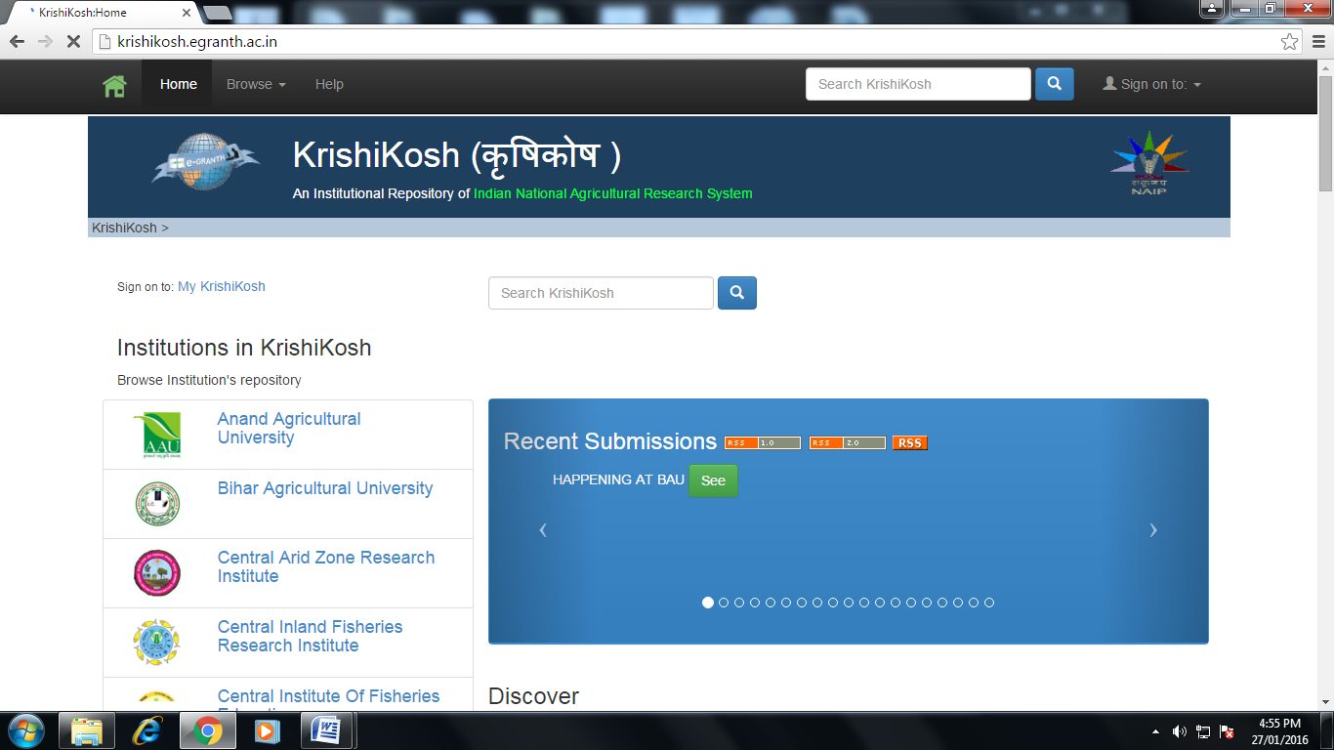
Home page of Krishiprabha Electronic Theses Database.
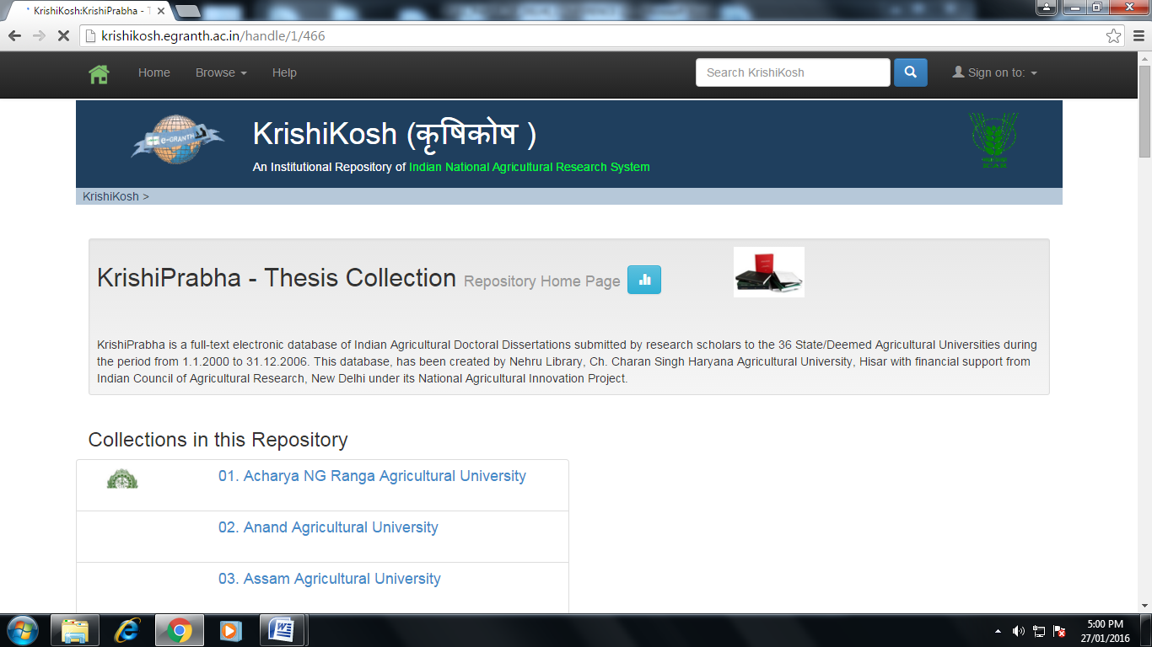

Home page of Indian Agriculture Research Institute,Pusa
References
Yatrik Patel, J K Vijayakumar and T A V Murthy (2004). DSpace@INFLIBNET: an
Indian initiative to develop Digital Repositories/e-Archives (in press)
MacKenzie Smith and others (2003). DSpace: An Open Source Dynamic Digital
Repository, D-Lib Magazine, 9(1)
www.pitsau.ac.in ( Accessed 17 Jan 2016)
www.dcfr.res.in ( Accessed 17 Jan 2016)
www.nirjaft.res.in( Accessed 18 Jan 2016)
krishikosh.egranth.ac.in. ( Accessed 18 Jan 2016)
www.cifa.in (Accessed 19 Jan 2016)
www.nbpgr.ernet.in ( Accessed 20 Jan 2016)

