Accepted manuscript of paper published in:

Kumar, V., Balaji, B. P., & Monika. (2020). Correlates of the national ranking of higher education institutions and funding of academic libraries: An empirical analysis. The Journal of Academic Librarianship, 102264. https://doi.org/10.1016/j.acalib.2020.102264

Correlates of the national ranking of higher education institutions and funding of academic libraries: an empirical analysis

Abstract

In the 21st-century knowledge society, academic libraries are central to institutions and are challenged for their relevance amidst disruptive technological innovations and competition. This paper aims to understand the pattern of library funding in the top Indian Higher Educational Institutions (HEIs) by comparing their library budgets. Using data from the National Institute Ranking Framework (NIRF) 2019 ranking of institutions we analyzed the library budgets to find out if there are correlations between the ranking of the institution against the budget of concerned academic libraries comparing the data in three independent categories of the NIRF Rankings 2019 which are: Overall, Universities and Colleges categories. Findings indicate that, although universities and colleges have a higher number of enrolled students to serve in comparison to overall HEIs, spend lesser capital towards the teaching-learning activities. This assessment finds a significant positive correlation between capital expenditure and the national ranking score in all three categories of ranking. Results confirm a strong correlation between the library expenditure and national ranking score, indicating that the institutions spending more towards libraries also score higher in the national rankings. The study also found that on an average Rs. 7491 is spent by Indian HEIs per user, while universities and colleges spent Rs. 4369 and Rs. 370.66, respectively. These findings will be of importance to higher education policymakers, academic administrators, librarians and funding agencies—evaluating academic libraries to achieve higher rankings. The findings have implications in linking the library expenditure to rankings.

Keywords: India Higher Education, National Ranking, NIRF, Academic Library, Library Budget

Introduction

Academic libraries as commons for promoting inclusion, information access and equality for learning communities is vital for building a knowledge society. In higher education, they engage learners with print and multimedia learning resources to enrich studies, research and practice for student success and skill development. Centric to academic values and enabling learning environments, academic libraries are indispensable to institutional programmes in building research-driven environments strengthening learning outcomes and supporting information literacy and lifelong learning (Cox, 2018; Bennett, 2011). They contribute to building the institution’s reputation and prestige by providing collections of library resources and services that support faculty research and learner needs, thus bringing positive impact on institutional rankings (Weiner, 2009; Oakleaf, 2011). Increasingly academic library services have been evaluated against the learning outcomes, effectiveness (Atkinson, 2017) and “ways in which determinants of library quality have been broadly linked to educational outcomes” (Pritchard, 1996) and in documenting how their performance contributes to institutional goals and outcomes (Lindauer, 1998). Some of the essential functions of academic libraries are providing information literacy, assist in student attainment/academic success and driving research impact and hence the distinction and framework between what constitute measuring performance and key performance indicators are made (Appleton, 2018). Most importantly, for building a reputation, brand value and student engagement, academic library as a space of learning have been considered for promoting educational equality and measuring the satisfaction of users is critical in-service areas. Appleton (2011) listed prominent service areas such as “enrollment, induction, information skills training, study support (e.g. access to resources), staff support (e.g. advice, help, guidance, customer service), assessment (e.g. coursework submission)”.

Amidst all the changes in higher education, academic libraries strive for assessment indicators to include them in ranking frameworks, when the university rankings are measured with no standardized indicators globally to have a clear conception of the frameworks, methodologies and data in the evolving higher education institutional assessment scenarios as Daraio, Bonaccorsi & Simar (2015) argued. This is to prevent false or unrealistic expectations out of it when funding and accreditation of institute are at stake if not ranked in the global league of universities (Vernon, Balas & Momani, 2018; Gorman, 2016; Federkeil, 2008; Federkeil, 2009). Frenken, Heimeriks and Hoekman (2017) identified that since the achievement of high ranking became strategic imperative as a mission for research excellence, internationalization and innovation among the academic leadership and administrators, which should positively influence university rankings with benchmarks where the country differences are inherent. This requires further adapting to the modern pluralities and therefore necessitates academic libraries to build, useful, sustainable and practical assessment tools for demonstrating library value, services and impact (Boulton, 2011; Khomyakov, 2017). Table 1 lists a few of the assessment tools used by academic libraries.

Aligned with institutional mission, academic libraries lead in the production of scientific knowledge, providing legitimate access to scholarly, institutional knowledge. In the changing landscape of information explosion, academic libraries and HEIs are in the transition from traditional information gatekeepers to players effectively assisting the use of ubiquitous information to various library users, amidst the disruptive technological innovations and competition (Wegner & Zemsky, 2018; American Library Association, 2007). Academic libraries not only facilitate student learning and success, but they also demonstrate their value through evidence like impact assessments, metrics and outreach activities (ACRL, 2018) and thus need to incorporate an institutional strategy for resource allocation in their planning processes.

Academic libraries with a wide range of services are providing access to print and multimedia resources, offer user instruction, reference services, manage archives, institutional outputs and data; support communities of academic, research and practice. Performance-based evaluation of academic library services is the basis for the allocation of institutional funding. Hence, communicating the value of academic libraries remains the central aim for assessment of library services and therefore, to all external agencies who evaluate the impact of academic library services (Jackson, 2015a). Pivotal to that mission is the ranking of institutions and hence service excellence and high-service performance push academic libraries to strive for inclusive, user-friendly and value-added library services. As part of the library assessment process, academic libraries measure service areas such as undergraduate instruction, events, research and teaching support, digital collections, library spaces and library technology to standardize outcome measurements (Ackermann, Goek & Plagman, 2018). However, not all the measures undertaken by academic libraries define performance such as usage, quality of service and outcomes, though many of these measures are labelled as metrics, they do not capture the library’s performance (Brophy, 2006; Holmes & Parsons, 2016).
Moreover, library collection as a base for the benchmark is overtaken by information control which focuses both on availability and access to print and electronic resources, may give overall satisfaction over the gate visits and physical access to the library (Jackson, 2015a). Impact factor of journals and citations are frequently used as a significant and relevant measure for impact assessment in rankings of HEIs. However, research outputs and citations of the institutions cannot determine the rankings of the institute, as disciplinary coverage is biased towards science and technology and data on social sciences, arts and humanities are entirely not available in India and elsewhere (Boulton, 2011; Mukherjee, 2016).

In academic administration, library budgets are one of the critical investments in terms of money, material and human resources required for library operations. However, academic libraries have taken time to realize the importance of outcomes and impact of online services to the changing times. This is in terms of value propositions libraries hold and the intangible benefits which are beyond measurement. Key performance indicators developed help to assess what is the quality of library service and the benefits of using those services. With growing demands for guidelines and methods to assess specific library outcomes against the library budget, however, there is a need to use indicators to measure specific outcomes and impact of library services, performance against strategic objectives became necessary. Academic libraries are reinventing and consolidating their positions globally to demonstrate research and societal impact and higher education in India is no exception to this trend.

Table 1. Performance indicator benchmarks in academic libraries.
Indicator | Benchmark
Service quality | LibQual+, SERVQUAL
Library strategy | Annual Strategy and Five-year Plans
Standards | ISO Certifications, Quality Management System, Total Quality Management Systems
Satisfaction/Feedback | User Surveys
Key Result Indicator (Outcomes) | Performance Indicators
Impact assessment | MINES for Libraries

Increasingly questioned about the return on investment on library spending, academic libraries are liable to institutions on where the inputs are working and communicate where the value propositions lie to all the stakeholders. This is measured through metrics like per capita expenditure in academic libraries, holdings per user, library footfalls (students, faculty, visitors and members), usage of print and electronic resources, user satisfaction data, social outreach and research impact for policymaking (alternative metrics, social media attention, events, communications); and the value of the library to the local community and its social impact. Rankings do measure the quantity of research output, disciplinary concentrations, cross-country and institutional collaboration of authors, citation per article by faculty (Mukherjee, 2016). Hence, the paradigm shift is from input/output planning processes to outcomes and impacts (such as library usage) and the values which are demonstrated because of this (Appleton, 2017). Importance of measuring and assessing the impacts or effects of teaching, learning, and other institutional activities and to which academic libraries tied strategically to demonstrate is an invaluable contribution for institutional ranking, research performance assessment through specific key performance indicators (Lindauer, 1998; Brophy, 2006). Accreditation agencies, institutions of higher learning and professional organizations emphasize the need of learning outcomes in the academic and research settings, against the set goals.

Academic libraries in the digital environment are questioned for their value and benefits as the traditional means of information access is very globalized. Academic libraries have long discussed and demonstrated the principles of performance and their indicators through evidence and outcome-based assessment models as standards (ACRL, 2018). In an increasing economically constrained space in higher education, academic libraries are under pressure to demonstrate accountability through meaningful measures and the relevance of organizational impact. Weiner (2005) in an assessment of impact and quality of libraries found there is “a relationship between the ARL Index and services; between the number of undergraduate students and services; and between instructional presentations and operating expenditures.” Academic libraries are central to the institutional performance through accreditation, rankings, the prestige of the institution and contribute to teaching and learning, assessment of library spaces, performance measures and on library value (Heath, 2011). Transitions of service quality of academic libraries in an online environment necessitated rethinking the performance, regardless of the format of the information, location and user groups with a broadening perception and to meet user expectations (Manjunatha & Shivalingaiah, 2004). In the UK, Oppenheim and Stuart (2004) evaluated the Research Assessment Exercise (RAE) ratings, and the amount spent on the library both at macro and micro levels. They concluded that there was a “statistically significant correlation between library spending and RAE ratings at an institutional level and that the best institutions have both the best RAE scores and the best libraries”. Information literacy, information seeking patterns, information resources use, library collections, metrics of student retention, academic performance and engagement are prominent features for academic libraries. Understanding accreditation evaluation as librarians and documentation of best practices of service quality, benchmarks and performance indicators gains prominence here. Libraries are not a significant factor in most university rankings worldwide, and if included only, they can represent library expenditures and student surveys as frequently used indicators for measuring library services and performance. Libraries need to respond to under- or misrepresentation in rankings by demonstrating the impact of the library services on other indicators used in rankings or by offering more meaningful measures of library quality (Jackson, 2015b).

Ranking of Higher Educational Institutions in India
As shown in figure 1 in India, there are over 993 universities, 39,931 colleges and 10,725 stand-alone institutions offering academic and professional education, making it one of the largest educational systems in the world (AISHE, 2019). The number of higher educational institutions have been increasing year on year, and Indian higher education is a complex system in various levels from the undergraduate to the advanced programs in tertiary education. Providing comprehensive coverage of Indian higher education system on the number of colleges and universities, the Gross Enrollment Ratio (GER) in India is increasing, whereas the allocation for higher education as a percentage of the total budget is almost constant as shown in Figure 2 (AISHE, 2019; AISHE, 2018; Reddy, Xie & Tang, 2016; Raman, 2019). Despite there is a definite increase in the expenditure on higher education, the same is not in proportion to the growth in the GER (Singh, 2015). It indicates that the per capita expenditure is not increasing over the years, and has been stagnant at 1.47 percent for over twelve years until 2018-19 (Raman, 2019). In the year 2017-18, government spending on education was low at 2.7% of the total GDP of the country, which is not an adequate investment in the social sector (Sanghera, 2018) and hence needs educational policy interventions (Mitra, 2015). Nevertheless, it has continuously been questioned for the quality of education and program as to why Indian universities do not get ranked in international world rankings, having low research metrics and lack of publications of high-quality research in top journals (Reddy et al., 2016). Despite these lackings, the academics think that the parameters used in the global rankings are more inclined towards the already reputed institutions, especially the ‘perception’ parameter.

In India, national rankings of academic institutions is a long-felt need to increase competitiveness and quality to bring Indian higher educational institutions on par with global institutions. Consequently, NIRF ranking as a new method was released for the first time in 2016, evaluating and ranking Indian HEIs based on local parameters, that matters most to domestic students and parents and also competitive to global ranking parameters. The benchmarks used in the NIRF rankings are: ‘Teaching, Learning and Resources’, ‘Research and Professional Practice’, ‘Graduation Outcomes’, ‘Outreach and Inclusivity’ and ‘Peer Perception’ for ranking institutions (NIRF, 2019). Library expenditures were for the first time used as an indicator in the category ‘Teaching, Learning and Resources’ in this institutional ranking in the 2016 version of this ranking (NIRF, 2019). Additionally, the Ministry of Education has been making efforts to create a set of world-class universities, also known as Institutions of Eminence and selected twenty-five institutions in India both government-funded and privately-run universities.

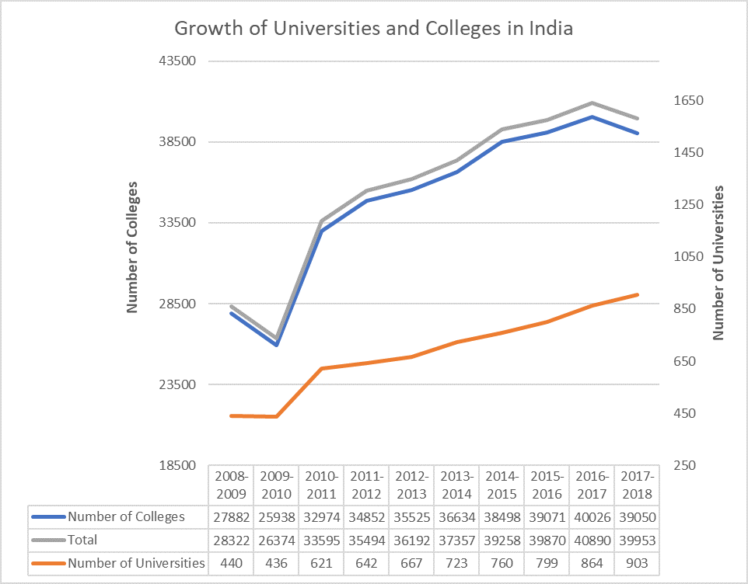
Figure 1. Growth of universities and colleges in India.

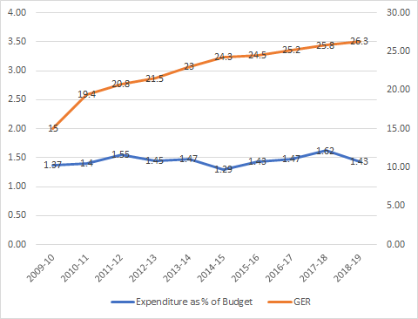

Figure 2. Gross enrollment ratio and expenditure on higher education as % of budget from 2009 to 2019.

Budget of academic libraries
In India, budgets of academic libraries are managed from April to March of the following year, per fiscal year, for example from April 01, 2020, to March 31, 2021. Library budgeting includes operational and capital costs. Many universities in India have library committees(majorly membered by academics) which oversee, monitor and administer library budgets by tracking quarterly spending, getting into library cooperatives and consortia. Many leading institutes are spending high on the acquisition of eBooks and e-journals (Singh & Pandita, 2019). Although few of the state councils regulate the higher education of states, there is no data of library budgets available in the public domain at the regional and state levels.

The transition in academic libraries from a collections-based physical facility to an online environment offering a new range of products and services brought in a lot of challenges and advantages, despite the realities of collection of self-sufficiency is a fallacy. The library will have to prove its value of contributing to vital institutional outcomes, especially for accreditation bodies, is the teaching-learning role of libraries, but challenging to measure (van Reenen, 2001). This transformation of academic libraries from stacks to the web environment has not been easy to manage in collection development, needs assessment of users when the open-access resources are rich and scholarly publishing became linked to library services (Lewis, 2013). Hence, they responded to these transitions, in the wake of “explosion of networked information resources, third-party providers, self-publishing,” and many other variations of the traditional mechanisms of information gatekeeping to producing, organizing, and delivering scholarly information and access (Pritchard, 1996).

In a developing country context, lack of resources could be linked to the underperformance of institutions, where understanding the need for institutional ranking at all levels is critical. It must be communicated to all the internal and external stakeholders as part of the process for the strategic development of the institute (Platis, 2017) for institutions to improve their rankings. Academic libraries should understand that ranking methodologies consider research productivity (quantity) and visibility of that research (means) as indicators of institutional performance. The per faculty research output of the institution, expenditure on publishing research articles and total expenditure on library against the faculty are also evaluated. In other words, academic libraries support and enhance institutional access to learning resources anywhere, anytime and in building scholarly infrastructure to disseminate knowledge outputs. In India, academic libraries remain underfunded, hence need the support of all stakeholders despite being a significant influence in university rankings through citations and scholarly dissemination of research outputs. Librarians must understand the process of ranking institutions to communicate the measures directly incorporated in rankings and what benchmarks of library services are relatable and to what degree they convey service quality (Jackson, 2015b).

Related studies
This review evaluates the importance of academic libraries in national, regional and world rankings and what earlier studies demonstrated about the academic libraries’ role in institutional rankings in the Indian context, compared with the global developments. Ranking systems globally account research performance as a top indicator for assessing academic performance, and for which academic libraries contribute immensely through both measurable and intangible ways. Academic libraries are considered for their space as a facility, research support centre and as a provider of learning resources. Academic libraries started to evaluate their services, collections and impact, which are crucial for the accreditation; research impact and achievements in a competitive environment by examining the user satisfaction and perception of service quality and the outcomes. If there are no adequate checks in place identifying the gaps, processes and understanding of quality concepts among the library staff will be difficult(Nejati & Nejati, 2008; Azadeh, Dizaji & Neshat, 2013). In examining the relationship between scholarly output and institutional ranking, there is a correlation found in high-ranked Indian universities on the impact of scholarly output against university ranking (Sheeja, Mathew & Cherukodan 2018).

Proving the relevance and importance of academic libraries took shape in multiple ways through value, impact and outcomes; measuring through statistical models and quantitative assessments; and evaluation of service quality (Hall, Thornton & Town, 2011). In a three-year period of study Pandita and Singh (2018) analyzed the spending pattern of university libraries in India and reported that “on an average, 44 percent of the library budget in the university libraries across India was spent on the procurement of print resources and 56 percent towards the procurement of electronic resources; averagely each university library in India spends Rs. 58.74 million on the procurement of library resources each year; and spends Rs. 0.364 million on the resource procurement against each faculty member, whereas faculty members during the period of this study had on an average published 3.73 research articles”. For measuring the service quality of the academic library, standards, metrics, guidelines and assessment tools are critical for categories: “Environment, equipment and physical facilities”, “Public services”, “Non-book materials”, “Staff (librarians and their co-workers)”, and “Information literacy and user education” (Babalhavaeji, Isfandyari-Moghaddam, Aqili & Shakooii, 2009).

In a three-year study, Singh and Pandita (2017) analyzed the library budgets with the faculty publications and reported that libraries of management institutes in India spend on an average Rs. 0.986/million on the “resource procurement against each published research article and Rs 1.166/million on the resource procurement against each faculty member.” A ten-year study by Singh and Mahajan (2017) found that the budget allocation for library print books and electronic journals had tremendously increased in the five university libraries of Punjab and Haryana region in India. Pandita and Singh (2016) on studying the trends on resource procurement among the top twenty university libraries for a period of three years found that the investment on acquiring electronic resources increased, but “no direct correlation was found between the amount spent against each faculty member and the average research articles produced by each faculty member.”

In one of the earliest studies in the United States, Piternick (1963) found that the growth of academic libraries in the 20th-century in terms of holdings and doubling time of library collections had a significant effect on the ranking of institutions. Noh (2012) correlated that the impact of university library resources on the research achievement output using Structural Equation Model in the process and proved that labor, budget, investment on e-resources did enhance the research achievements of academic libraries. In a study of exploring the influence of academic libraries in maintaining university reputation in the USA, Orduña-Malea and Regazzi (2013) found correlations among university web indicators, whereas the “strength of correlation is moderate in terms of page count, and weak in terms of visits” and concluded the “correlation among university web indicators and research expenditures depends on the student population.” As an essential contributor to university quality and representation, Jackson (2017) examined academic libraries through the “library value framed in three forms of external evaluation: accreditation, university rankings, and student surveys.” and how they are continued to be measured through “collections, spaces, and expenditures, despite the significant expansion of library services into non-traditional areas, including teaching and research, scholarly communications, and data management and visualization” as advanced forms of support to enhance the library services.

In a similar study, Jackson (2015b) noted that in university rankings how some of the “indicators used to rank universities favor libraries with more highly rated physical facilities, while largely ignoring the impact that other services have on library quality.” Dempsey and Malpas (2018) discussed the changing trends in academic libraries in a diversified higher education system around research, liberal education and career preparation. From a collection-based to service-based models, academic library services are steadily building a strategic fit to the institutions they serve in the digital environment to achieve the desired outcomes of learning (Andres, 2019).

Methodology
The purpose of this study was to understand the institutional budget and spending towards the library corresponding to the student strength and other expenditure by the HEIs in India. Specifically, the study is based on the following research questions:

RQ1: What are the trends observed in the last three-year library expenditure from 2015-16 through 2017-18 by the top-ranked HEIs in India?
RQ2: What proportion of total capital expenditure towards teaching, learning and research activities has been dedicated to libraries by the top-ranked HEIs in India during the period from 2015-16 through 2017-18?
RQ3: Is there any correlation between the total capital expenditure, expenditure towards library, per capita expenditure towards the library, proportion of library expenditure to total capital expenditure and the NIRF scores of the institutions in the NIRF rankings?
RQ4: How these correlations differ among the three categories of NIRF rankings: Overall, Universities and Colleges?

In order to answer these questions, secondary data was collected from the reports of the National Institutional Ranking Framework (NIRF) 2019 released by the Ministry of Human Resource Development (MHRD), (which is renamed as Ministry of Education now ), Government of India (GOI). In a first-ever attempt in November 2015 the MHRD, GOI devised a ranking methodology for ranking all the Higher Educational Institutions(HEIs) in India. Having released the rankings for the years 2016, 2017, 2018, 2019 and 2020 edition is the latest ranking released in June 2020. The rankings employ objective criteria and metrics computed for the overall performance of top 100 universities and colleges, and subject-specific institutes in Engineering, Management, Pharmacy, Law, Architecture and Medical categories (NIRF, 2019). The rankings also release the bands for institutions ranking below top 100 places in the rankings. The ‘Institute Data’ files are released for only the top 100 ranked institutions in each of the categories as mentioned earlier. In order to participate in the respective year’s rankings, the framework requires HEIs to upload their institutional data on the NIRF website in a prescribed format. The process involves furnishing information under several heads such as administrative, financial and academic data related to students, faculty and infrastructure. The NIRF team verifies the claims for the authenticity of the claimed values(NIRF, 2019).

The data belonging to variables, such as NIRF Rank and NIRF Score, Capital Expenditure on Library, Total Capital Expenditure, Total Students Strength (Undergraduate, Postgraduate and PhD) were collected from the ‘Institute Data’ files from the NIRF portal. Library expenditure data for the last three years(2015-16, 2016-17 and 2017-18) available in the Institute data files under the heading: “Financial Resources: Utilized Amount for the Capital expenditure for previous three years” in the report were collated. Since the study is limited to analyze only the three categories of Universities, Colleges and the Overall rankings, data related to top 100 universities, colleges and overall HEIs were only considered for this study. Further, to discover trends and critical insights, the data were tabulated and analyzed using Python language and other visualization libraries which is discussed below.

To download the ‘Institute Data’ files available in PDF format on the NIRF portal ‘beautifulsoup4’ and ‘requests’ Python packages were used, once the files are downloaded, the data of each file were extracted using ‘tabula-py’ Python wrapper that captures tabular data in PDF files and converts into ‘pandas’ DataFrames. For easier processing, we used ‘pandas’ package’s inbuilt functions, such as describe to calculate the descriptive statistics, and for visualizations, we deployed the ‘seaborn’ and ‘matplotlib’ statistical graphics libraries. Similarly, to calculate the simple correlations, ‘pearsonr’ function from the ‘SciPy’ library is used.

Analysis
State-wise distribution of colleges, universities and overall institutions
Before examining the expenditure of academic libraries in India, we describe in detail the proportion of universities, colleges included in the NIRF ranking dataset used in this study. According to the AISHE (2019) report, there are more than 993 universities 39,931 colleges and 10,725 institutions in India. Figure 3 shows the distribution of high-ranked colleges in the Colleges ranking category. In this ranking, eleven states have the most number of colleges represented, which are from Tamil Nadu (35) followed by Delhi (29) and Kerala (18). Other states ranked with a smaller number of colleges are from West Bengal (6), Maharashtra (3), Andhra Pradesh, Chandigarh and Gujarat (2 each), Karnataka, Puducherry and Telangana (1 each).

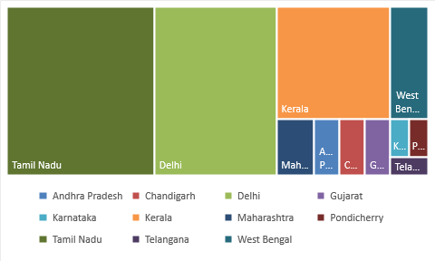
Figure 3. State-wise representation of colleges in NIRF top 100 Colleges category.

In the Universities ranking category, 25 states have their representation where the highest number of universities are from Tamil Nadu (21) followed by Maharashtra (11) and Karnataka (10). Other states such as Delhi (6), Andhra Pradesh and West Bengal (5 each ), Assam, Telangana and Kerala ( 4 each), Haryana (3), Jammu and Kashmir, Odisha, Puducherry ( 2 each), Chandigarh, Goa, Himachal Pradesh, Jharkhand, Meghalaya, Mizoram, Uttarakhand and Gujarat ( 1 each) have universities in the top-ranked 100 places in the Universities category of the NIRF rankings.
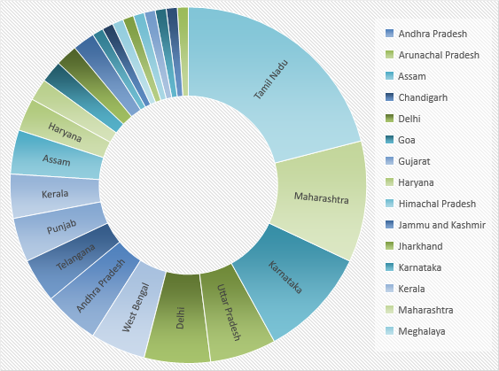
Figure 4. State-wise representation of universities in NIRF top 100 Universities category.

Similarly, in the third category of Overall HEIs ranking category, that includes all kinds of higher educational institutions such as universities, colleges, engineering, medical, management, law, pharmacy, and architecture are listed for their performance. Figure 5 shows that 24 states have their representation in the rankings. Among them, the highest number of institutions are from Tamil Nadu (21) followed by Maharashtra (12) and West Bengal (8). Other states which have competitive universities are from Delhi, Karnataka and Uttar Pradesh ( 7 each), Kerala, Odisha, Punjab, Telangana ( 4 each), Andhra Pradesh and Assam ( 3 each), Gujarat, Jharkhand, Rajasthan, Uttarakhand ( 2 each), Bihar, Chandigarh, Haryana, Himachal Pradesh, Jammu and Kashmir, Madhya Pradesh, Meghalaya, Puducherry ( 1 each) in the top 100 Overall ranking category. Since this distribution is from twenty-four states it reveals that there is a three fourth of representation comes from all over India in the top-ranked institutions used in this study.

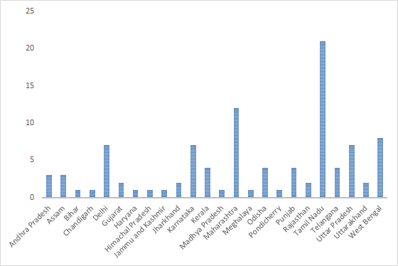
Figure 5. State-wise number of HEIs represented in NIRF top-100 Overall category.

Student Strength
As far as the student strength is concerned in the Overall HEIs ranking category, an average of 8579.74 student strength was observed with a standard deviation of 8308.78. The maximum student strength was found in SRM Institute of Science and Technology, Chennai with 50,989 students. In contrast, minimum student strength was observed in Indian Institute of Management Calcutta, Kolkata with 1222 students.

Table 2. Number of enrolled students in all three ranking categories
Number of Enrolled Students
Category of HEI | count | mean | std | min | 25% | 50% | 75% | max
Overall | 100 | 8579.74 | 8308.78 | 1222 | 3608 | 5736.5 | 10561.5 | 50989
University | 100 | 8524.96 | 8392.99 | 1003 | 3201.5 | 5149 | 10561.5 | 50989
College | 100 | 3584.34 | 2278.13 | 415 | 2056 | 3243 | 4589 | 11837

In the Universities ranking category, an average of 8524.96 student strength was observed with a standard deviation of 8392.99. The maximum student strength was found in SRM Institute of Science and Technology, Chennai with 50,989 students whereas minimum student strength was from the Central University of Punjab, Bathinda with 1003 students. In the Colleges ranking category, average 3584.34 student strength was observed with a standard deviation of 2278.13. The maximum student strength was found in PSG College of Arts and Science, Coimbatore with 11,837 students whereas minimum student strength was from Rajiv Gandhi Institute of Information Technology and Biotechnology, Pune with 415 students.
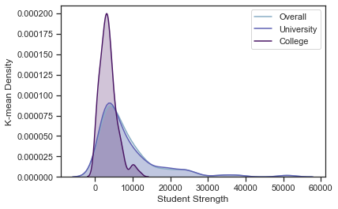
Figure 6. Kernel density graph of student strength in all three ranking categories

Further, it is also observed that 25 % of the HEIs in the Overall ranking category has student strength less than or equal to 3608. In comparison, 25 % of universities have student strength less than or equal to 3201.5, and 25 % of colleges have student strength less than or equal to 2056 students. Similarly, 50 % of the HEIs in Overall ranking, University ranking and College ranking categories have student strengths less than or equal to 5736.5, 5149 and 3243, respectively. Moreover, 75 % of the HEIs in Overall ranking, University ranking and College ranking categories have student strengths less than or equal to 10561.5, 10561.5 and 4589, respectively. Furthermore, 50 % of the HEIs in Overall ranking, University ranking and College ranking categories have student strengths lies between 3608 to 10561.5, 3201.5 to 10561.5 and 2056 to 4589 respectively. As visualized in Figure 6, if we compare the mean student strength of universities and colleges with the Overall HEIs student strength, it can be said that the universities are 2.60% behind the overall ranking mean student strength. In contrast, the colleges are 57.96% behind the overall HEIs student strength.

Capital Expenditure
The capital expenditure is an indicator of the financial resources utilized to create infrastructure facilitating teaching-learning ecosystem in the HEIs. It includes amounts utilized in the heads such as the library, equipment for laboratories, engineering workshops and other expenditure on the creation of capital assets; however, it does not include any expenditure on the purchase of land or expenditure on buildings.

Table 3. Capital expenditure by all three ranking categories.
Average Capital Expenditure (INR in Million)
Category of HEI | count | mean | std | min | 25% | 50% | 75% | max
Overall | 100 | 326.24 | 303.55 | 14.79 | 146.95 | 244.58 | 413.83 | 1814.85
University | 100 | 235.1 | 226.62 | 7.41 | 73.63 | 166.91 | 297.14 | 1191
College | 100 | 10.87 | 10.32 | 0.41 | 4.04 | 7.3 | 13.85 | 47.62

As tabulated in Table 3 in the Overall category of ranking, it was observed that during the last three years an average of 326.24 million rupees was spent by HEIs in India with a standard deviation of Rs. 303.55 million on the creation of capital assets. The maximum capital expenditure was made by the Indian Institute of Technology Delhi, New Delhi with Rs. 1814.85 million, whereas the minimum capital expenditure was observed in Pondicherry University, Puducherry with Rs. 14.79 million. If we remove outliers, the mean shifts to Rs. 297.64 million with a standard deviation of Rs. 229.27 million. Concerning Universities category of ranking, it was noted that during the years 2015-16 through 2017-18, an average of Rs. 235.10 million rupees were spent by universities in India with a standard deviation of 226.62 million on the creation of capital assets. The maximum capital expenditure was made by SRM Institute of Science and Technology, Chennai with Rs. 1191 million, whereas the minimum capital expenditure was observed in Dibrugarh University, Dibrugarh with Rs. 7.41 million. If we remove outliers, the mean value shifts to Rs. 216.14 million with a standard deviation of Rs. 185.04.

Similarly, in the Colleges Ranking, it was observed that during the last three years colleges spent an average of 10.87 million rupees in India with a standard deviation of 10.32 million on the creation of capital assets. The maximum capital expenditure was made by Madras Christian College, Chennai with Rs. 47.62 million, whereas the minimum capital expenditure was observed in Sri Meenakshi Government College for Women, Madurai with Rs. 0.41 million. If we remove outliers, the mean shifts to Rs. 10.16 million with a standard deviation of Rs. 9.14 million.

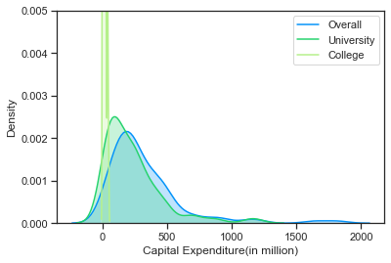
Figure 7. Kernel density graph of average capital expenditure in all three ranking categories

Further, it is also observed that 25 % of the HEIs in the Overall ranking category spent capital expenditure less than or equal to Rs 146.95 million. In comparison, 25 % of universities have spent less than or equal to Rs. 73.63 million and 25 % of colleges have spent less than or equal to Rs. 4.04 million. Similarly, 50 % of the HEIs in Overall ranking, University ranking, and College ranking categories have spent capital expenditure less than or equal to Rs. 244.58 million, Rs. 166.91 million and Rs. 7.3 million respectively. Moreover, 75 % of the HEIs in Overall ranking, University ranking and College ranking categories have spent less than or equal to Rs. 413.83 million, Rs. 297.14 million and Rs. 13.85 million, respectively. Furthermore, 50 % of the HEIs in Overall ranking, University ranking and College ranking categories capital expenditure lies between Rs. 146.95 million to Rs 413.83 million, Rs. 73.63 million to Rs. 297.14 million and Rs. 4.04 million to Rs. 13.85 million, respectively. If we compare the mean capital expenditure of universities and colleges with the overall HEIs capital expenditure, it can be said that the universities are 27.93% behind the overall HEIs mean whereas the colleges are 95.37% behind as illustrated through kernel density graph in Figure 7.

Library Expenditure
Generally, budget allocation and spending of allocated funds help to assess the desired outcomes in terms of usage, collection development and acquisition of print and multimedia resources. Therefore, the expenditure on the library indicates the difference to measure the academic performance of the HEIs.

Table 4. Average library expenditure by all three ranking categories.
Average Library Expenditure (INR in Million)
Category of HEI | count | mean | std | min | 25% | 50% | 75% | max
Overall | 100 | 45.47 | 54.12 | 2.8 | 12.74 | 27.57 | 50.85 | 389.79
University | 100 | 32.55 | 48.67 | 2.06 | 7.61 | 18.39 | 35.27 | 389.79
College | 100 | 1.18 | 1.17 | 0.1 | 0.51 | 0.93 | 1.51 | 9.72

In the Overall category of ranking, the analysis reveals that for the three years from 2015-16 through 2017-18, it was observed that during the last three years the top 100 HEIs spent an average 45.47 million rupees in India with a standard deviation of 54.12 million on libraries as shown in Table 4. The maximum expenditure on the library was made by Homi Bhabha National Institute, Mumbai with 389.79 million. In contrast, the minimum capital expenditure was observed in Sri Sivasubramaniya Nadar College of Engineering, Kancheepuram with Rs. 2.8 million. If we remove outliers, the mean expenditure on library shifts to Rs. 41.99 million with a standard deviation of Rs. 41.67 million.

Whereas in the University’s Ranking, it was observed that during the last three years an average of 32.55 million rupees was spent by top 100 universities in India with a standard deviation of 48.67 million on libraries. The maximum expenditure on the library was made by Homi Bhabha National Institute, Mumbai with 389.79 million whereas the minimum capital expenditure was observed in Gandhigram Rural Institute, Gandhigram with 2.06 million. If we remove outliers, the mean shifts to Rs. 28.94 million with a standard deviation of Rs. 32.82 million.

Similarly, in the College’s Ranking, it was observed that during the last three years an average of Rs. Top 100 colleges spent 1.18 million rupees in India with a standard deviation of 1.17 million on libraries. The maximum expenditure on the library was made by Hans Raj College, Delhi with Rs. 9.72 million whereas the minimum expenditure on the library was made by Women’s Christian College, Nagercoil with Rs. 0.1 million. If we remove outliers, the mean shifts to Rs. 1.1 million with a standard deviation of Rs. 0.8 million.

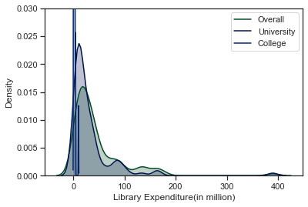
Figure 8. Kernel density graph of average library expenditure in all three ranking categories

Further, it is also observed that 25 % of the HEIs in the Overall ranking category spent library expenditure less than or equal to Rs 12.74 million while 25 % of universities have spent less than or equal to Rs. 7.61 million and 25 % of colleges have spent less than or equal to Rs. 0.51 million. Similarly, 50 % of the HEIs in Overall ranking, University ranking and College ranking categories have spent library expenditure less than or equal to Rs. 27.57 million, Rs. 18.39 million and Rs. 0.93 million respectively. Moreover, 75 % of the HEIs in Overall ranking, University ranking and College ranking categories have spent less than or equal to Rs. 50.85 million, Rs. 35.270 million and Rs. 1.51 million respectively. Furthermore, 50 % of the HEIs in Overall ranking, University ranking and College ranking categories library expenditure lies between Rs. 12.74 million to Rs 50.85 million, Rs. 7.61 million to Rs. 35.27 million and Rs 0.51 million to Rs. 1.51 million respectively. If we compare the mean expenditure on libraries by top 100 universities and colleges with the overall HEIs library expenditure, it can be said that the universities are 28.41% behind the overall HEIs mean whereas the colleges are 66.60% behind as shown in Figure 8.

Trends in library expenditure
Considering the research question, to analyze the trends of library expenditure in the last three years, it is found that while there is steady growth in the library expenditure of Overall HEIs and Universities, there is a slight decline in the library expenditure of Colleges since the 2016-17 academic year (see Figure 9).

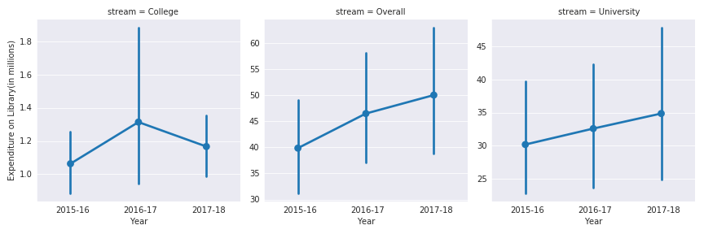
Figure 9. Trends of library expenditure in the last three years in all three ranking categories

Trends in capital expenditure
However, for the research question regarding the trends in total capital expenditure a different trend is observed, wherein the total capital expenditure of colleges and overall HEIs are found to be growing steadily, whilst there is a steep decline observed in the average capital expenditure of universities in the years, 2017-18(See Figure 10).
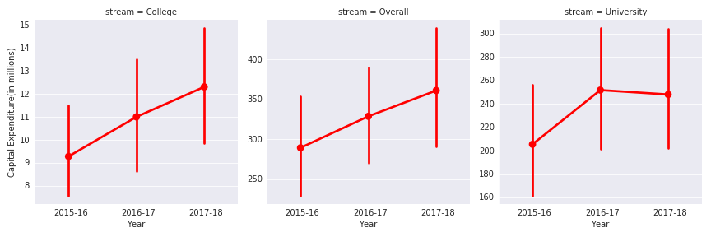
Figure 10. Trends of total capital expenditure in the last three years in all three ranking categories

Proportion of Library versus Capital Expenditure
By understanding the statistics related to capital expenditure and library expenditure, it will be interesting to observe the proportion of library to capital expenditure made.

Table 5. Last three-year average proportion of library to capital expenditure by all three ranking categories
Proportion of Library to Capital Expenditure
Category of HEI | count | mean | std | min | 25% | 50% | 75% | max
Overall | 100 | 0.19 | 0.30 | 0.02 | 0.08 | 0.12 | 0.20 | 2.49
University | 100 | 0.23 | 0.35 | 0.01 | 0.07 | 0.11 | 0.21 | 2.49
College | 100 | 0.17 | 0.17 | 0.01 | 0.07 | 0.12 | 0.23 | 0.88

In the Overall Ranking, it was observed that the top 100 HEIs in India spend an average of 19.04 % of their capital expenditure on libraries with a standard deviation of 30.36 (Table 5). Pondicherry University, Puducherry spent the maximum proportion with 249.03% whereas the minimum proportion spent by Tamil Nadu Agricultural University, Coimbatore with 1.82%. If we remove outliers, the mean proportion of library expenditure shifts to 14.41 % with a standard deviation of 11.25. The maximum value also changes and Guru Gobind Singh Indraprastha University, New Delhi comes into the picture with 60.18%.

Meanwhile, in the Universities ranking, it was observed that the top 100 universities in India spend an average of 22.63 % of their capital expenditure on libraries with a standard deviation of 35.34. Pondicherry University, Puducherry spent the maximum proportion with 249.03% whereas the minimum proportion was used by Mangalore University, Mangalagangotri with 1.01%. If we remove outliers, the mean proportion of library expenditure shifts to 19.15 % with a standard deviation of 24.50. The maximum value also changes and HBNI comes into the picture with 120.54%.

Similarly, in the Colleges ranking, it was observed that the top 100 colleges in India spend an average of 17.20 % of their capital expenditure on libraries with a standard deviation of 16.72. Keshav Mahavidyalya, Delhi spent the maximum proportion with 87.80% whereas the minimum proportion was used by Newman College, Idukki with 1.24%. If we remove outliers, the mean proportion of library expenditure shifts to 15.19 % with a standard deviation of 12.28. The maximum value also changes Jesus & Mary College, New Delhi comes into the picture with 58.12% of capital expenditure spent towards the library.

Furthermore, 50 % of the HEIs in Overall ranking, University ranking and College ranking categories spend a proportion of their capital expenditure towards library lies between 0.08 to 0.20, 0.07 to 0.21 and 0.07 to 0.23 million respectively. If we compare the mean proportions of capital expenditure spent on libraries by top 100 universities and colleges with the overall HEIs proportions, it can be said that the universities are 18.86% ahead of the overall HEIs mean whereas the colleges are 24% behind (see the kernel density graph in Figure 11).

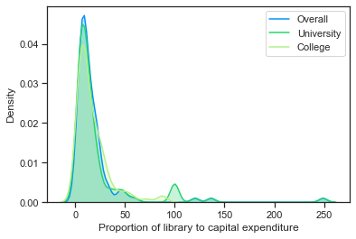
Figure 11. Proportion of Library versus Capital Expenditure in all three ranking categories.

Per capita expenditure
Another interesting variable to measure would be the per capita expenditure made by the libraries of the HEIs in India. The per capita expenditure is a strong indicator of the financial health of a library. The more per capita, the better is the financial health of the library. Since we have both student strength and the expenditure of libraries of individual institutions, we can calculate the per capita for each institution. The per capita is calculated as the total expenditure made on library divided by the total number of users. Since in the case of academic libraries, all the registered students of HEIs become members at the time of admission itself we treat the student strength as the number of users as per the below formula:
$$Per capita (p) library expenditure= \frac{Library Expenditure (EL)}{Student Strength (SS)}$$

Table 6. Per capita library expenditure by all three ranking categories.
Per Capita Library Expenditure (INR)
Category of Ranking | count | mean | std | min | 25% | 50% | 75% | max
Overall | 100 | 9174.99 | 15578.7 | 335 | 1902.75 | 4323.5 | 9040 | 126430
University | 100 | 5590.35 | 13308.48 | 335 | 1680 | 2883 | 5374 | 126430
College | 100 | 441.52 | 522.4413 | 37 | 200 | 291 | 449.25 | 3177

In the Overall Ranking, it was observed that the top 100 HEIs in India has an average per capita expenditure of Rs. 9175, with a standard deviation of 15578.69 (Table 6). The maximum per capita was observed in Homi Bhabha National Institute, Mumbai with Rs. 126430 whereas the minimum per capita was observed in Amity University, Gautam Budh Nagar with Rs. 335. If we remove outliers, the mean per capita library expenditure shifts to Rs. 7491 with a standard deviation of Rs. 8923.91. The maximum value also changes as Indian Institute of Technology Mandi, Mandi comes into the picture with 45008 per capita expenditure.

While in the Universities ranking, it was observed that the top 100 universities in India spend an average of Rs. 5590.35 with a standard deviation of 13308.48. The maximum per capita was observed in Homi Bhabha National Institute, Mumbai with Rs. 126430 whereas the minimum per capita was observed in Amity University, Gautam Budh Nagar with Rs.335. If we remove outliers, the mean per capita library expenditure shifts to Rs. 4369.74 with a standard deviation of Rs. 5330. The maximum value also changes and Indian Institute of Science, Bengaluru comes into the picture with 41139 per capita expenditure.

Similarly, in the Colleges ranking, it was observed that the top 100 colleges in India spend an average of Rs. 441.52 with a standard deviation of 522.44. The maximum per capita was observed in Shaheed Rajguru College of Applied Sciences for Women, Delhi with Rs. 3177, whereas the minimum per capita was observed in Muthurangam Government Arts College, Vellore with Rs.37. If we remove outliers, the mean per capita library expenditure shifts to Rs. 370.66 with a standard deviation of Rs.328.64. The maximum value also changes Hans Raj College, Delhi comes into the picture with 1974 per capita expenditure.

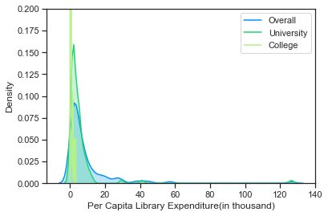
Figure 12. Per capita library expenditure in all three ranking categories.

Further, it is also observed that 50 % of the HEIs in Overall ranking, University ranking and College ranking categories have per capital expenditure between Rs. 1902.75 to Rs. 9040, Rs. 1680 to Rs. 5374 and Rs. 200 to Rs. 449.25 respectively. If we compare the mean per capita library expenditure by libraries of top 100 universities and colleges with the overall HEIs, it can be said that the universities are 39.06% behind the overall HEIs mean whereas the colleges are 92.01% behind (see Figure 12).

Correlational analysis
Correlation analysis is a statistical method to find out the degree of association between the values of two or more variables calculated based on the change in the value of another variable when the value of one is changed. The degree of association is calculated based on a coefficient called correlation coefficient and usually denoted by symbol ‘r’. The value of ‘r’ lies between -1 to +1, including 0. A positive value of ‘r’ shows the existence of a positive association between the two variables, wherein a higher value of ‘r’ denotes a high degree of the association. In contrast, low value denotes a low degree of association among the variables. It must be noted that the existence of a correlation does not represent a cause and effect relationship; it just shows that the two variables are correlated with each other.
The NIRF Score is the score of individual institute obtained in the national rankings. An institute with higher NIRF Score will be considered top in the ranking list in comparison to institute scoring lesser NIRF Score, in other words, NIRF Score decides the place of the institute in the ranking list. As per one of the research questions, we were interested in analyzing only the existence of simple linear correlations between the NIRF Score with other variables, such as Total Capital Expenditure, Expenditure on Library, Per Capita Expenditure, Proportion of Library to Capital Expenditure. To perform the simple correlation analysis, we calculated Pearson’s Correlation Coefficient(r) and tested at the 95% level of significance. We tested the null hypothesis H₀: r = 0, and alternate hypothesis H₁: r ≠ 0

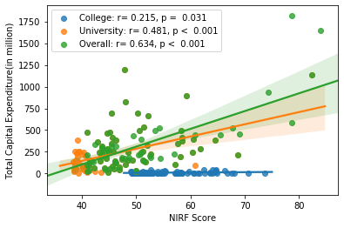(a) | 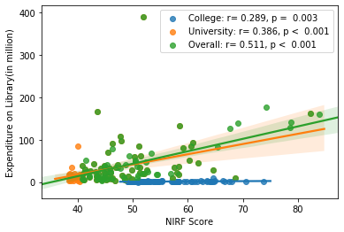(b)
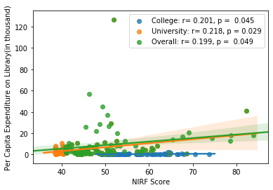  (c) | 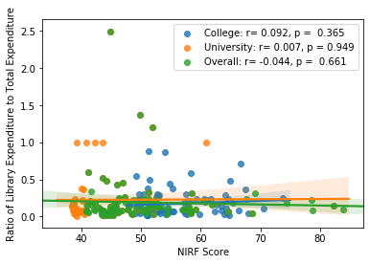(d)
Figure 13. Correlational Analysis between NIRF Score and other variables.

The Pearson’s product-moment correlation coefficient was computed to assess the relationship between the amount of Capital Expenditure made by top 100 HEIs of India and their respective NIRF Score. There was a significant positive correlation in all the categories of ranking. In the case of Overall category, the correlation was found highly positive and significant, r = 0.634, n=100, p < 0.001. This found to be true in the case of universities(r = 0.481, n=100, p < 0.001) and colleges(r = 0.215, n=100, p = 0.031) too. This shows that, increases in the amount of Capital Expenditure were correlated with the increases in the NIRF Score (Figure 13 (a))

Similarly, Pearson’s product-moment correlation coefficient was computed to assess the relationship between the amount of Library Expenditure made by top 100 HEIs of India and their respective NIRF Score. There was a significant positive correlation in all the categories of ranking. In the case of Overall category, the correlation was found positive and significant, r = 0.511, n=100, p < 0.001. This found to be true in the case of universities(r = 0.386, n=100, p < 0.001) and colleges(r = 0.289, n=100, p = 0.003) too. This shows that, increases in the amount of Library Expenditure were correlated with the increases in the NIRF Score (Figure 13 (b)).
Figure 13(c) shows the correlation coefficient between the Per Capita Expenditure towards the library to the ranking scores. It was found that there is a significant positive correlation between them; however, the correlation strength found to be moderate in all the categories of ranking. In the case of Overall category, the correlation was found positive and significant, r = 0.199, n=100, p = 0.049. This found to be true in the case of universities(r = 0.218, n=100, p = 0.029) and colleges(r = 0.201, n=100, p = 0.045) too. This suggests that libraries with higher Per Capita Expenditure tend to get higher ranking scores. Further, the correlation coefficient between the Proportion of Library to Capital Expenditure and the NIRF Score. It was found that there is an insignificant correlation between the variables in question. In fact, in the Overall category, there exists a negative correlation; however, it is insignificant. From the above analysis, we can say that there is no difference in the results of the correlational analysis among the Overall (r = -0.044, n=100, p = 0.661)and the rankings of Universities(r = 0.007, n=100, p = 0.949) and Colleges(r = 0.092, n=100, p = 0.365), all points to no association between the variables in question(Figure 13(d)).

Discussion

By analyzing the total expenditure on libraries by top NIRF ranked institutes, universities and colleges in India, this study aimed to identify notable patterns related to attributes viz, the total capital expenditure, the library expenditure, per capita expenditure towards the library and the proportion of library budget to total capital expenditure towards teaching, learning and research activities in the last three years. This section summarizes the findings and contributions made from the analysis of data.

As for the total capital expenditure, it was observed that during the last three years an average of 297.64 million rupees was spent by HEIs in India on the creation of capital assets for the teaching, learning and research activities. On the other hand, the universities in India spent 216.14 million rupees, and the colleges spent 10.16 million rupees. The result indicated that the expenditure towards teaching, learning and research activities differs among the types of institutions. The universities spend 27.93% less than the spending of overall HEIs while colleges spend 95.37% less. These findings indicate that the financial structure of colleges is not satisfactory, as they spend significantly less in comparison to overall HEIs expenditure. These findings have clear implications for the policymakers to increase the funding to colleges so that they could compete with the other HEIs. However, if we compare the student strength of these institutions, the colleges have 57.96% fewer students than overall HEIs, while universities have just 2.60 % fewer students. This indicates that in spite of having more number of students, the universities and colleges are spending less money towards the teaching-learning activities in comparison to overall HEIs. As far the trends are concerned, the total capital expenditure of Colleges and Overall HEIs are growing steadily. At the same time, there is a steep decline in the capital expenditure of universities in the last academic year.
Further, a significant positive correlation between the capital expenditure to the national ranking score was observed in all the categories of ranking. This shows that increases in the amount of Capital Expenditure were correlated with the increases in the NIRF Score. This found to be true in the case of universities and colleges as well.

With regards to the library expenditure, we found that during the last three years, an average of 45.57 million rupees were spent by HEIs in India on libraries. On the other hand, the universities in India spent an average of 28.94 million rupees, and the colleges spent just 1.1 million rupees on libraries. It indicates that there is a high level of variation in the spending of institutions towards the library. The universities spend 28.41% less than the amount spent by overall HEIs whereas colleges spend 66.50% less. The last three years trends indicate that while there is steady growth in the library expenditure of Overall HEIs and universities, there is a slight decline in the library expenditure of colleges since the 2016-17 academic year. Also, a significant positive correlation exists between the library expenditure and national ranking score. This indicates that the institutions spending more towards libraries also score higher in the national rankings. This finding supports the results of Noh (2012), Oppenheim and Stuart (2004) and Kiviniemi et al., (2009) that concluded that there was a statistically significant correlation between library spending and national ratings at an institutional level worth the investments and that the best institutions have both the best rating scores and the best libraries.

Concerning the proportion of library expenditure to total capital expenditure, data indicates that during the last three years Indian HEIs spent 19.04 % of their capital expenditure on libraries while the universities and colleges spent 22.63 % and 17.18 %, respectively. Thus, it can be said that the universities spend 18.86 % more on libraries in terms of the proportion of their total capital expenditure in comparison to overall HEIs while colleges spend only 24% less than the overall HEIs. This finding is in line with the findings of Manjunath (2009). No significant correlation was found between the Proportion of Library expenditure to the Capital expenditure.

The per capita expenditure of a library indicates the amount spent by a library towards the unit user. Regarding per capita expenditure, it was found that Rs. 7491 is spent by Indian HEIs per user, while universities and colleges spent Rs. 4369 and Rs. 370.66, respectively. In comparison to HEIs, universities and colleges spend 39.06% and 92.01% less, respectively. For the existence of correlation between the per capita expenditure of library to the national ranking scores(NIRF Score), a significant positive correlation was found; however, the correlation strength found to be moderate in all the categories of ranking. This suggests that libraries with higher per capita expenditure tend to get higher ranking scores.

These findings have important implications for the academic librarians and funders to understand the trend and the correlates of library-specific variables to the national ranking scores. However, the study has few limitations too, firstly, the data for the study comprises of top 100 universities, whereas there are more than 900 universities in India. Similarly, in the case of colleges, the representation is only of 100 colleges whereas a total 39,931 colleges exist in India. Although the institutions in the present study are the top representative institutions of India, more comprehensive data related to all the universities, colleges and institutions would have indeed yielded better results. Secondly, As an empirical study, this analysis only covers three years of study from 2015-16, 2016-17 and 2017-18, so the timescale is limited although similar studies demand a larger timescale of data represented as Kiviniemi, Laitinen and Saarti (2009) pointed out for statistical analysis, and the results might change considering a more extended period. Thirdly, only the total library expenditure data is considered for this study more insights could have been obtained if the data related to various other heads, such as e-resources, print resources and services in the library expenditure is also available. Further, the correlation analysis conducted in this study was limited in terms of simple correlations, however, partial correlation analysis controlling the effect of other variables or a multiple correlation analysis considering data related to other relevant variables mentioned above would have increased the generalisability of the results.
Notwithstanding the relatively limited sample and unavailability of granular data this work offers valuable insights into the funding of academic libraries in India, especially among the top-ranked HEIs, the results obtained in this study have important implications.

Further, the role of academic libraries in institutional rankings needs to be measured not only in terms of expenditure but also in terms of the services supporting the teaching-learning activities, research productivity, data management and scholarly communications activities.

Conclusion
Ranking systems themselves are evolving in the academic and research performance settings. In such a scenario, the global academic community should take into consideration the role and importance of academic libraries play in driving research impact and achievement in their mission to create a global workforce of competitive and employable graduates. As this study demonstrated in India, the rapid growth of HEIs and the subsequent increase of enrollments did not keep up with the quality measures and values academic libraries create and strive for—may yet to be understood for research and innovation. As the contributions of academic libraries are tremendous towards the research performance of the institutions, it is unthinkable without academic libraries in the HEIs. Rankings do not adequately measure the educational quality, which is directly related to the level and access to library resources and their quality assurance, which significantly vary in the developing countries. For the growing knowledge society, HEIs are expected to play a transformative role to lead and impact society for a sustainable and resilient future. Hence, the higher education sector should recognize that the quality of academic libraries is central in rankings of institutions. As this demonstrated, the per capita expenditure should be defined and measured to the needs and challenges of current times for better allocation of funds for various programs and purposes to build balanced and inclusive academic libraries. As specific and more-detailed library budget data is not available across the three categories of HEIs, we examined in the rankings, and it has been a challenge to differentiate the use of access to print and electronic resources in academic libraries although the electronic acquisitions are increasing considerably. Annual audit of library spending at the national, regional, state and local level will bring accountability to where resource allocation should be made by the academic administrators and top management of the institutions. This, in turn, necessitates the communication and clear guidelines from the national funding agencies regarding the minimum allocation of financial resources to academic libraries and the mechanisms to achieve the goals. As and when academic library budget data having detailed granularity is available in the public domain for most of the Indian HEIs, our further study will concentrate upon a longitudinal study of analyzing the library expenditures in the future.

References

Ackermann, E., Goek, S., & Plagman, E. (2018). Outcome measurement in academic libraries: Adapting the project outcome model. Retrieved from https://www.libraryassessment.org/wp-content/uploads/2019/07/1-Ackermann-Goek-Plagman-OutcomeMeasurement.pdf
AISHE (2019). All India survey on higher education 2018-19. Retrieved from http://aishe.nic.in/aishe/viewDocument.action?documentId=262
AISHE (2018). All India survey on higher education 2017-18. Retrieved from http://aishe.nic.in/aishe/viewDocument.action?documentId=245
Andres, M. (2019). Measurement of academic library outcomes towards achieving institutional outcomes of State Universities and Colleges (SUCs) in the Philippines. In IFLA World Library and Information Congress 2019, August 22-23, University of Piraeus, Greece (pp. 1–47). Retrieved from http://library.ifla.org/2724/1/s16-2019-andres-en.pdf
Appleton, L. (2011). Assuring quality using “moments of truth’’ in super-converged services. In I. Hall, S. Thornton, & S. Town (Eds.), Proceedings of the 9th Northumbria International Conference on Performance Measurement in Libraries and Information Services, August 22-26, 2011 (pp. 7–11). York, UK: University of York.
Appleton, L. (2017). Libraries and key performance indicators. Amsterdam: Elsevier.
Appleton, L. (2018, April 04). Using key performance indicators to measure library performance. Retrieved from https://libraryconnect.elsevier.com/articles/using-key-performance-indicators-measure-library-performance.
ACRL (2018, February). Standards for libraries in higher education. Retrieved from http://www.ala.org/acrl/standards/standardslibraries.
Atkinson, J. (2017). Academic libraries and quality: An analysis and evaluation framework. New Review of Academic Librarianship, 23(4), 421–441. https://doi.org/10.1080/13614533.2017.1316749
Azadeh, F., Dizaji, E. H., & Neshat, N. (2013). Evidence of excellence based on the EFQM Model: A case study of the National Library and Archives of Iran. Libri, 63(3). https://doi.org/10.1515/libri-2013-0019
Babalhavaeji, F., Isfandyari-Moghaddam, A., Aqili, S. V., & Shakooii, A. (2009). Quality assessment of academic library performance: the case of an Iranian academic library. Malaysian Journal of Library & Information Science, 14(2), 51–81.
Bennett, S. (2011). Learning behaviors and learning spaces. Portal: Library and the academy, 11(3), 765–789. https://doi.org/10.1353/pla.2011.0033.
Boulton, G. (2011). University rankings: Diversity, excellence and the European initiative. Procedia - Social and Behavioral Sciences, 13, 74–82. https://doi.org/10.1016/j.sbspro.2011.03.006
Brophy, P. (2006). Measuring library performance: Principles and techniques. London: Facet Publishing.
Cox, A. M. (2018). Space and embodiment in informal learning. Higher Education, 75(6), 1077–1090. https://doi.org/10.1007/s10734-017-0186-1
Daraio, C., Bonaccorsi, A., & Simar, L. (2015). Rankings and university performance: A conditional multidimensional approach. European Journal of Operational Research, 244(3), 918–930. https://doi.org/10.1016/j.ejor.2015.02.005
Dempsey, L., & Malpas, C. (2018). Academic library futures in a diversified university system. In N. W. Gleason (Ed.), Higher education in the era of the fourth industrial revolution (pp. 65–89). Singapore: Springer.
Federkeil, G. (2008). Rankings and quality assurance in higher education. Higher Education in Europe, 33(2–3), 219–231. https://doi.org/10.1080/03797720802254023
Federkeil, G. (2009). Reputation indicators in rankings of higher education institutions. In J. Knight (Ed.), University rankings, diversity, and the new landscape of higher education (pp. 19–33). Leiden: Brill.
Frenken, K., Heimeriks, G. J., & Hoekman, J. (2017). What drives university research performance? An analysis using the CWTS Leiden Ranking data. Journal of Informetrics, 11(3), 859–872. https://doi.org/10.1016/j.joi.2017.06.006
Gorman, C. (2016). College rankings: Can’t love ’em, can’t leave ’em. She Ji: The Journal of Design, Economics, and Innovation, 2(3), 236–238. https://doi.org/10.1016/j.sheji.2017.03.004
Hall, I., Thornton, S., & Town, S. (Eds.). (2011). Proving value in challenging times. Proceedings of the 9th Northumbria international conference on performance measurement in libraries and information services, August 22-26. York, UK: University of York.
Heath, F. (2011). Library assessment: The way we have grown. The Library Quarterly, 81(1), 7–25. https://doi.org/10.1086/657448
Holmes, A., & Parsons, F. (2016). The institutional HE quality perspective. In J. Atkinson (Ed.), quality and the academic library: Reviewing, assessing and enhancing service provision (pp. 17–26). Amsterdam: Chandos.
Jackson, B. (2015a). What do university rankings tell us about perceptions of library value? In S. Durso, S. Hiller, M. Kyrillidou, & A. Pappalardo (Eds.), Proceedings of the 2014 Library Assessment Conference (pp. 431–437). Washington, D.C.: Association of Research Libraries.
Jackson, B. (2015b). University rankings: How well do they measure library service quality? Portal: Libraries and the Academy, 15(2), 315–330. https://doi.org/10.1353/pla.2015.0026
Jackson, B. (2017). The representation of library value in extra-institutional evaluations of university quality. Canadian Journal of Higher Education, 47(1), 80–96.
Khomyakov, M. B. (2017). Building a world-class university and the role of university ranking: A Russian case. In Downing, K., & Ganotice, Jr., F. A. (Eds.), World university rankings and the future of higher education (pp. 393–419). Hershey, PA: IGI Global.
Kiviniemi, V., Laitinen, M., & Saarti, J. (2009). Are libraries worth investing in? Finnish university libraries and their effect on the national economy. LIBER Quarterly, 19(1), 54–61.
Lewis, D. W. (2013). From stacks to the web: The transformation of academic library collecting. College & Research Libraries, 74(2), 159–176.
Lindauer, B. G. (1998). Defining and measuring the library’s impact on campus wide outcomes. College & Research Libraries, 59(6), 546–570. https://doi.org/10.5860/crl.59.6.546
Manjunatha, K., & Shivalingaiah, D. (2004). Customer’s perception of service quality in libraries. Annals of Library and Information Studies, 51(4), 145–151.
Mitra, A. (2015). Public spending in higher education in India. Higher Education for the Future, 2(1), 71–91. https://doi.org/10.1177/2347631114558191
Mukherjee, B. (2016). Ranking Indian universities through research and professional practices of National Institutional Ranking Framework (NIRF): A case study of select central universities in India. Journal of Indian Library Association, 52(4), 93–107.
Sheeja, N. K., Mathew, S., & Cherukodan, S. (2018). Impact of scholarly output on university ranking. Global Knowledge, Memory and Communication, 67(3), 154–165. https://doi.org/10.1108/GKMC-11-2017-0087
Nejati, M., & Nejati, M. (2008). Service quality at University of Tehran central library. Library Management, 29(6/7), 571–582.
NIRF (2019), NIRF India Rankings 2019. Retrieved from https://www.nirfindia.org/nirfpdfcdn/2019/flipbook/index.html
Noh, Y. (2012). The impact of university library resources on university research achievement outputs. Aslib Proceedings, 64(2), 109–133. https://doi.org/10.1108/00012531211215150
Oakleaf, M. (2011). What’s the value of an academic library? The development of the ACRL value of academic libraries comprehensive research review and report. Australian Academic & Research Libraries, 42(1), 1–13. https://doi.org/10.1080/00048623.2011.10722200
Oppenheim, C., & Stuart, D. (2004). Is there a correlation between investment in an academic library and a higher education institution’s rating in the Research Assessment Exercise? Aslib Proceedings, 56(3), 156–165. https://doi.org/10.1108/00012530410699578
Orduña-Malea, E., & Regazzi, J. (2013). Influence of the academic library on us university reputation: A webometric approach. Technologies, 1(2), 26–43. https://doi.org/10.3390/technologies1020026
Pandita, R., & Singh, S. (2016). Collection building trend among the institutes of higher learning in India: A preferential race between print and electronic resources. Collection Building, 35(4), 119–126. https://doi.org/10.1108/CB-08-2016-0018
Pandita, R., & Singh, S. (2018). Resource procurement trend among leading university libraries in India : A study of ascribed and achieved ranking. Annals of Library and Information Studies, 65(4), 228–238.
Piternick, G. (1963). Library growth and academic quality. College & Research Libraries, 24(3), 223–229. https://doi.org/10.5860/crl_24_03_223
Platis, M. (2017). Role of university rankings in the context of lack of resources: National and Institutional Challenges. In Downing, K., & Ganotice, Jr., F. A. (Eds.), World university rankings and the future of higher education (pp. 186–208). Hershey, PA: IGI Global.
Pritchard, S. M. (1996). Determining quality in academic libraries. Library Trends, 44(3), 572–594.
Raman, S. (2019, January 30). Interim Budget 2019: What govt needs to do to boost higher education bodies. Business Standard. Retrieved from https://www.business-standard.com/article/interim-budget-2019/budget-2019-what-govt-needs-to-do-to-boost-higher-education-institutions-119013000149_1.html
Reddy, K. S., Xie, E., & Tang, Q. (2016). Higher education, high-impact research, and world university rankings: A case of India and comparison with China. Pacific Science Review B: Humanities and Social Sciences, 2(1), 1–21. https://doi.org/10.1016/j.psrb.2016.09.004
Sanghera, T. (2018, September 25). India risking economic future by underinvesting in health, education: New study. IndiaSpend. Retrieved from https://www.indiaspend.com/india-risking-economic-future-by-underinvesting-in-health-education-new-study/
Singh, H., & Mahajan, P. (2017). Relationship between budget allocation and growth of resources at the university libraries of Northern India – a study. Collection Building, 36(3), 127–134. https://doi.org/10.1108/CB-01-2017-0005
Singh, I. P. (2015, May 23). Per capita expenditure decreasing on higher education: UGC Chairman. The Times of India. Retrieved from https://timesofindia.indiatimes.com/home/education/news/Per-capita-expenditure-decreasing-on-higher-education-UGC-Chairman/articleshow/47400357.cms
Singh, S., & Pandita, R. (2017). Impact of library spending on the research output of the institution: A study of leading management institutes across India. Library Management, 38(8/9), 437–454. https://doi.org/10.1108/LM-12-2016-0092
Singh, S., & Pandita, R. (2019). Returns on Library Investment: A Study of the Leading Engineering and Technology Institutes in India. Library Philosophy and Practice, (2359). https://digitalcommons.unl.edu/libphilprac/2359/
van Reenen, J. (2001). Library budgets and academic library rankings in times of transition. The Bottom Line, 14(4), 213–219. https://doi.org/10.1108/08880450110408490
Vernon, M. M., Balas, E. A., & Momani, S. (2018). Are university rankings useful to improve research? A systematic review. PLOS ONE, 13(3), e0193762. https://doi.org/10.1371/journal.pone.0193762
Wegner, G., & Zemsky, R. (2018). Changing Roles of Academic and Research Libraries. Association of College & Research Libraries. https://doi.org/7d1f911e-de0c-45e9-aab1-b283a08256fa
Weiner, S. A. (2005). library quality and impact: Is there a relationship between new measures and traditional measures? The Journal of Academic Librarianship, 31(5), 432–437. https://doi.org/10.1016/j.acalib.2005.05.004
Weiner, S. A. (2009). The contribution of the library to the reputation of a university. The Journal of Academic Librarianship, 35(1), 3–13. https://doi.org/10.1016/j.acalib.2008.10.003

https://www.ugc.ac.in/ioe/
https://www.nirfindia.org/
https://pypi.org/project/beautifulsoup4/
https://pypi.org/project/requests/
https://pypi.org/project/tabula-py/
https://pypi.org/project/pandas/
https://pypi.org/project/seaborn/
https://pypi.org/project/matplotlib/
https://pypi.org/project/scipy/

