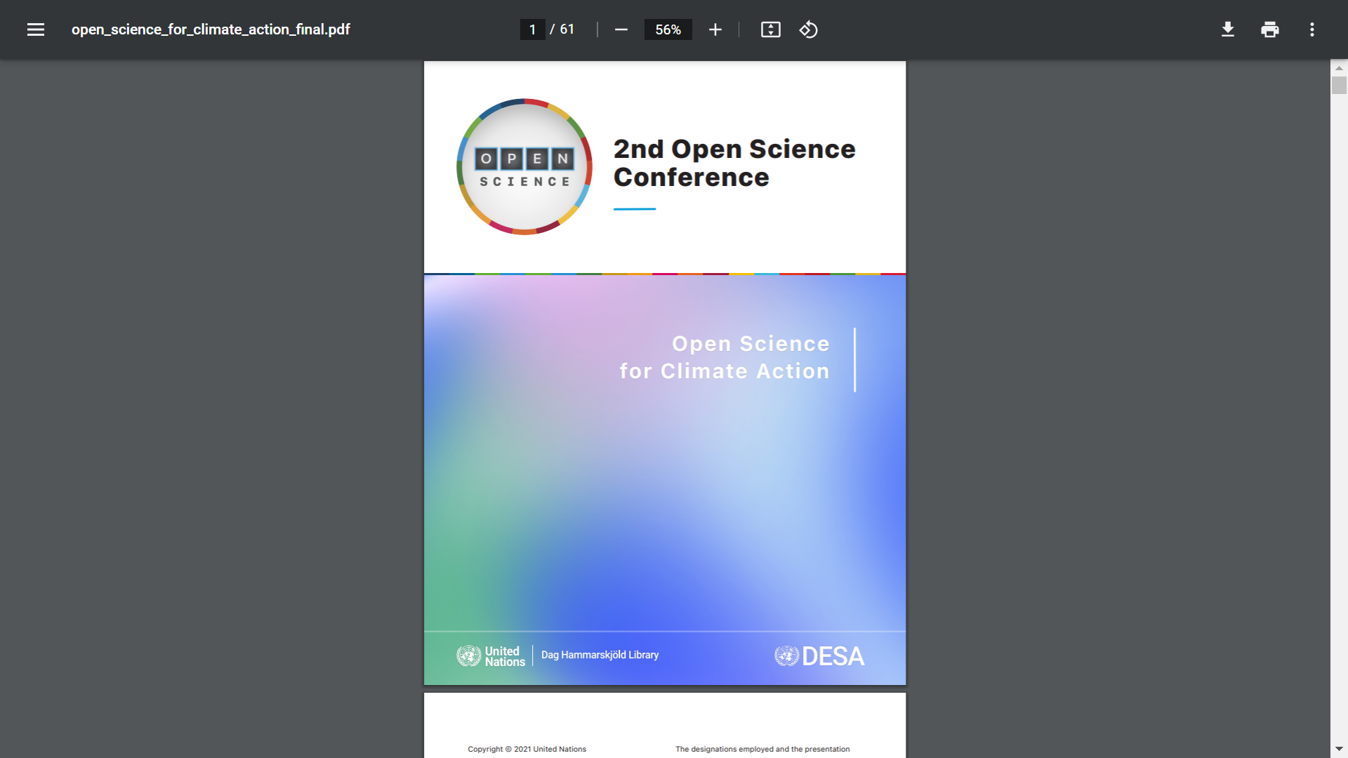

**Lessons learned from the pandemic and of interest for climate change emergencies***[1]*

Dominique Babini[2] y Laura Rovelli[3]

* **#OpenScience needs to be the default with no paywalls for participants and no paywalls for beneficiaries-the case of open access**

In the initial months of the COVID-19 public health emergency, a request from national science advisors from a dozen countries to scholarly publishers[4] resulted in publishers providing free access to coronavirus-related articles, but this exemption of payment to read COVID-19 research results in subscription journals will be limited to the duration of this crisis. And these exemptions of payments are not applicable for authors and institutions needing to publish their research and data on COVID-19 in open access journals charging article processing charges (APC).

Paywalls to read or to publish results of publicly-funded research should not exist. Scholarly communications infrastructures can be owned and managed by the scholarly community providing non-profit services, as is the case of many open access publishing initiatives in universities and other research institutions worldwide.

This is the case of Latin America, which today is the most advanced region in the world as per percentage of scientific output in local and regional publications available in open access[5]. Journals in Latin America are published by universities and other scholarly institutions, and funded as part of the cost of research, with no charge to read and no charge to publish. In a study about the use of these open access contents[6], 75% of use comes from university students, professors and researchers, and to a lesser extent by practitioners and citizens looking for information in the Web.

Community-led open access and open science has better chances to be more inclusive, equitable and sustainable.

* **Assessment of scholarly publishing based on traditional indicators (e.g. impact factor of journals) does not contribute to incentivize inclusive and participatory open science practices using bibliodiverse and multilingual local as well as international open access venues for publishing**

The dominant use of the impact factor (IF) to assess research being published -an indicator based on collections of journals with very poor presence of quality journals from developing regions in languages other than English- is a practice that does not incentivize open science.

Putting all quality controlled collections available in diversity of open publishing venues -publishing platforms, preprint and data archives, and institutional and subject repositories- on the same footing during research assessment practices, could remove some of the pressure to publish in prestige journals with high IF. And it will make the DORA and Leiden recommendations easier to implement.

**\* Mission-oriented research assessment requires contextualizing frameworks and situated methodologies, particular or extended evaluation criteria, and reviewers with wider backgrounds and expertise and the participation of social movements and/or local communities.**

Lessons learned from the COVID 19 pandemic and of interest for climate change emergencies make emphasis on the trend towards high-quality mission-oriented research to improve policy efforts for global sustainability, its contribution to solving social and environmental issues and increase public engagement.

On the road of an increasing demand for new indicators to capture the contribution of research to society, particularly those aligned with The United Nation’s Sustainable Development Goals (SDGs) – established as part of the UN’s Agenda 2030 –there is a need to compare various methodologies, each of them with a particular understanding of the SDGs and evaluate their use for specific contexts and purposes in Latin America and the Caribbean[7] . Mission-oriented research assessment might require referencing frameworks and situated methodologies, particular or extended evaluation criteria, and reviewers with wider backgrounds and expertise, practitioners, or non-academic stakeholders and the participation of social movements and/or local communities[8].

From our experience and perspective, as a network of more than 800 research institutions in 55 countries, there is a unique opportunity to address those concerns by reviewing evaluation procedures and making a transition to open science practices (UNESCO, 2021) and producing new data and analysis that can contribute to strengthen the interactions between science systems and society.

1. In: United Nations 2° International Conference on Open Science publication “Open Science for Climate Action”, 2021, https://www.un.org/sites/un2.un.org/files/open_science_for_climate_action_final.pdf
2. Open Science Advisor at CLACSO-Latin American Council of Social Sciences. ORCID 0000-0002-5752-7060
3. Coordinator of the Latin American Forum on Research Assessment (FOLEC-CLACSO). ORCID 0000-0001-7059-149X
4. https://wellcome.org/sites/default/files/covid19-open-access-letter.pdf
5. <http://www.unesco.org/new/en/communication-and-information/portals-and-platforms/go>

   ap/access-by-region/latin-america-and-the-caribbean/
6. https://figshare.com/articles/presentation/Research_is_also_for_non_scholars_Lessons_from_Latin_America/3187551
7. # See Ráfols, Ismael (2021). Consensus and dissensus in ‘mappings’ of science for Sustainable Development Goals (SDGs). http://strings.org.uk/consensus-and-dissensus-in-mappings-of-science-for-sustainable-development-goals-sdgs/

  
8. Science Europe (2020). Science Europe Study on Research Assessment Practices. Technopolis Groups.

   Final Report https://www.scienceeurope.org/media/fmdihoqy/se-study-on-research-assessment-practices-report.pdf