Building the JSTOR OAI-PMH Service:
A Technical Case Study in Best Practices

Michael Krot
and
David Yakimischak

krot@jstor.org, davidyak@jstor.org
http://www.jstor.org

Abstract

The goal of this case study is to share the learning experience of implementing the JSTOR OAI-PMH Interface at JSTOR. This paper is designed to assist implementers of OAI-PMH repositories in applying best practices to their development process. In particular, the JSTOR OAI-PMH System has been designed as a framework to deliver content restricted by subscription while interfacing with a wide variety of Authorization/Authentication systems. Likewise, the JSTOR OAI-PMH service has been built to interact with differing repository implementations with minimal programming effort.

Introduction

JSTOR is a not-for-profit organization with a mission to help the scholarly community take advantage of advances in information technology. This includes: (1) building a reliable and comprehensive archive of core scholarly journals, and (2) dramatically improving access to this scholarly material. In pursuing its mission, JSTOR takes a system-wide perspective, seeking benefits for libraries, publishers and scholars.

In addition to the page images and OCR text that JSTOR gathers, they also collect metadata about the publications in our archive. The metadata describe items such as the journal, volume, issue, article, page, title, author, abstract, and keywords. This metadata is used internally and externally (to JSTOR). Until recently, JSTOR has been developing custom data formats and transmission methods for each particular need.

Recently, JSTOR embarked upon a project to create a standard interface to its metadata. We selected the OAI-PMH (Open Archives Initiative – Protocol for Metadata Harvesting).

Although JSTOR has not yet made a decision on how and when to publicly expose this interface, they do intend to use this interface experimentally, and to use it for internal data movement purposes.

One of the challenges faced by JSTOR during this development was that we had determined that the underlying archive structure and systems architecture at JSTOR was in need of significant improvement. Thus it was necessary for the development of the OAI-PMH System to be done in such a way as to accommodate new, undefined data archives and repository structures. This may have made the OAI-PMH project more generalized and abstracted than it would have been, if we were dealing with a single, well-defined repository. In the long term, we believe that this will provide additional flexibility, and re-use of this software into applications that could not have been predicted at construction time.

That said, the OAI-PMH interface may allow additional flexibility and separation, providing a standardized interface to be able to move metadata (and possibly journal content itself) easily and freely within internal JSTOR systems that may be under a tremendous amount of change themselves.

Goals of OAI-PMH Project

We wished to embark upon a project that would allow the individuals involved to learn a new analysis and design methodology, namely the Unified Process (UP). Lightweight UP is going to form the basis of the new JSTOR software development methodology, and this allowed for a low pressure learning environment for the principals. We believe that the OAI-PMH software forms a key intellectual investment for JSTOR, and thus we decided to follow a very formal and rigorous process in defining and implementing this interface. It will live in some form for a very long time to come, and thus was worthy of creating with investment-grade quality in mind.

The initial application identified was for internal use. This will allow JSTOR to exercise their software, and learn its capabilities, in a situation that is not customer-facing and under significant visibility or marketplace demands.

Ithaka is a new organization dedicated to the potential sharing and commonality of affiliates such as JSTOR, ARTstor, E-Archiving and the Mellon Foundation. As JSTOR contributes to a new Ithaka-wide development model, this OAI-PMH software may become part of the shared Ithaka software platform. The general-purpose nature of the software lends itself to new and unanticipated applications.

Development Methodology

Before developing the software for our system, the first step was to identify initial constraints and requirements. This step was necessary to determine the scope of the project and to help inform the design process.

The specific constraints JSTOR faced are explained below:

Large Amount of Data – The JSTOR archive is fairly large with over 570 journals represented. Between these journals, JSTOR has archived over 100,000 issues and over 2.5 million articles. In the OAI-PMH System, we needed to be able to move journal-level, issue-level, and article level metadata quickly and easily from this large collection. There was also discussion of moving some of our 15 million OCR’ed pages, which further underscored the need for a robust, scalable system.

Content Limited by Customer – Prior policy at JSTOR has specified that metadata is to be shared with participating institutions only. Participants subscribe to collections of journals and should only have access to the metadata for those particular journals. One participant might have access to 500 journals; another might have access to a handful. JSTOR’s public system uses an authorization/authentication system to assure users have access to the journals in their subscription.

Core Components in Transition – It was obvious that JSTOR’s OAI-PMH System would need to interact with JSTOR’s Authorization/Authentication system to get subscription information for visiting harvesters. While this was a known constraint, JSTOR was in the process of redeveloping the Authentication/Authorization system and we knew very little of the final implementation. Thus, whatever the final design of the OAI-PMH System would have to accommodate a wide variety of implementations of this core component.

Likewise, JSTOR was in the initial stages of replacing the existing metadata repository. The system would have to be able to work with any underlying repository implementation with minimal programming effort.

Java Programming Language – Java is used company wide within JSTOR and is the preferred programming language. Using a common language allows us to share development tasks, helps maintain good object oriented code, and allows components to interface more easily with one another. We also decided early on that the OAI-PMH System would work well as a web application and would probably utilize servlets.

Code must be Reusable/Extensible – As mentioned earlier, JSTOR shares a unique relationship with several sister organizations through Ithaka. The OAI-PMH System would ideally be built to be reusable by these sister organizations, each of which may have different implementations of core components. This further underscored the need for design that accommodated multiple implementations of repositories and authorization systems.

No Existing Applications – While several implementations of OAI-PMH delivery systems exist, an initial survey of the existing tools showed that none could meet our specific requirements. Many implementations were tied specific repository implementations, were not written in Java, and/or did not contain the necessary hooks for limiting content based on subscription levels.

Based on the analysis of these initial constraints, we began the next steps of looking into how we would approach the development of our OAI-PMH System.

Process

While JSTOR has long-standing software development processes in place, one goal of our organization is to keep abreast of new development processes. As was mentioned earlier, JSTOR was interested in incorporating a lightweight Unified Process into the existing software development process.

The Unified Process is based on requirements driven, iterative design. At the end of each iteration, a working prototype is available and stakeholders have the ability to sign off on any design decisions. The details of a formal Unified Process are far too numerous to explain here. A wide array of books and websites are available for those interested in learning more about the process.

Ultimately, a lightweight version of the Unified Process was used in the development of the OAI-PMH System. This was done because that, while useful in certain environments, the full Unified Process was too formal for JSTOR’s needs. Previously, JSTOR staff had experimented with and incorporated Extreme Programming (XP) into the design process. Taking a more moderate approach to the Unified Process meant that it was possible to incorporate elements of XP, such as extensive use of pair programming and unit testing (JUnit) while designing the OAI-PMH System.

Because our internal experience with Unified Process was limited before this project, JSTOR hired Object Insight from Ann Arbor, Michigan to help us with the application of Unified Process to the design of our OAI-PMH System. Object Insight is a consulting company that specializes in the Unified Process. Their assistance was both indispensable and highly instructive as we developed the JSTOR OAI-PMH System.

Notation, Tools, and Testing

As is standard practice with the Unified Process, Unified Modeling Language (UML) manner is which we recorded the iterations of the design process. UML is a standard form of notation that provides a set of tools for describing complex, object oriented software projects. Throughout this paper, you will see several examples of UML describing the OAI-PMH System we created. Unfortunately, we do have the time or space to fully describe UML.

The development tools used for this project included Eclipse, JVision, and Omondo. Eclipse is an open source Integrated Development Environment (IDE) that is primarily used for developing Java applications. JVision is an application designed by Object Insight which used for creating UML. Likewise, Omondo is used for creating UML but has the added convenience of being an Eclipse plug-in. Omondo allows users to generate Java classes from UML and was used extensively during the later phases of the project.

The JSTOR OAI-PMH System was developed using Java 1.4.2_02, Tomcat 4.1.28 and is compliant with the Java Servlet 2.3 specifications. Testing involved unit tests with JUnit and load testing with Astra Load Test.

Requirements Gathering through Use Case Modeling

Though we completed an initial requirements analysis, the Unified Process dictates a more formal gathering of functional requirements through use case modeling. A good definition of a use case model is:

“A use-case model consists of actors, use cases, and relations among them. Actors represent everything that must exchange information with the system, including what are typically called users. When an actor uses the system, the system performs a use case. A good use case is a sequence of transactions that yields a measurable result of value for an actor. The collection of use cases is the system's complete functionality.”

Use case modeling serves many purposes. It is an excellent tool for narrowing requirements and planning a system without spending time coding. It also creates sharable artifacts in a standardized language (UML), which allows all stakeholders to approve of and sign off on key aspects of the initial design before beginning any implementation.
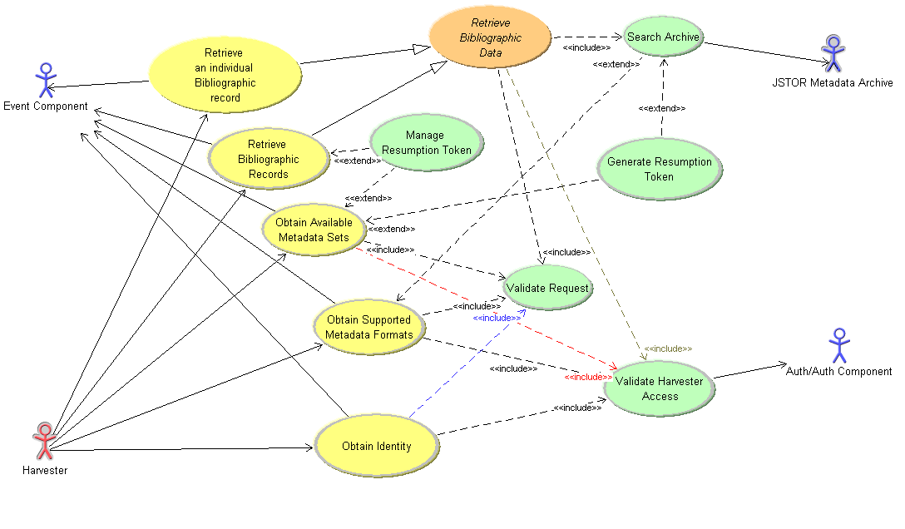
OAI-PMH System Use Case Diagram

In this diagram, there are four actors, each represented by the symbol that looks like a stick man. In this diagram, each actor corresponds to an external system that interacts with the JSTOR OAI-PMH System. The “Harvester” represents the harvester requesting data. The “Authorization/Authentication Component” (or “Auth/Auth Component”) represents the system that will determine access rights and subscription levels. The “JSTOR Metadata Archive” represents the metadata repository. Finally, the “Event Component” is responsible for logging the activities of the OAI-PMH system and saving them for reporting purposes. The Event Component is not discussed in detail in this paper, but its underlying implementation was likewise unknown as we developed our system.

The first four use cases have a direct relationship with OAI-PMH verbs. The relationships are as follows:

Retrieve an Individual Bibliographic Record – corresponds the verb “GetRecord”.
Obtain Available Metadata Sets – corresponds to “ListSets”
Obtain Supported Metadata Formats - corresponds to “ListMetadataFormats”
Obtain Identity – corresponds to “Identify”

If such a relationship exists between the use case and the verb, one might ask why the names of the verbs themselves were not used for the use cases. The reason behind the naming convention was simply that use case models are not supposed to be overly technical documents. Use cases models are, in theory, supposed to be artifacts that can be passed on to various stakeholders to be approved and should be expressed in the simplest terms possible. Because of this fact, it was decided that the more verbose name was appropriate.

It should be obvious that the “ListRecords” and “ListIdentifiers” verbs are missing from the above list. Both of these verbs are in fact contained within the Retrieve Bibliographic Records use case. It was decided that, because the basic mechanism of these two verbs was so similar, that they could be combined into one use case.

The remaining use cases are as follows:

Manage Resumption Token – This use case describes how a resumption token is handled when it is sent from the harvester.

Generate Resumption Token – This use case describes the process by which a resumption token is generated when a response is an excessive length.

Search Archive – This use case describes how a search is formulated and executed on the JSTOR Metadata Repository.

Validate Request – This use case describes how an incoming request is validated to make sure it has all appropriate parameters and correct syntax.

Validate Harvester Access – This use case describes how an incoming request is validated, with the help of the Auth/Auth Component, to ensure the Harvester has permission to access the resources it is requesting.

After creating the initial use case diagram, the next step was to write up detailed use case specifications. For each use case in the diagram, we wrote detailed a step-by-step analysis of what we expected to happen at each stage in the system. Once the use cases were fully detailed, we had a firm idea of our requirements for the system, before writing a single line of code.

Use Case Analysis

Once we had our use cases in hand, it was necessary to focus on one use case on which to focus our attention. We selected the Retrieve Bibliographic Records use case as we began our next steps because this use case touched on virtually every part of the System. This allowed us to both focus our attention while creating a framework that would allow us to later complete the remaining use cases.

A detailed collaboration diagram of the Retrieve Bibliographic Records use case can be found in Appendix A. Collaboration diagrams are good tools for helping identify basic objects and viewing how they may relate to each other, without coding. This diagram provides an excellent overview of the flow of events for this use case and it remains an important tangible artifact for future developers to examine in order to better understand the OAI-PMH System we developed.

One additional benefit of the collaboration diagram is to identify objects as they fall into the Model-View-Controller (MVC) design pattern. Well documented, the MVC pattern posits that objects come in three flavors; models which maintain the data, views which display the data, and controllers which control interactions between the models and views in the system. MVC is useful in cases like our own, where major components are in transition, because it allows us to clearly separate the view of the data as it appears to the harvester from the model of the data and how it is stored. The hope is that this type of design will limit code changes in the future by building in clear separation between objects and their prospective functions.

The collaboration diagram led directly to our View of Participating Classes (VOPC) diagram. This was useful in determining the cardinality of class relationships and allowed us to select appropriate data structures to reflect these relationships.

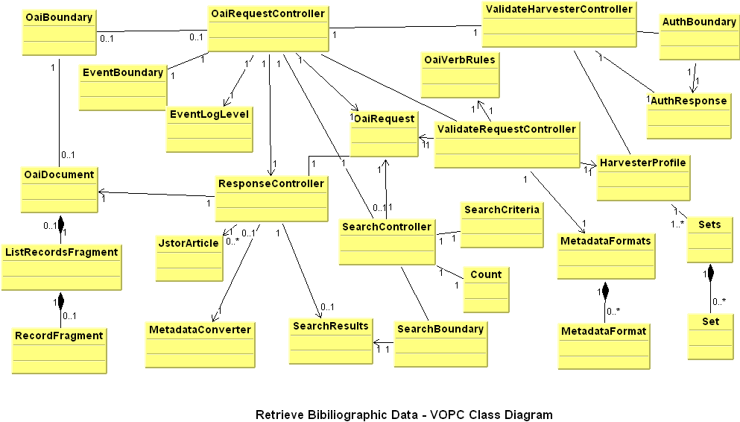

J2EE Design Patterns

J2EE Design Patterns provide a mechanism for applying proven solutions to common design problems. They serve as a blueprint of best practices for designing Java objects and expressing the relationships between. Design patterns mean that developers do not have to reinvent solutions to design issues that have been solved in the past and help minimize bad and inefficient design. As a result of these benefits, design patterns are widely used and understood in the software development community. By using design patterns, JSTOR was better able to create an OAI-PMH System that is easily understood by future developers and provide a framework where a minimum amount of work will be necessary for future customizations or enhancements.

In order to apply design patterns, we started with our VOPC diagram and examined the relationships of the classes we had identified. We then identified a number of patterns which suited these class relationships. The major patterns used included in the JSTOR OAI-PMH System are the Front Controller, Data Access Object, Transfer Object, Factory, and Singleton patterns.

In order to illustrate the use of Java Design Patterns, we will now explain the Data Access Object Factory. A Data Access Object can be used to abstract and encapsulate all access to the persistence store as it manages connections with the data source to obtain and store data. Combining the Abstract Factory pattern with DAO increases the flexibility of the application by allowing frequent changes to the underline persistence stores or to use more than one source. This was critical to success of the OAI-PMH System, as we had no clear idea of the final underlying implementation of the Authorization/Authentication System, the JSTOR Metadata Archive, or the Event Logger. By using this pattern, we were able to design software that is capable of having several different implementations of these components, so long as the implementations conform to the interfaces we developed.

The Abstract DAOFactory class defines the framework for concrete DAO Factories of the application. The class diagram for the abstract DAOFactory is shown in the figure below. This Factory produces HarvesterDAO to validate harvesters with authentication system, SearchDAO to obtain and search a record repository and EventLoggerDAO to log the application events with an event logging system. The getDAOFactory method creates and returns a singleton instance of a concrete factory based on the concrete factory class name. The class name of the implementation of the factory must be on the Java classpath and defined in the application’s properties file. In this instance, you see the JSTOR specific implementation of the interfaces.
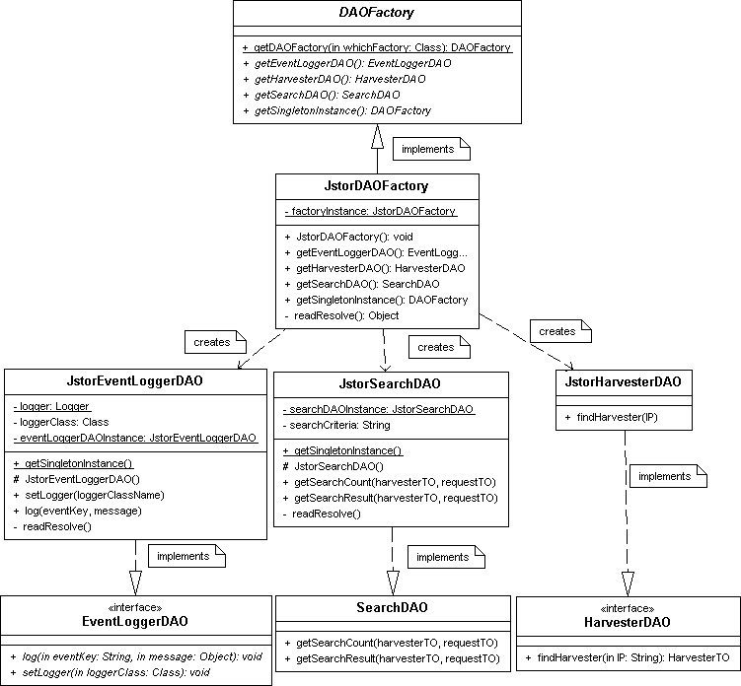

This design pattern has proven very flexible. It is critical to the design of our system and will allow us to plug in any implementation we desire for key components of the System. As proof of concept, we have used flat files, XML files, and a MySQL database as both an authorization system and a metadata repository

Conclusions

In this paper, we have tried to illustrate the manner in which we approached the development of the JSTOR OAI-PMH system. In particular, we have tried to demonstrate how we developed a design that would allow us to switch out the underlying implementation of our Authorization/Authentication services as well as our metadata repository.

When dealing with a great deal of uncertainty, we found the Unified Process to be of great assistance. Through the process, we were able to develop strict requirements for Systems when we didn’t know the underlying implementation of those systems. We were able to create code that will be easy to manage and maintain over time, and we were able to create a series of documents to help others as they work with our software.

For the Authorization/Authentication System, we ultimately determined this component had to provide two key bits of information. First, this System must provide simple permissions information (does the harvester have access to the system?) and secondly, if the harvester has permission, the AuthN/AuthZ system must provide some information about what sets the harvester can access. In order to accomplish this, it will be necessary for someone to write code to translate the response coming from that Auth/Auth System into something that our OAI-PMH System can understand, but we have made this easy through the use of interfaces which hide the underlying implementation details.

For the Metadata Repository, we rely on a similar mechanism to hide the underlying implementation details, though the requirements are more complex. The repository must know something about the type of object it is returning and all objects returned must implement a “Dublin Core” interface. The Dublin Core interface is applied to all records returned which, in turn, assures that every record can be transformed into oai_dc format.

The development of resumption tokens required a few more requirements from the repository. Namely, these were support for caching in some form (though this can be hidden in the actual implementation), the ability to return a count of all records meeting search criteria, and the ability to return the next n records in a series.

Ultimately, we found it very easy to meet these requirements with a variety of backend implementations including flat files, XML files, locally stored Java Objects, and a MySQL database. Because the actual implementation of the backend is hidden from the OAI-PMH delivery system, it is very each to switch out and plug in new implementations.

Future and Unresolved Issues

We are still finishing the OAI-PMH System and anticipate it will be fully functional and tested by spring of 2004. Once the system is functional, it still may be some time before we can actually actively use it for metadata harvesting. We will be using the system internally and will be actively reviewing how and when to make it available externally. There is a possibility of sharing the code on an exploratory basis, but we are still determining the best way to proceed with this question.

While the system is getting close to completion, we do have some unresolved issues that we actively examining. One such issue is to how best make available content that is new to a customer’s subscription base but is not new to the repository. In the JSTOR repository, content may exist in the repository, but it is only made visible to a participant when they have been given permission to view that object. For instance we may have archived the full run of a title from 1905 to 2004, but our agreement with the publisher states that we may only display content older than five years. This means, on January 1, 2004, our participant gains access to the year 1999. This concept of “new to my subscription” but not “new to the repository” was difficult to reconcile with the OAI standard as was ultimately handled using the OAI-PMH concept of sets. This particular limitation of the OAI-PMH Standard has been noted on other occasions on the OAI-Implementers list (http://www.openarchives.org/pipermail/oai-implementers/). This solution is somewhat dissatisfying. With this solution, harvesters are forced to be aware of new sets available to them.

One other issue we have debated is to how best associate metadata formats with the type of object returned from the repository. It is possible that a metadata format may be available for journal-level metadata that is not available for article-level metadata. This adds an additional requirement to the repository that it know what type of object it is returning and it also means that there needs to be an explicit way to represent a mapping between metadata formats and objects in the repository.

One final question for us is how open our current customers will be using the OAI-PMH Service once we it is available to them. JSTOR has interactions with a wide variety of institutions with varying degrees of technical capabilities. In order for this system to be successful, we will likely need to recommend and explain how to use a harvester. This has led to consideration of developing a harvester for both our own internal use and to share with our customers who would like to harvest from our site.

If you have any questions or comments, please feel free to contact Michael Krot at krot@jstor.org or David Yakimischak at davidyak@jstor.org.

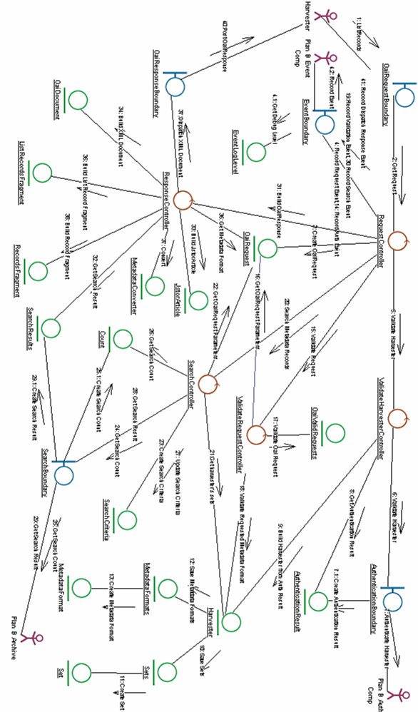
Appendix A: Retrieve Bibliographic Records Collaboration Diagram

.
Systems examined came mostly from OAI-Related Utilities page: Open Archives Initiative. Open Archives Initiative Tools. 9 Feb. 2004. http://www.openarchives.org/tools/tools.html
For more information on Object Insight see: http://www.object-insight.com/
For more information on Eclipse, and to download the product: http://www.eclipse.org
For more information on JVISION: http://www.object-insight.com/product/
For more information on Omondo: http://www.eclipseuml.com/
NSW Government Community Access to Natural Resources Information Program (02 Feb, 2004). CANRI website. http://www.canri.nsw.gov.au/glossary.html
For more information on Java Desiign patterns, see: http://java.sun.com/blueprints/patterns/
For more info see:http://java.sun.com/blueprints/corej2eepatterns/Patterns/DataAccessObject.html

