LEIDEN MATRIX
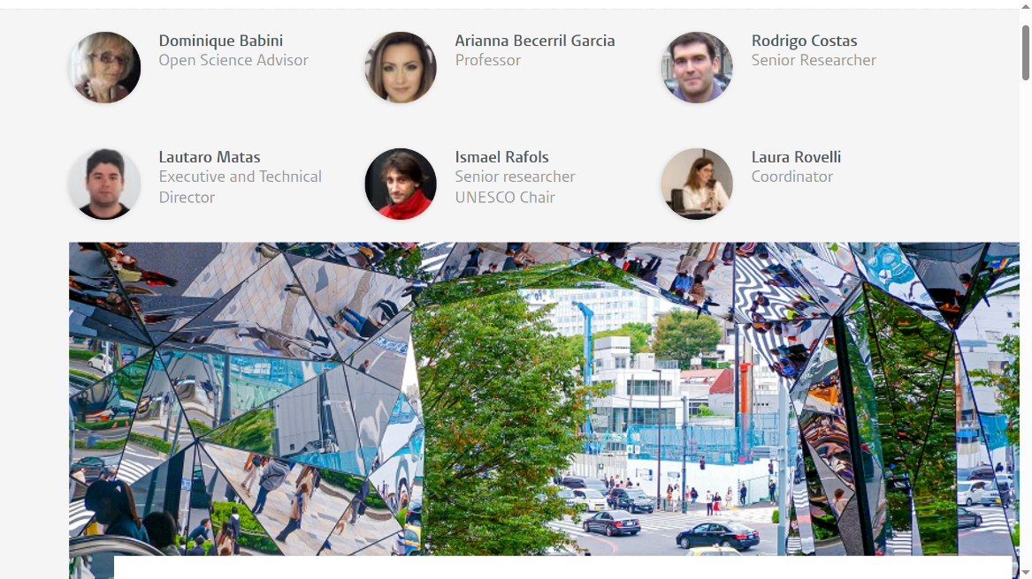

Not only Open, but also Diverse and Inclusive: Towards Decentralised and Federated Research Information Sources
April 22, 2024 • Science & Society • 6 min read

The Barcelona Declaration on Open Research Information highlights that research information systems should not only be open but also diverse and inclusive. We argue that this can only be achieved by interlinking various and decentralised research information sources.

The Barcelona Declaration: a call for openness… but also for diversity and inclusion
The launch of the Barcelona Declaration last week aims to mobilise the global research community towards making research information open and accessible. The most common argument for openness is that research information plays a central role in the evaluation of institutions and researchers, and in the retrieval of scientific outputs. Given this centrality, research information should not be locked inside proprietary infrastructure for science to advance.
In this blog post, we highlight that the Barcelona Declaration states that openness is indeed very important, but that openness is not enough: research information sources should also be diverse and inclusive, in line with the UNESCO Recommendations on Open Science.
Research information should avoid the biases documented in current mainstream sources, which are based in Western Europe and North America and tend to make less visible the science produced in other world regions, especially in the Global South. This is highlighted in the Barcelona Declaration which explains that decisions are routinely made ‘based on information that is biassed against less privileged languages, geographical regions, and research agendas’.
In short, diversity and inclusion of information are crucial for achieving fair and comprehensive monitoring and evaluation. But how do we achieve diversity and inclusion in research information?

Inclusion and diversity require multiple information sources
Research information is understood as including all bibliographic metadata, as well as metadata on other aspects of research such as samples, materials, research data, organisations, funding sources and grants.
In an ideal world, one might dream of a single database that would provide all this data for all the research across the planet. Yet in practice, this is not possible, perhaps not even desirable. Linguistic, institutional, local or regional research agendas and representation biases can be more effectively mitigated by ensuring the use of multiple sources that expand the thematic, geographical and linguistic scope of research information. The multiplicity of sources provides not only richer data but also broadens the cultural perspectives, thus supporting pluralism.
We propose three arguments why multiple sources lead to better monitoring and evaluation.
First, coverage (i.e. the number of relevant documents included) is not very high for many world regions, even in the largest databases such as OpenAlex. The deficit is particularly acute in territories where many journals do not use DOIs, such as Latin America or parts of Asia (e.g. South Korea), due to economic sanctions on countries such as Cuba, and to the high costs of DOIs in relation to journal resources. For example, only 20% of the documents captured in LA Referencia (a federation of repositories) and only 22% of the content published in Diamond OA journals in Latin America have DOIs; and none of the publications from SciELO Venezuela have DOIs.
In short, the adoption of some standards which are believed to be universal by the average Western expert is, in practice, very difficult in the contexts of many countries. Therefore, databases that aim to be global should include other Digital Unique Identifiers or the IDs of regional databases. The Decentralized Archival Resource Key (dARK) is a project by LA Referencia and IBICT that will provide a decentralised infrastructure and governance solution for persistent identifiers. Operating on a public good institutional network, dARK will offer an inclusive and interoperable approach, compatible with existing PID infrastructures.
The second argument is the richness of the metadata. A single global information source cannot support the same degree of detailed metadata that regional and specialised databases can provide for some specific issues. Just as PubMed offers richer metadata with regard to medical perspectives, when it comes to place, local information sources provide contextual know-how and a more detailed curation. For instance, the catalogue Latindex has rich journal metadata to help users distinguish among journals with more or less rigorous editorial practices. Redalyc’s open infrastructure provides access to the full text of Diamond OA journal articles as well as structured data in XML JATS, including mathematical expressions in MathML, audio, image, video and other multimedia content available in journal articles.
Moreover, local databases also produce classifications (e.g. disciplinary) in alignment with national institutions. Some local repositories cover some of the literature (including ‘grey’ documents such as policy reports) on socially relevant issues that are relatively neglected in the ‘international’ databases, such as tropical diseases or local policy.
The third argument for preserving a variety of information sources is pluralism. In a world that is unequal and undergoing serious conflicts, research information sources need to remain decentralised to accommodate a variety of perspectives on knowledge (local creativity, language, worldviews, histories, etc.), and preserve regional independence. Otherwise, there is a real danger that the choices of larger or dominant groups (for example, with regards to ontologies or selections) are adopted by default, without questioning, as has happened with commercial providers with problematic consequences in research assessment.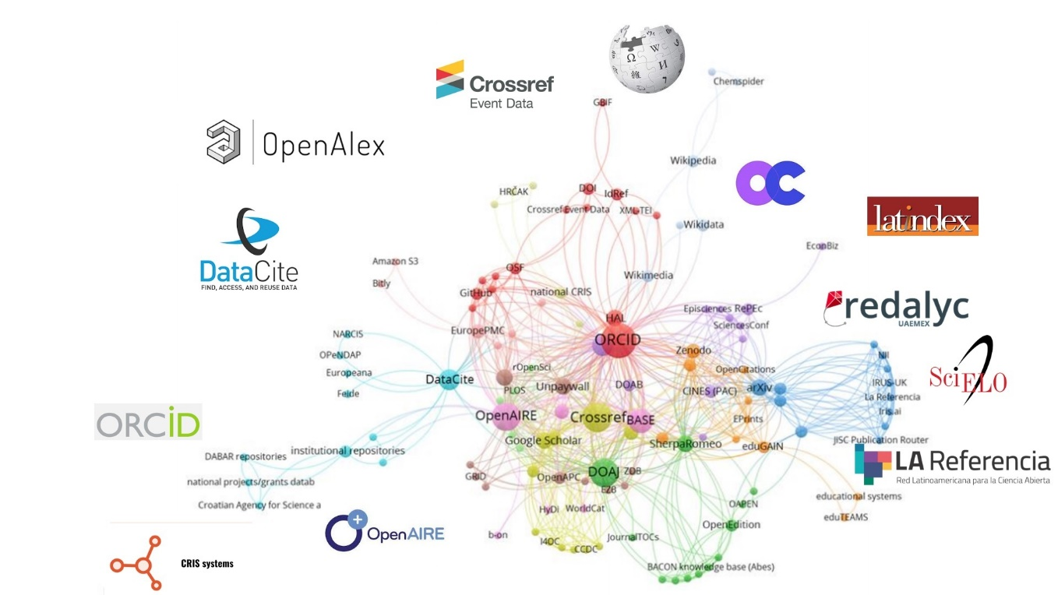
Figure 1. An illustration of a potential federation of open research information sources, with some prominent open research information sources. Based on Ficarra et al. (2020).

Opportunities for cooperation among already existing Open Research Sources
The path to open resource information is not about replacing Web of Science or Scopus with a single alternative source. On the contrary, we believe that a decentralised and federated research information ecosystem must be developed, so that diverse research information sources contribute to better coverage, richer metadata and pluralism.
Through interoperability agreements and interconnection of various sources, the use of communication protocols, standards and persistent identifiers, it should be possible to bring together information from multiple sources into applications designed for specific purposes in particular institutions. For instance, LA Referencia and Redalyc are collaborating to connect Diamond OA with Green OA content to improve visibility and research assessment.
With a multiplicity of sources, it becomes possible to pose questions in a plural and conditional manner, recognising that relevant knowledge differs across contexts. Instead of creating a singular “Observatory of Science” with a unique but inevitable partial perspective, the multiplicity of sources allows to organically build up a Multiversatory through the observation of the pluriverse of knowledge, showing different epistemic perspectives created under the lenses of particular languages, disciplines, communities and places, in contrast to mainstream descriptions.
The Barcelona Declaration explicitly supports this plural vision. It advocates that “information from different sources to be linked and integrated, so that decision making can take full advantage of all available information and can be based on a diversity of perspectives and an inclusive understanding of the issues at stake.”
Similarly, the declaration on research assessment (FOLEC) of the Latin American Council of Social Sciences (CLACSO) stresses that data sources should “reflect both the production disseminated in international repositories as well as that which is included in regional and local databases”.
In summary, there is an agreement that plural (i.e. decentralised) and interlinked (i.e. federated) research information sources are the way forward to ensure not only openness, but also diversity and inclusion. The Barcelona Declaration creates the momentum for all of us to continue working towards this goal.
Note: This blog post is based on some of the contributions from a webinar held on 22nd of March 2024 jointly organised by FOLEC-CLACSO and the CWTS UNESCO Chair. The recording is available here. The Spanish version of this blog post is available at the CLACSO website.
Header image by Susann Schuster on Unsplash
DOI: 10.59350/gmrzb-e2p83 (export/download/cite this blog post)
https://www.leidenmadtrics.nl/articles/not-only-open-but-also-diverse-and-inclusive-towards-decentralised-and-federated-research-information-sources

